**Azure Cloud Assignment**

Step 1: Create an Azure account and login to the Azure account.

Q1. Create a virtual network with 2 subnets. Each subnet should have 16 Ips only.

This is the Microsoft Azure HOME page.

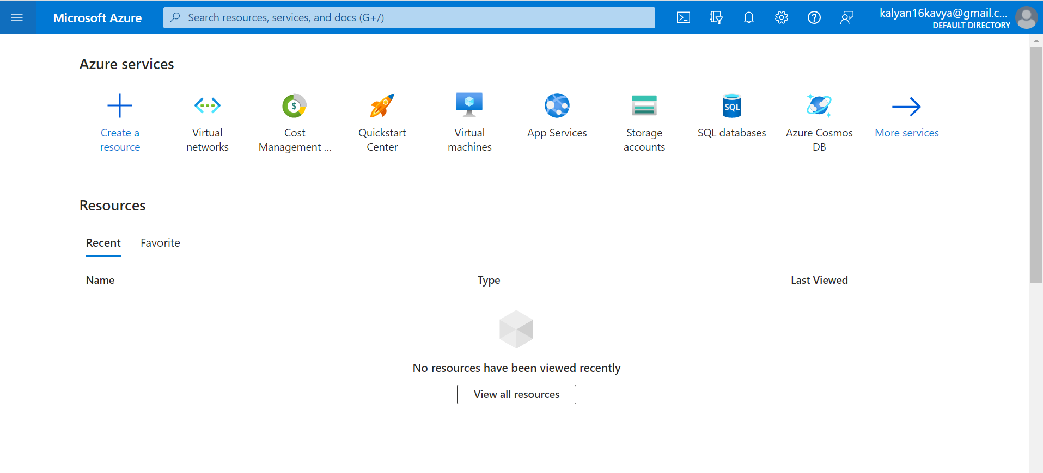

To create a Virtual Network, we need to click on this Virtual Network icon.

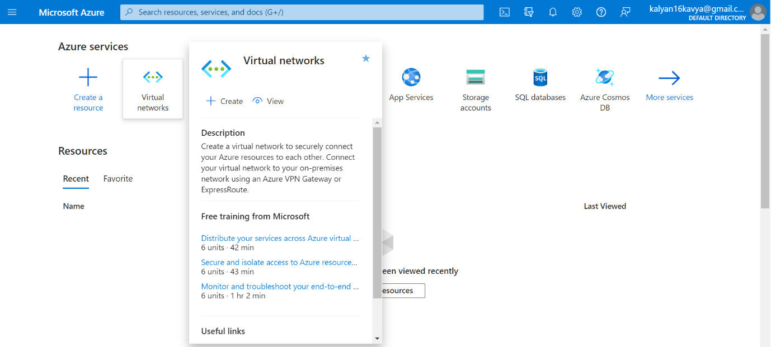

After clicking on the Virtual Network Icon, this page will come up, we need to click on Create on the top left corner below the Virtual network.

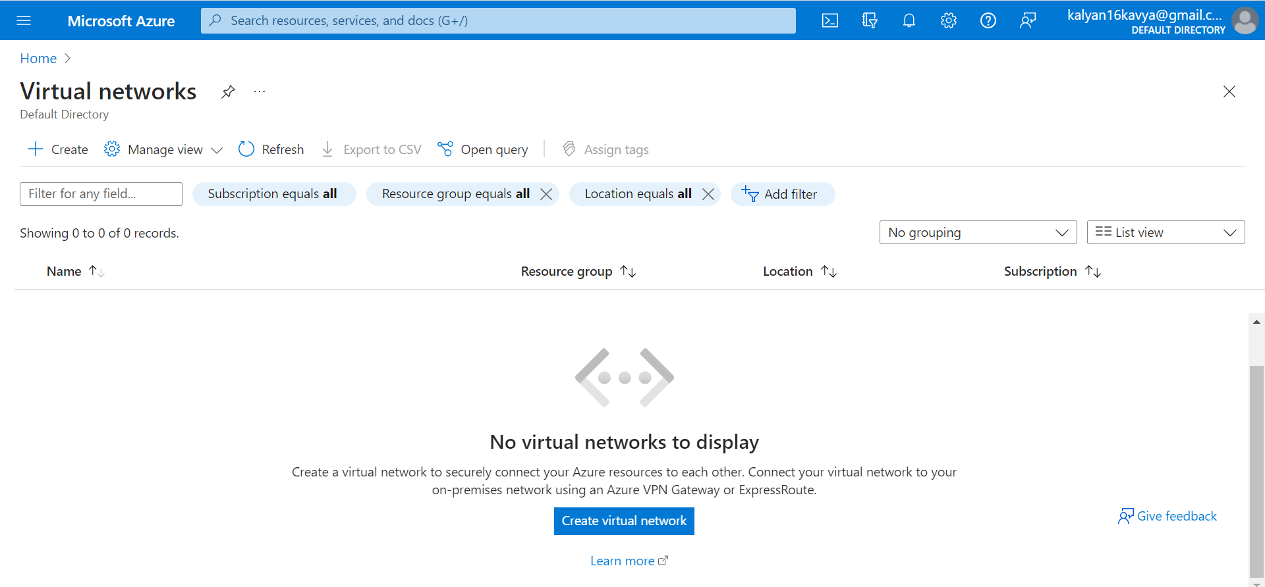

Add the Resource group or create a new resource group.

To create new Resource Group, click on create new under th Resource group tab and create a new resourse group.

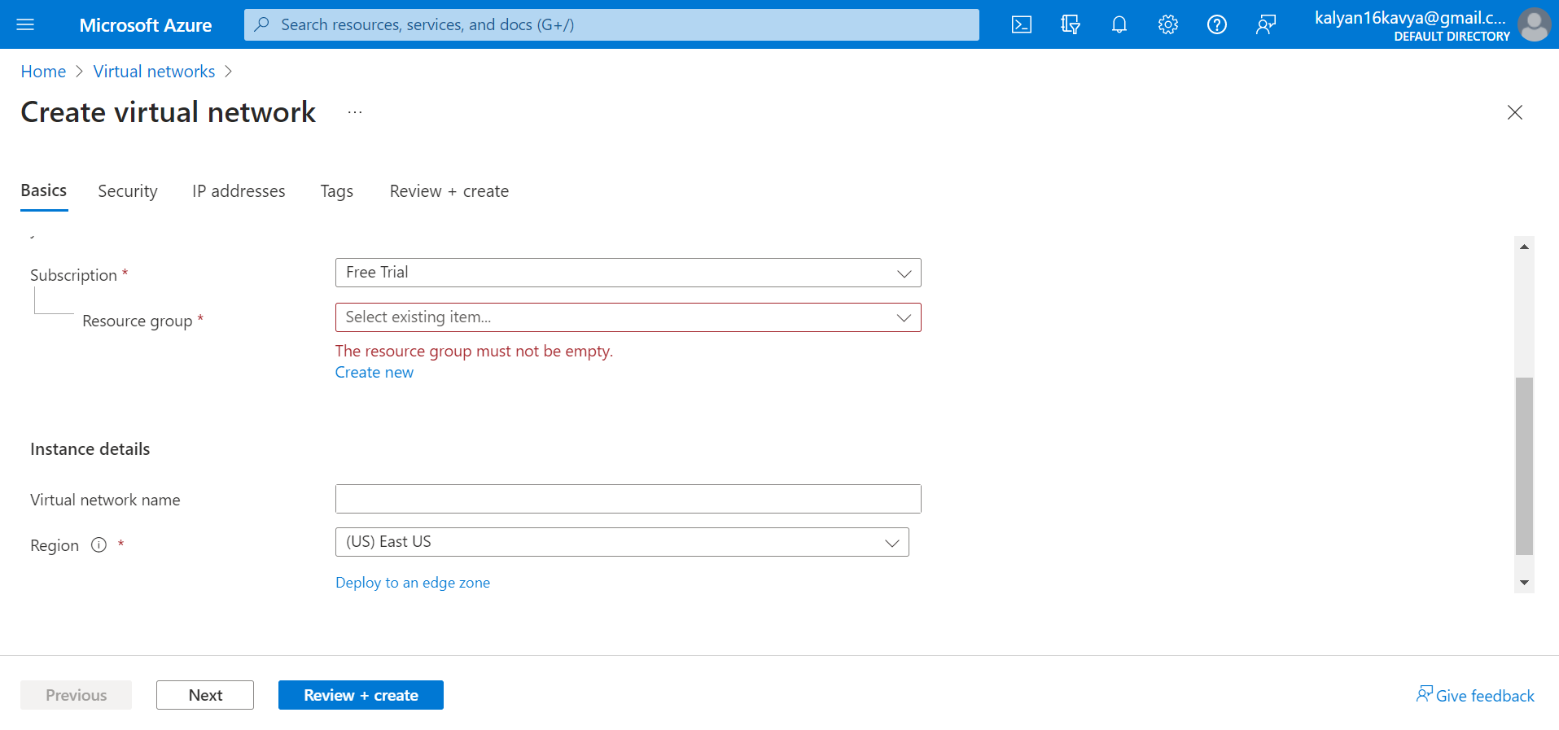

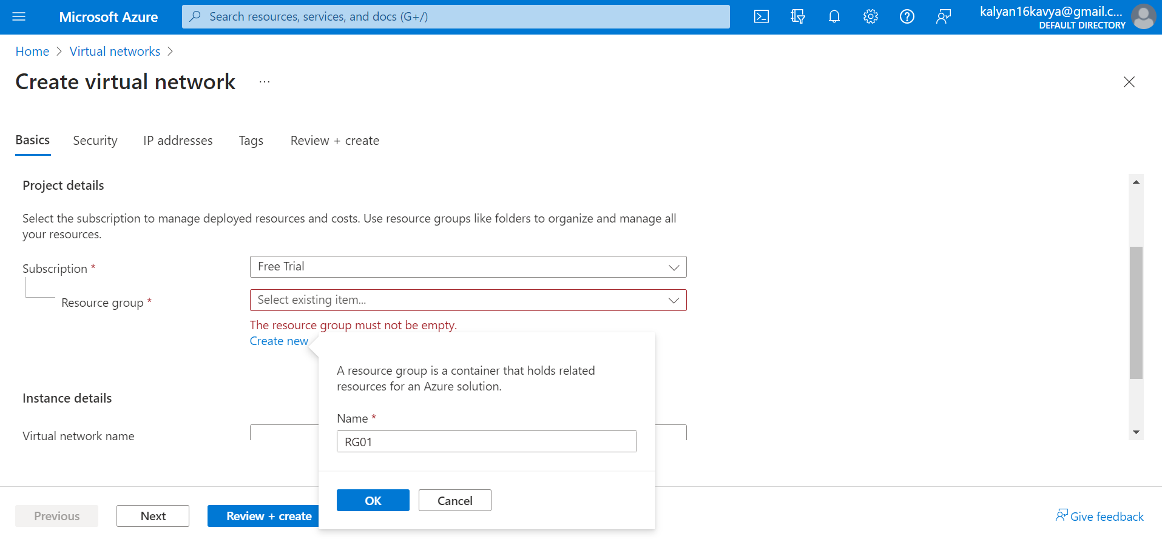

The name of the Virtual network should be unique. In our case the name is “MyVnet01”

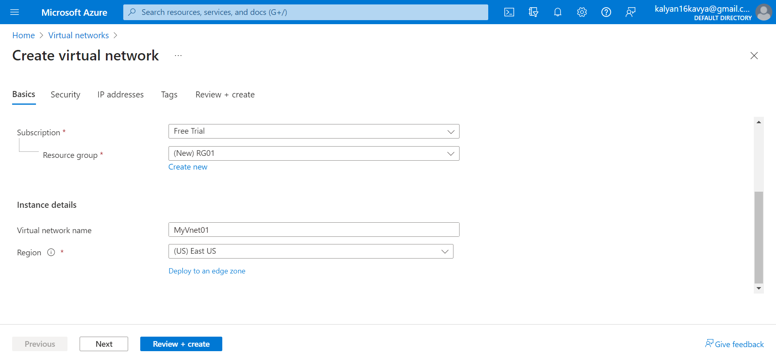

Let the remaining fields have default value. Then Click on Review and Create

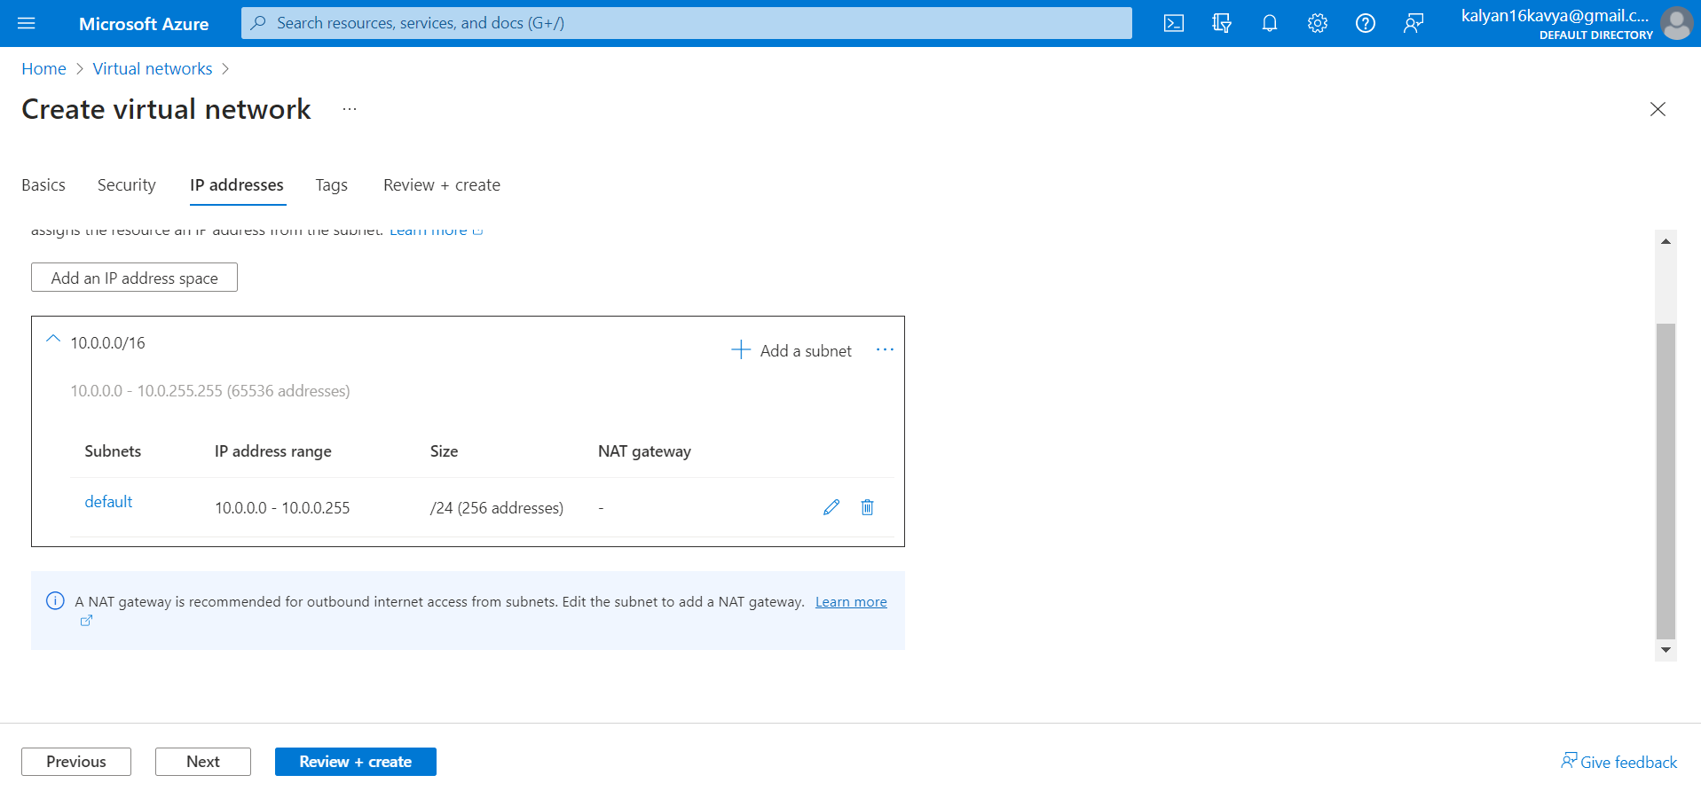

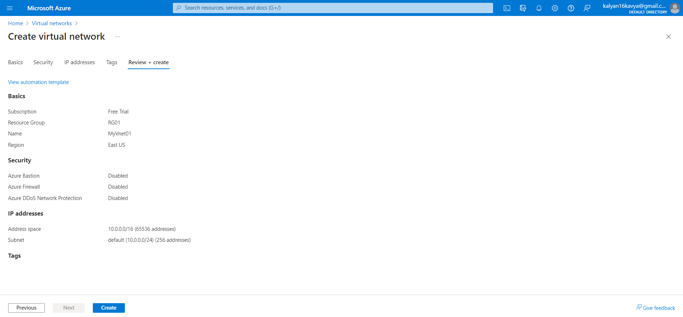

After clicking on create the deployment will take some time to get completed. Once the deployment is completed click on Go to Resources to view the details of the Virtual Network.

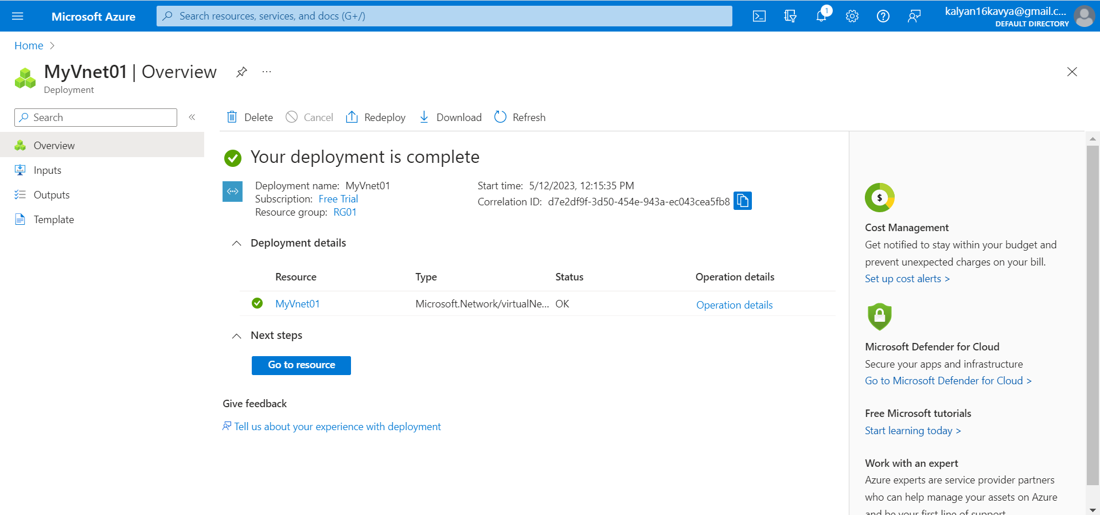

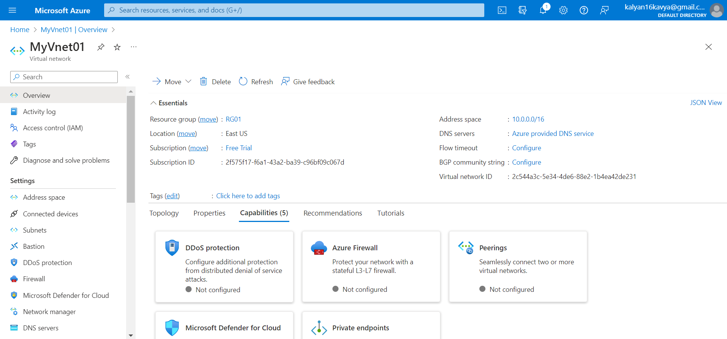

Inside the resource group a virtual network is created.

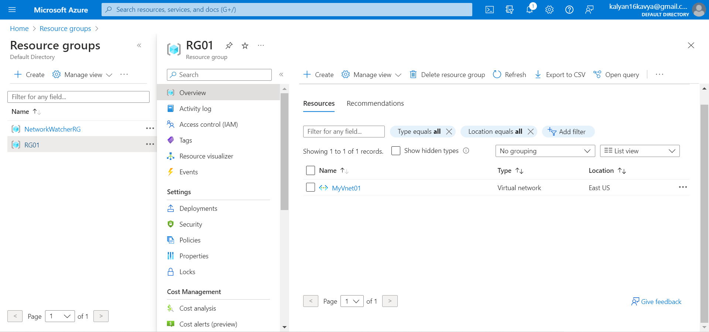

After clicking on MyVnet01, you can see a default subnet is created. We need to create 2 subnets inside MyVnet01.

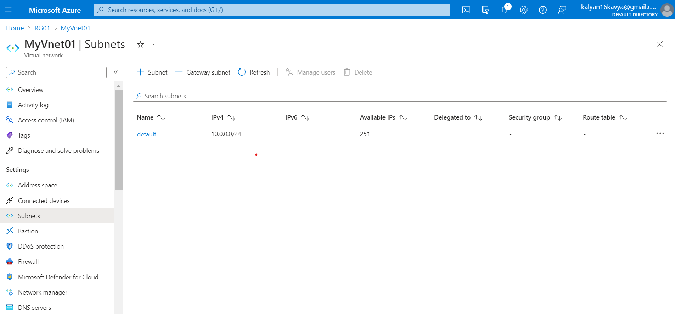

Click on +Subnet to create subnets. Add Subnet will pop-up.

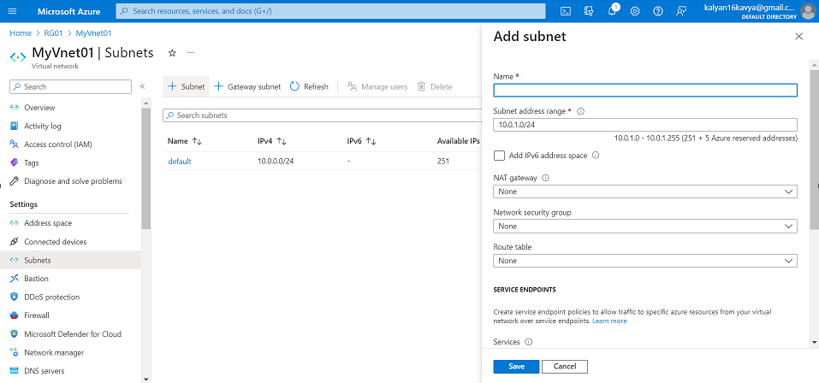

Add a unique name to the Subnet. As we need to create subnet with only 16Ips, we need to select the Subnet address range 10.0.1.0/28. For this the range is 10.0.1.0 – 10.0.1.15(11 + 5 Azure reserved addresses).

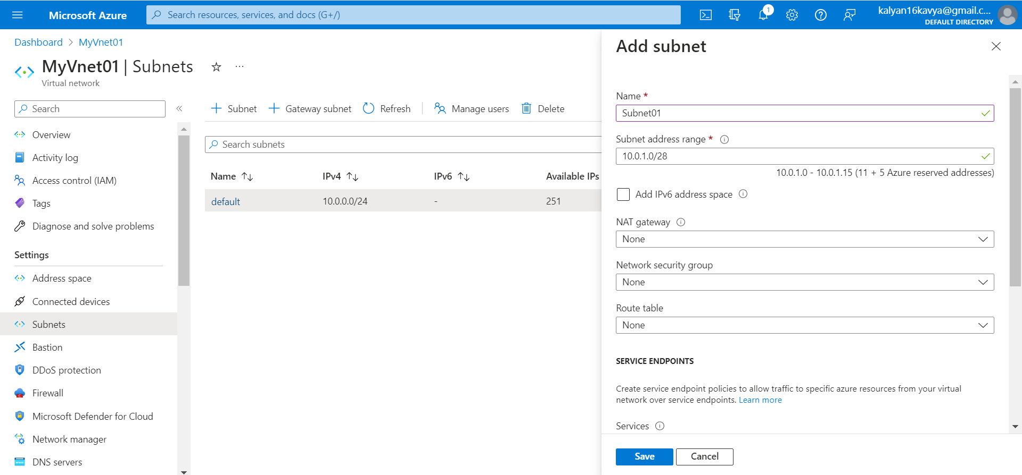

Let the other fields have default value. Clicking on Save a subnet is created.

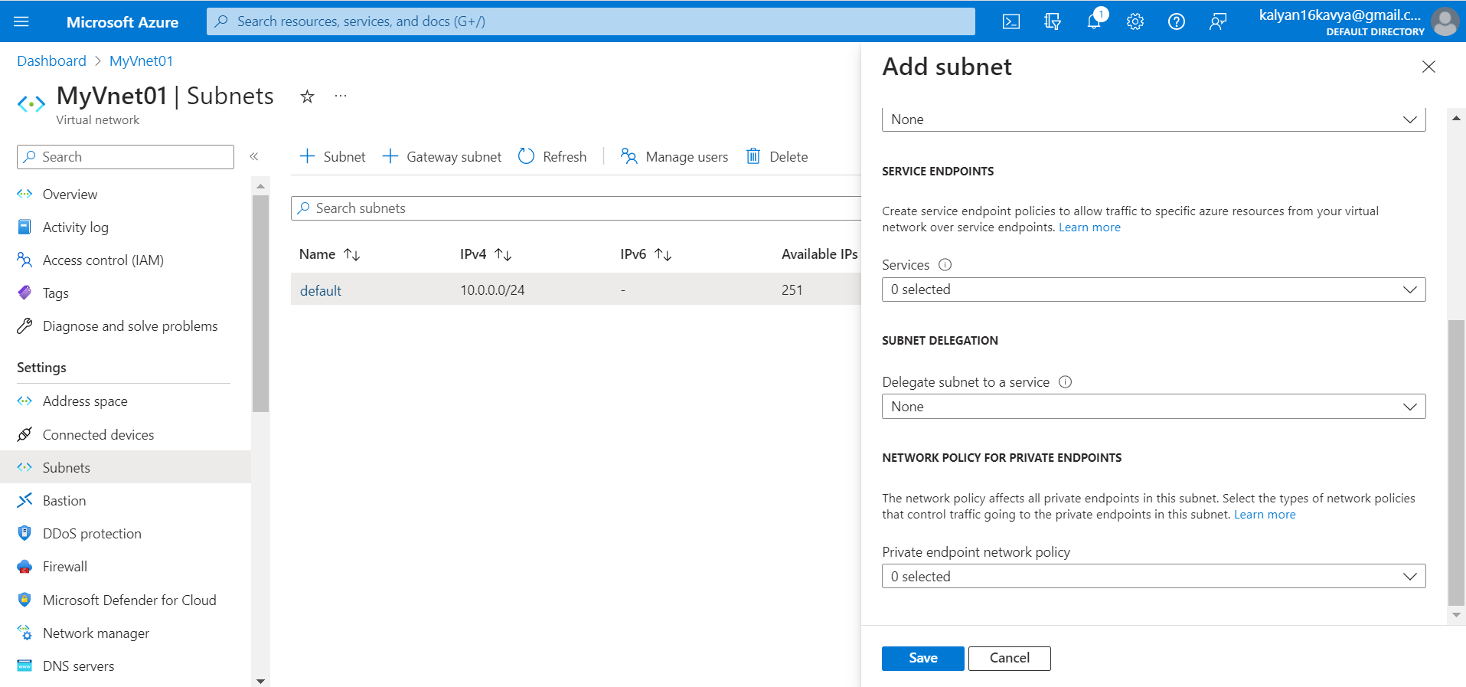

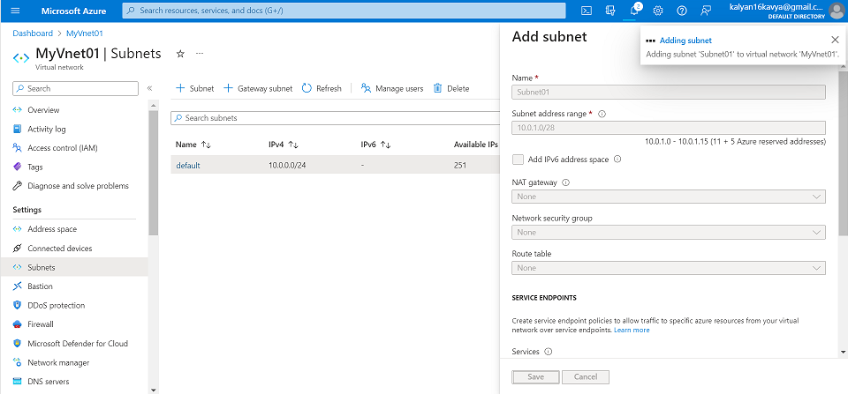

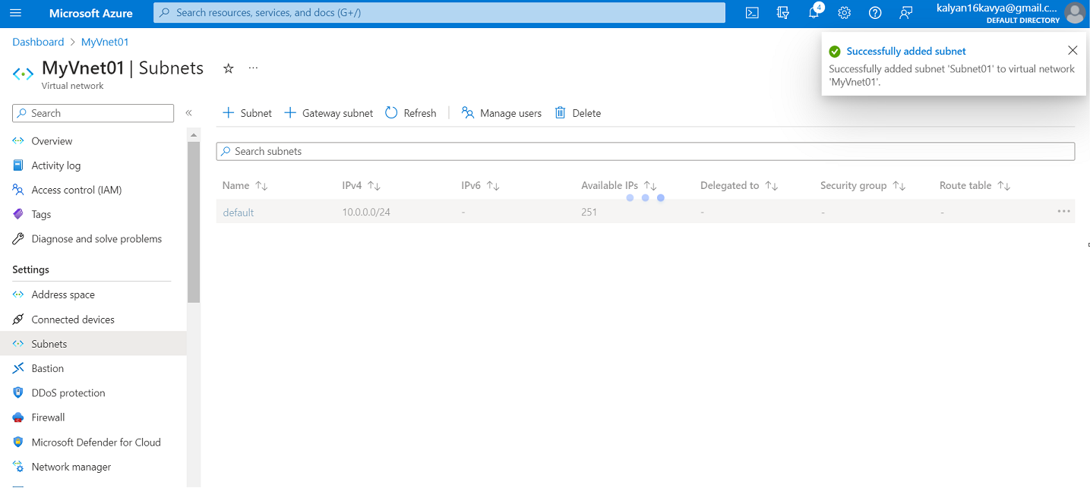

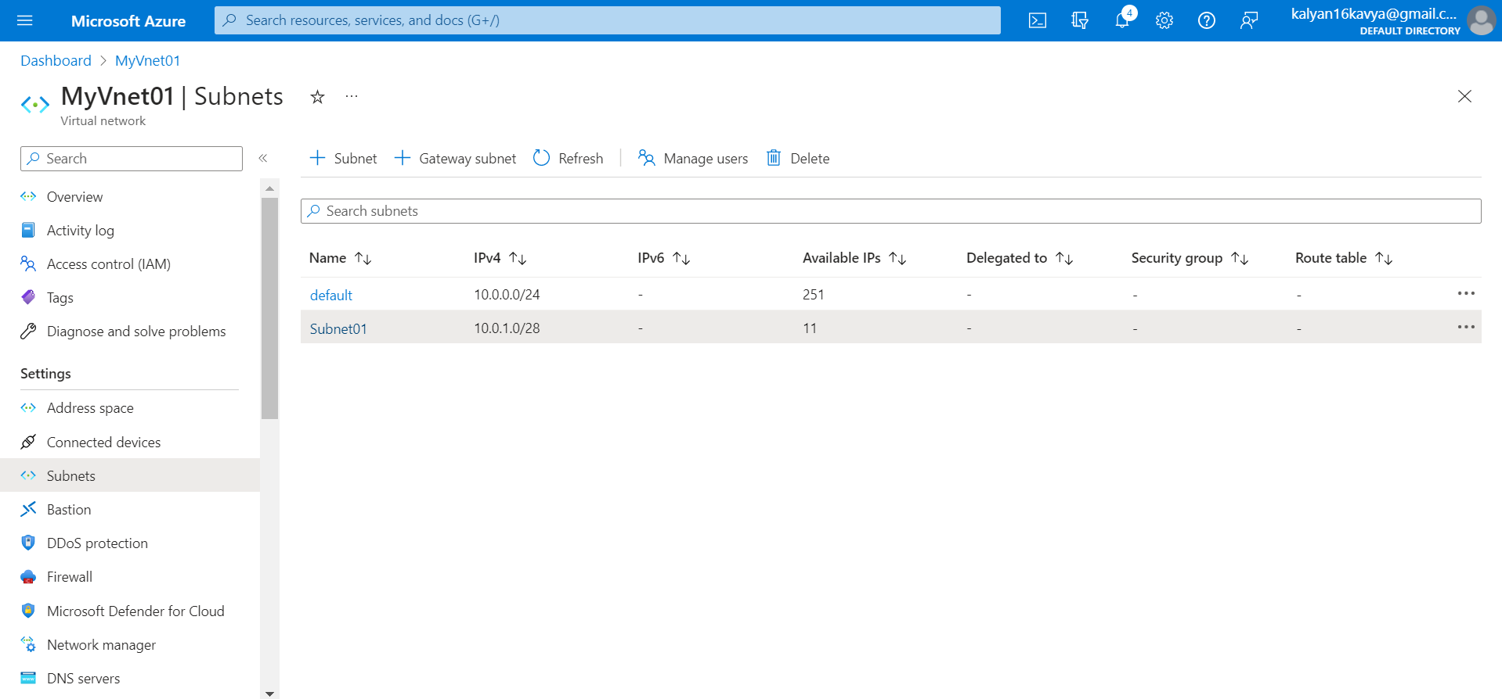

Create another subnet in similar way.

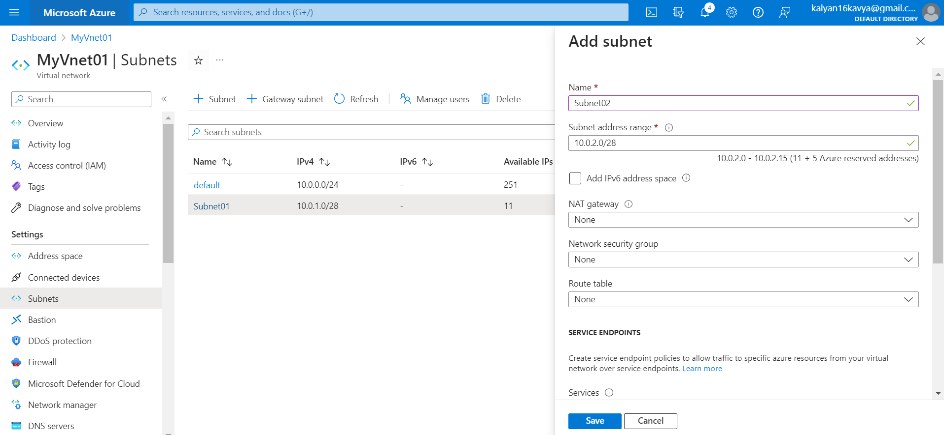

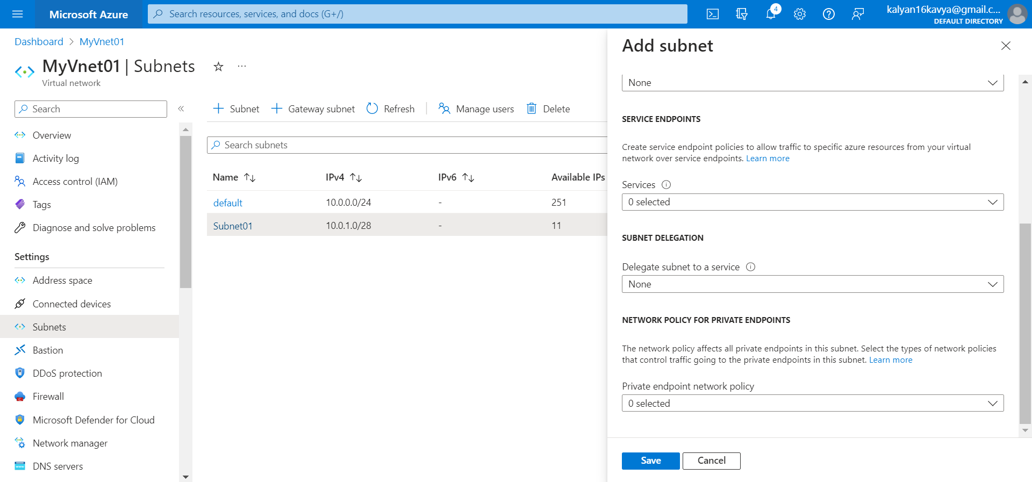

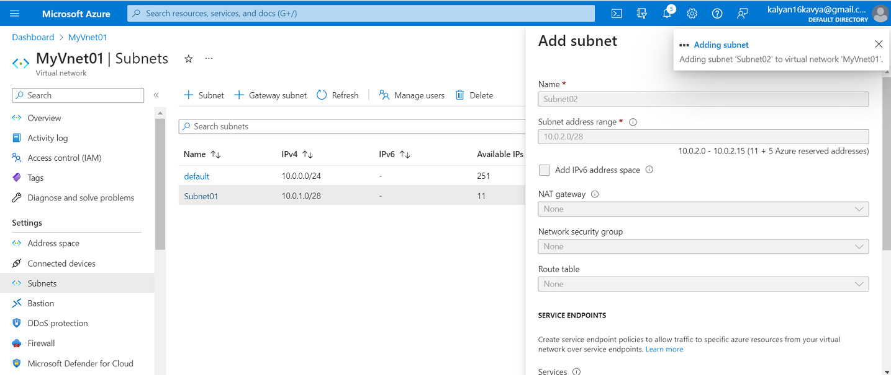

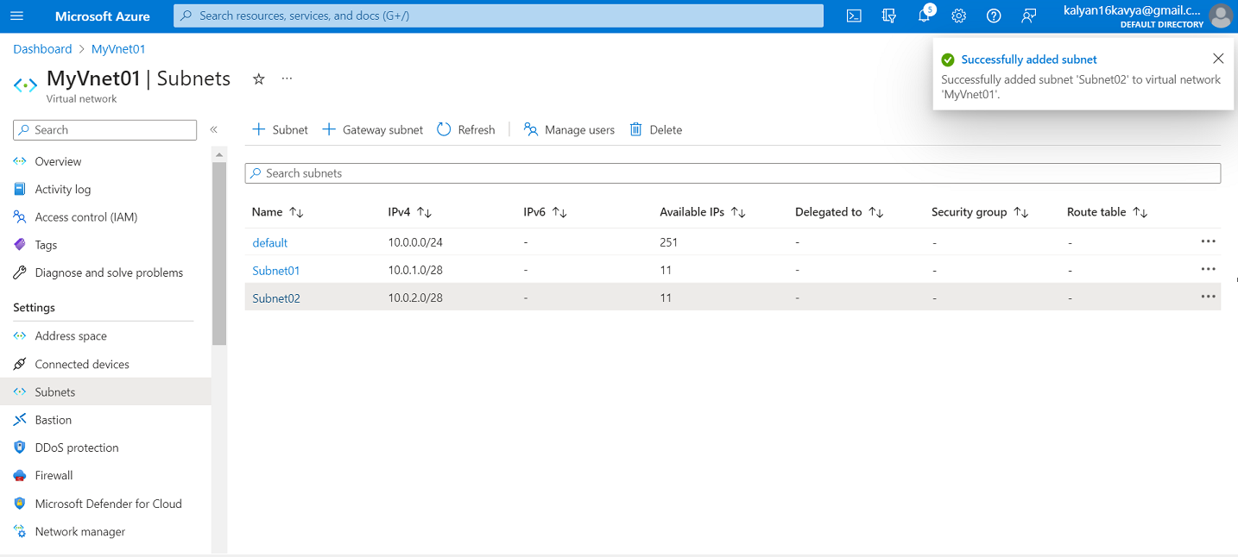

Delete the default subnet.

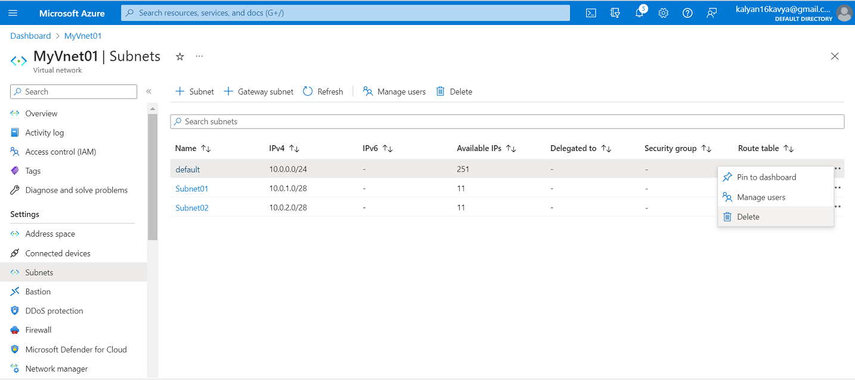

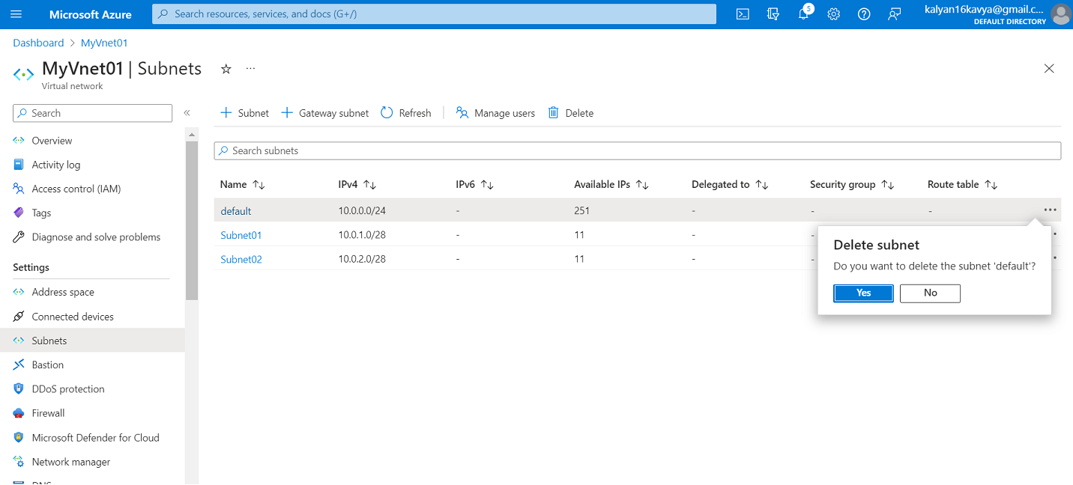

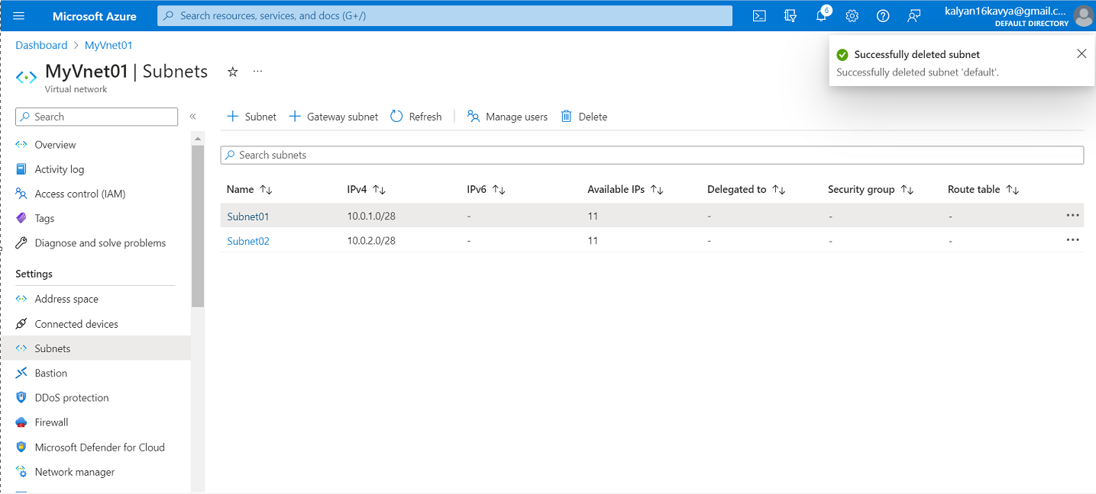

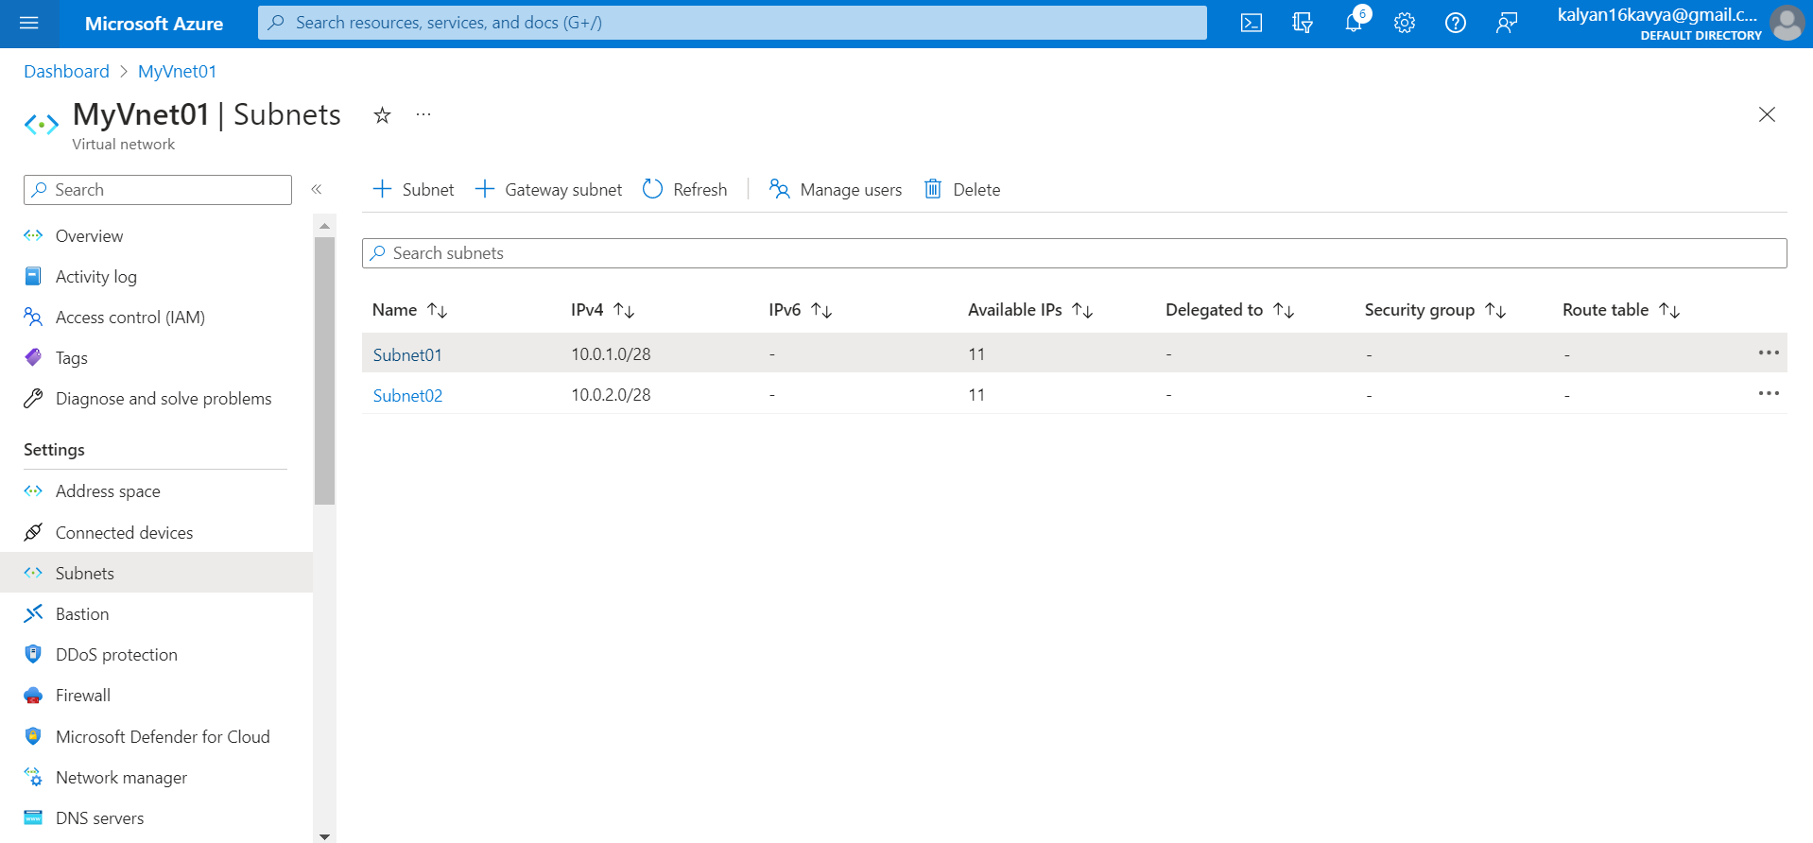

Q2. Inside one of the subnets, create a VM and deploy an application code inside it and it should leverage the database on the cloud (any existing application created by you before)

To create a Virtual machine inside a subnet, click on the virtual machine icon or search for virtual machine in the search bar.

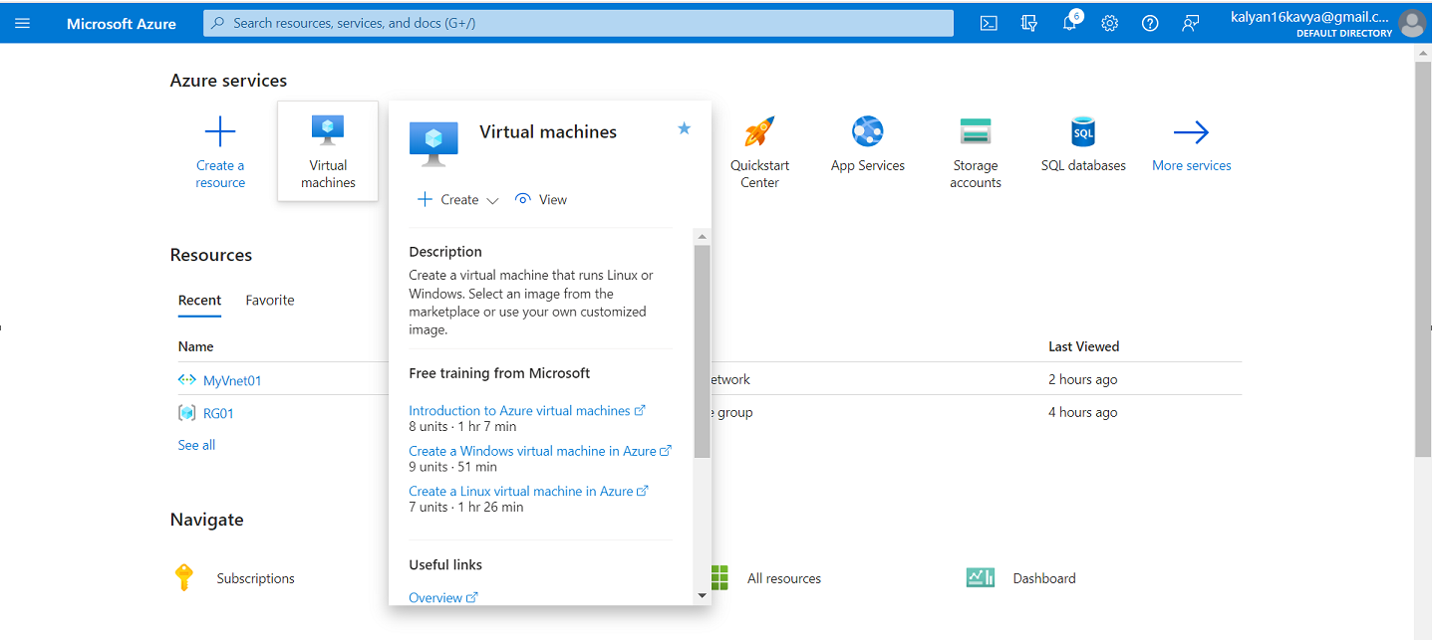

Click on + Create and Azure Virtual Machine.

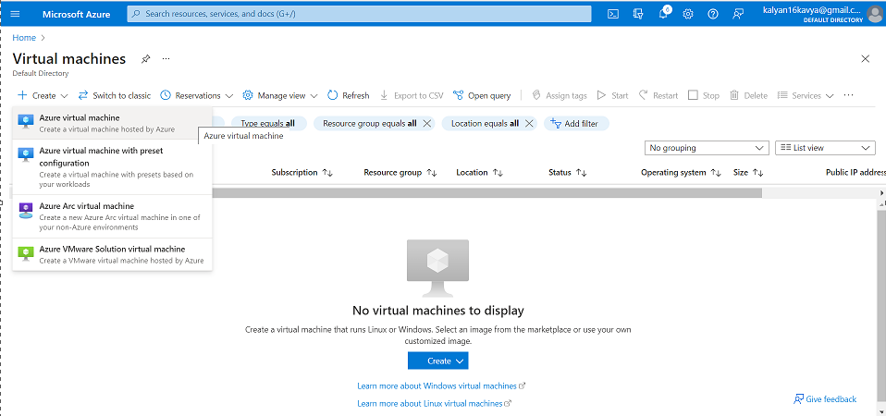

Add the Resource Group and a unique Virtual Machine name.

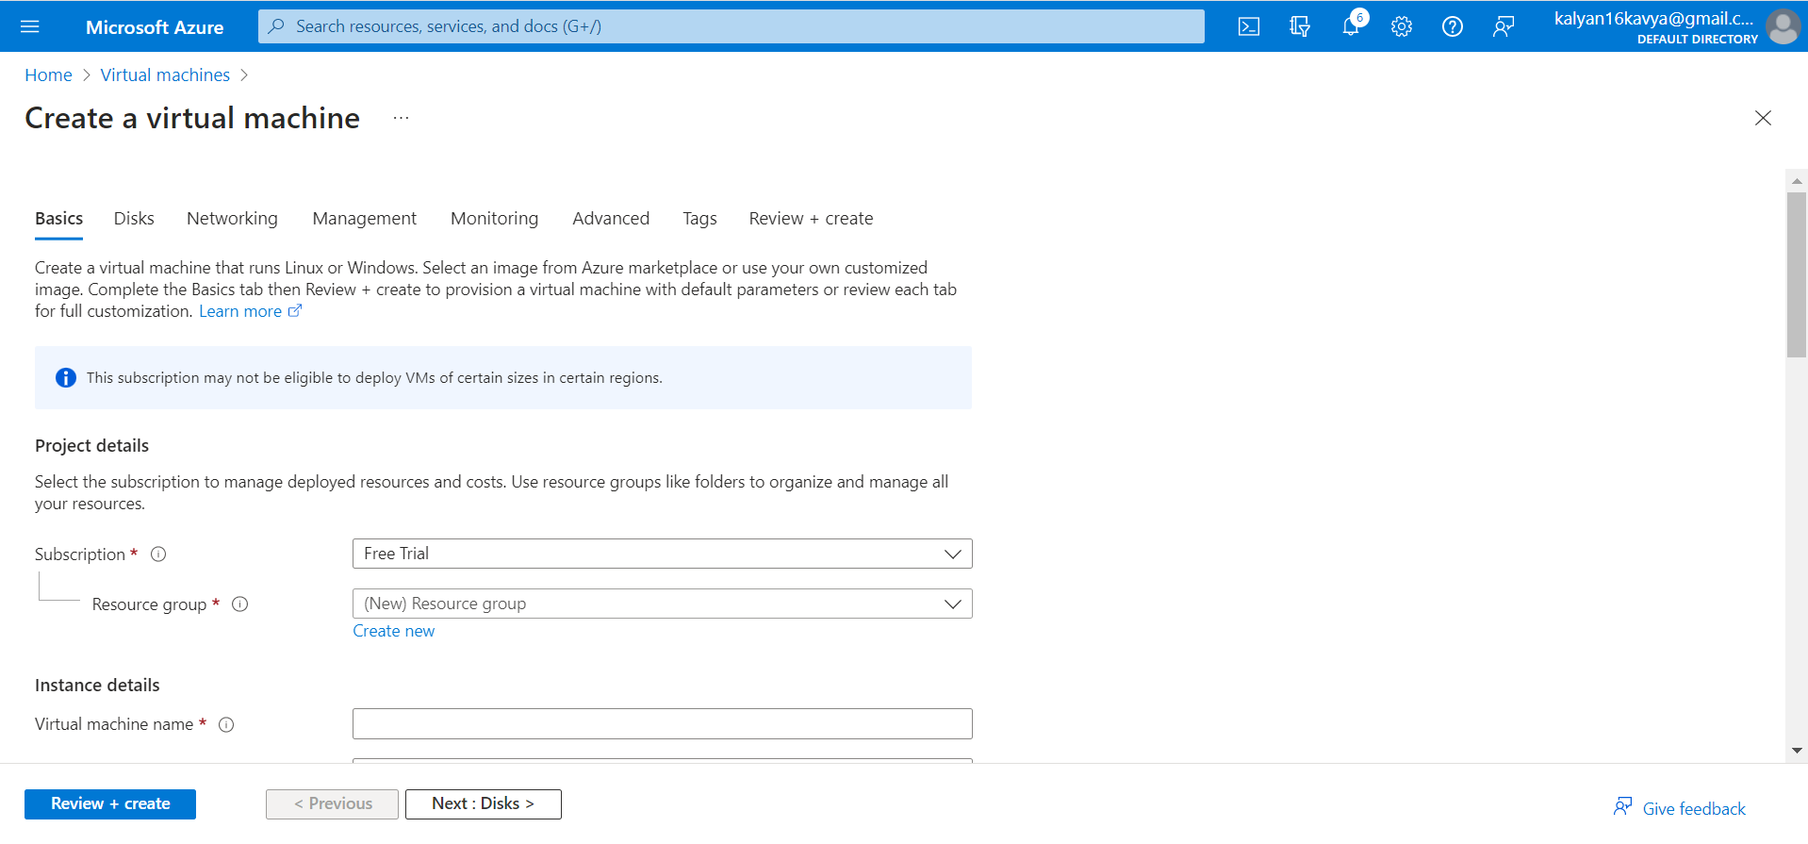

Select the Resource Group from the existing or create a new Resource Group.

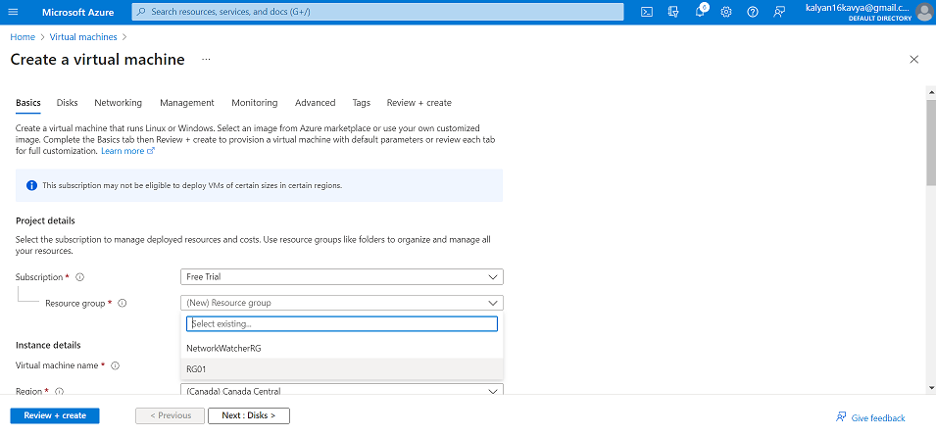

Add a unique name to the Virtual Machine “vm1”.

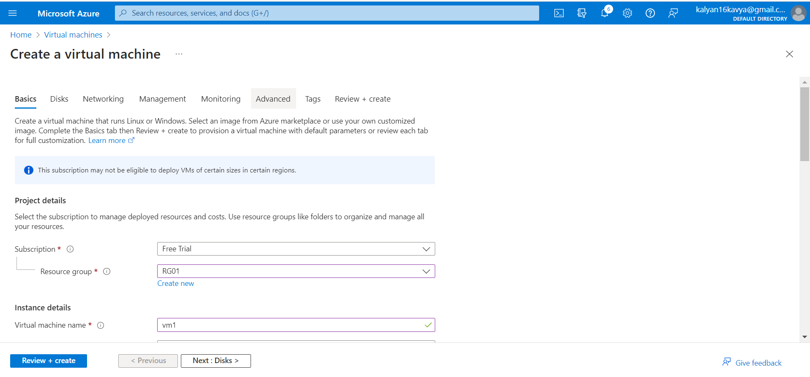

Select the Image as Windows Server 2022

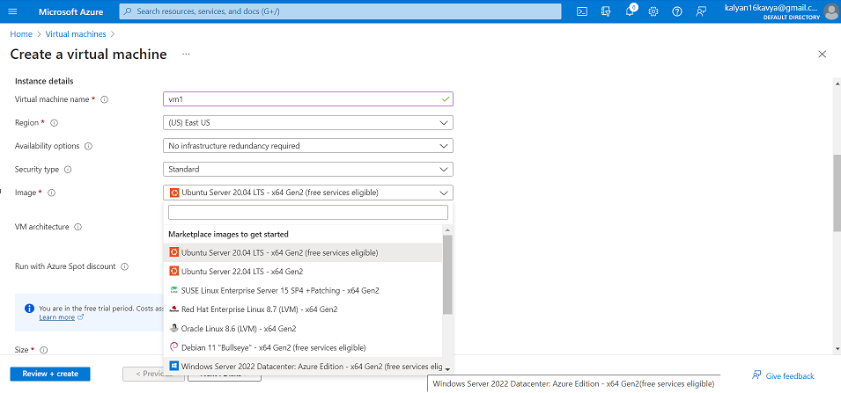

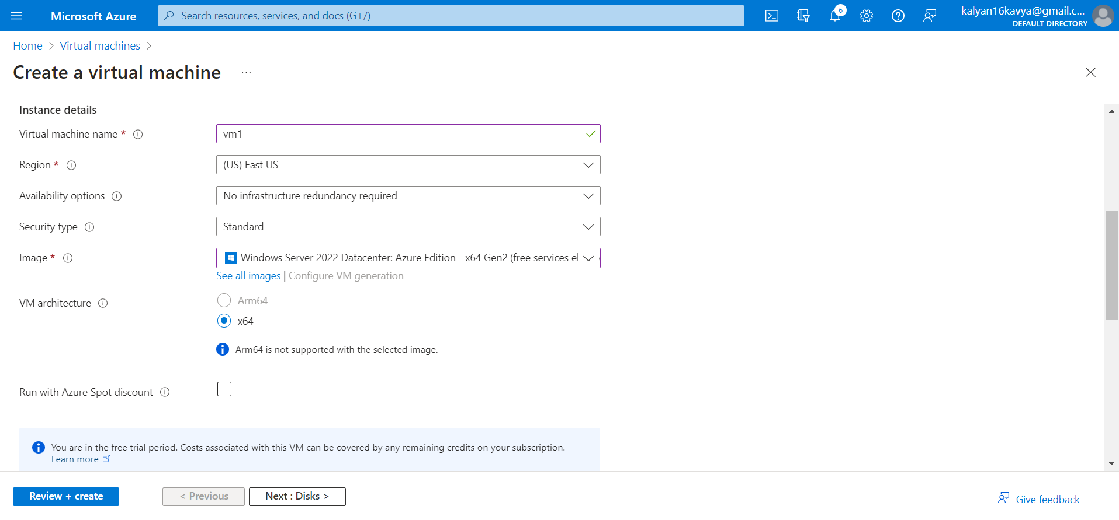

We need to create an administrator account. Add a unique username and password to create the account.

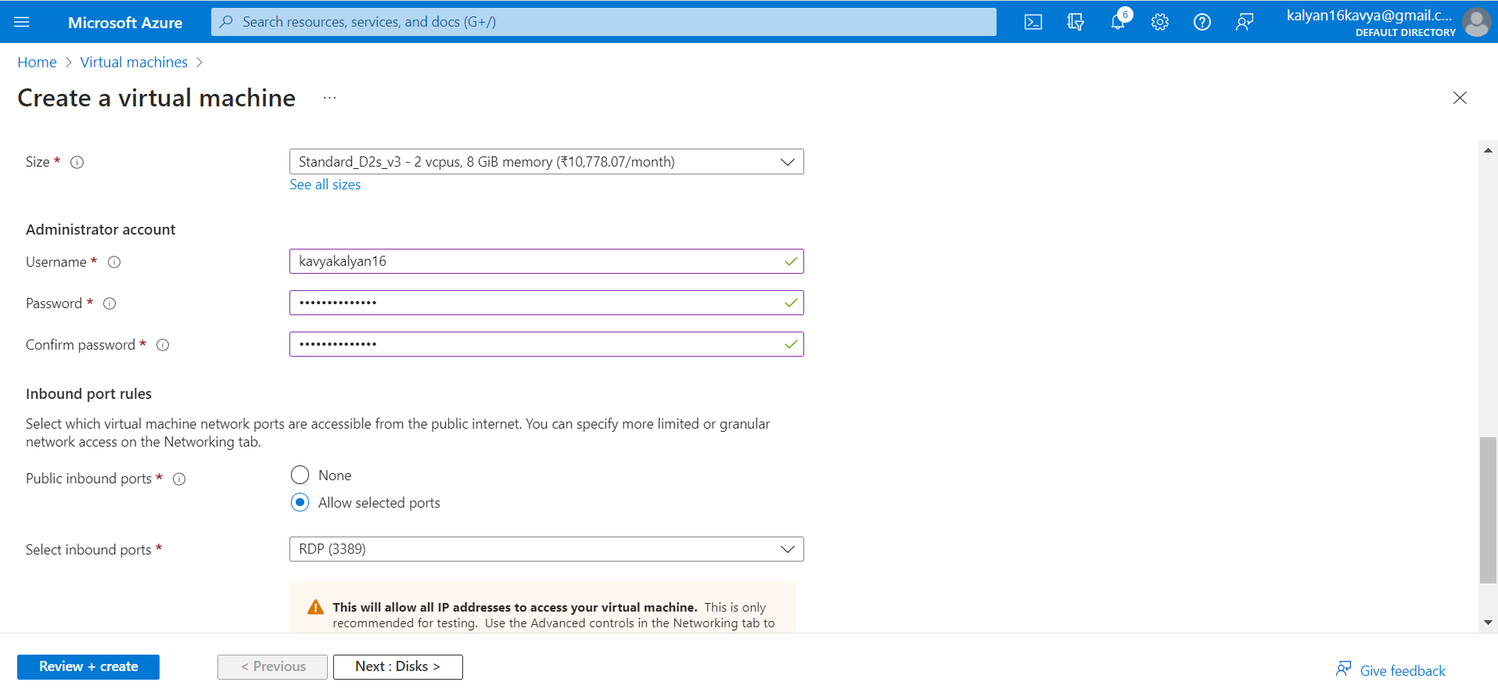

Let the remaining fields have default value.

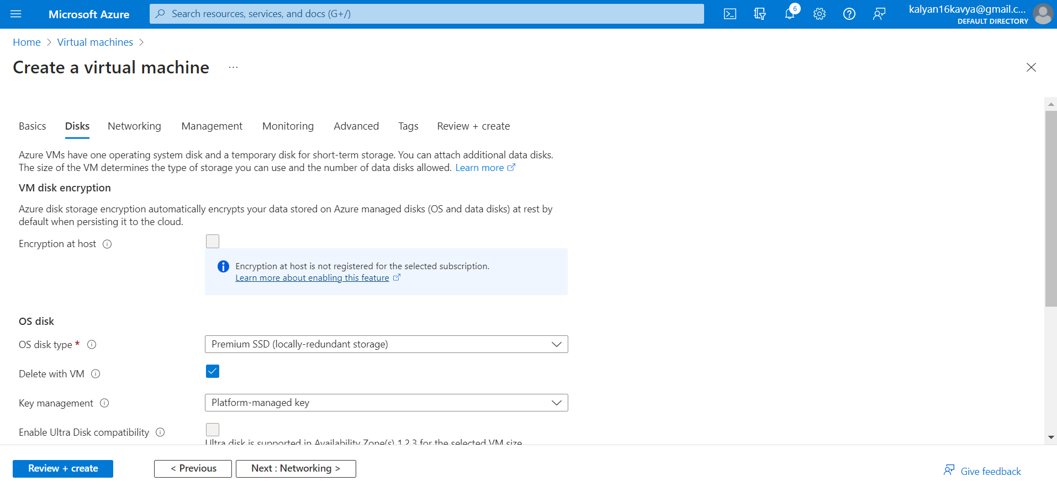

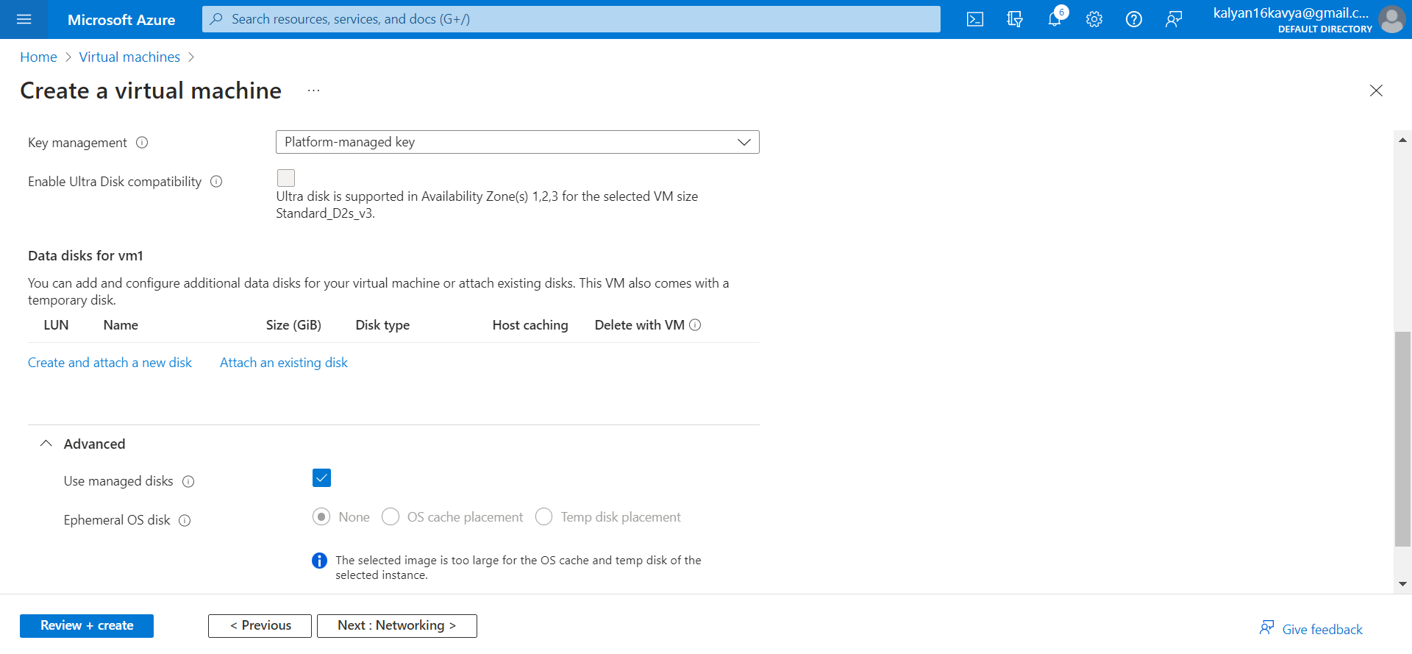

Under the Networking tab, Select the virtual network and the subnet we created.

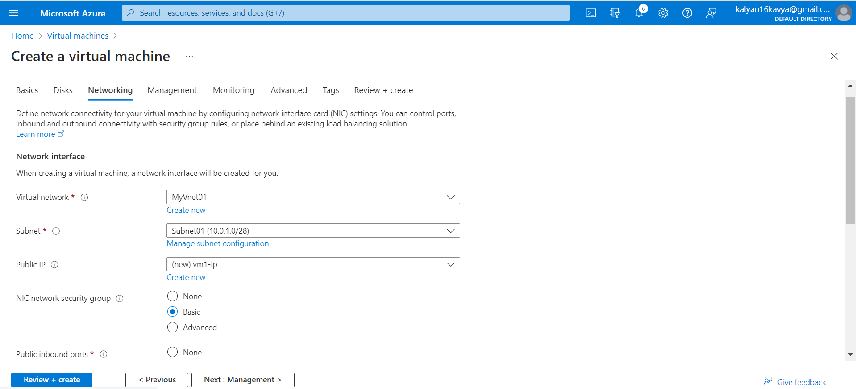

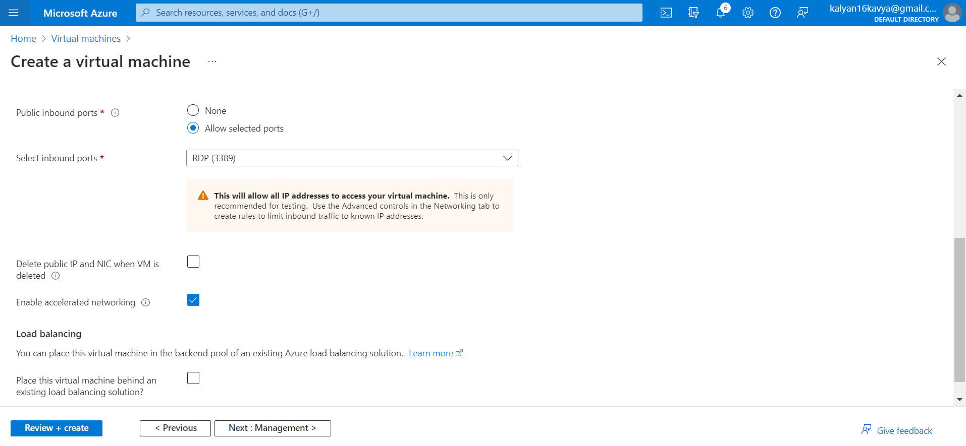

Let the remining tabs have default values. Click on Review + Create and review the details of the virtual machine.

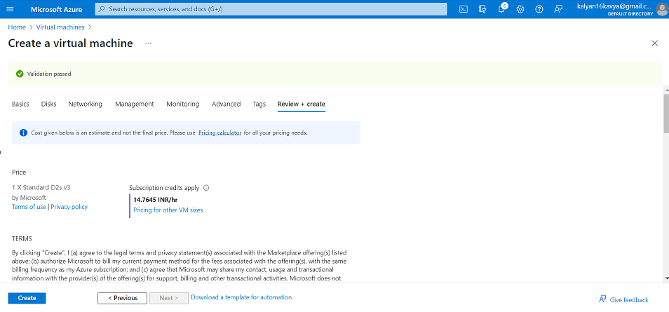

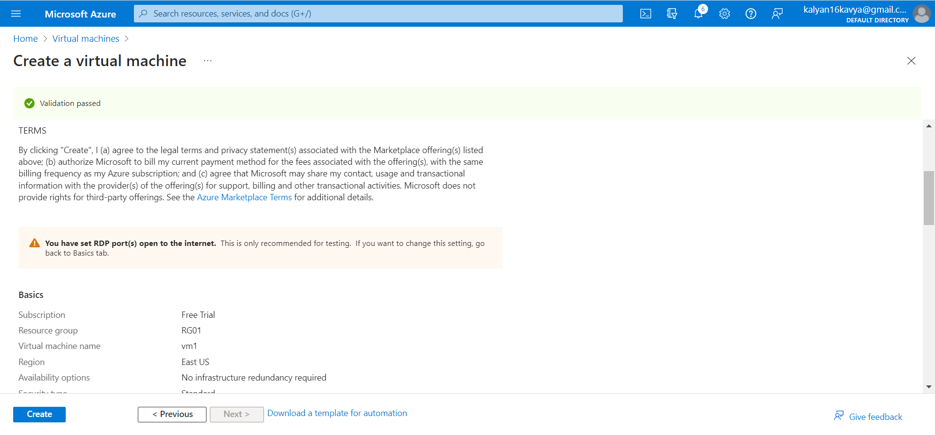

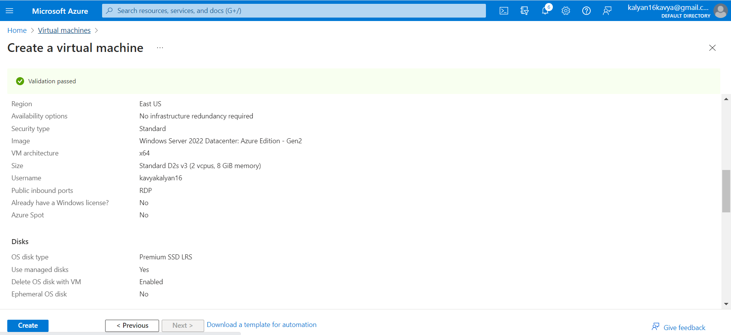

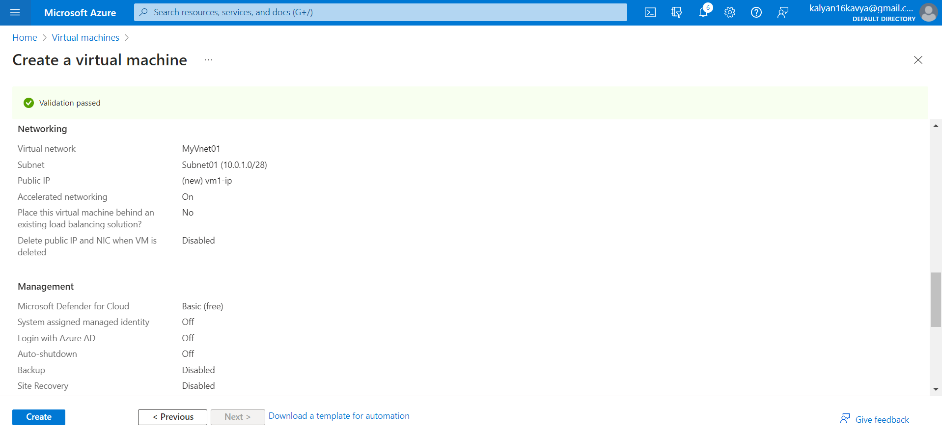

Click on create.

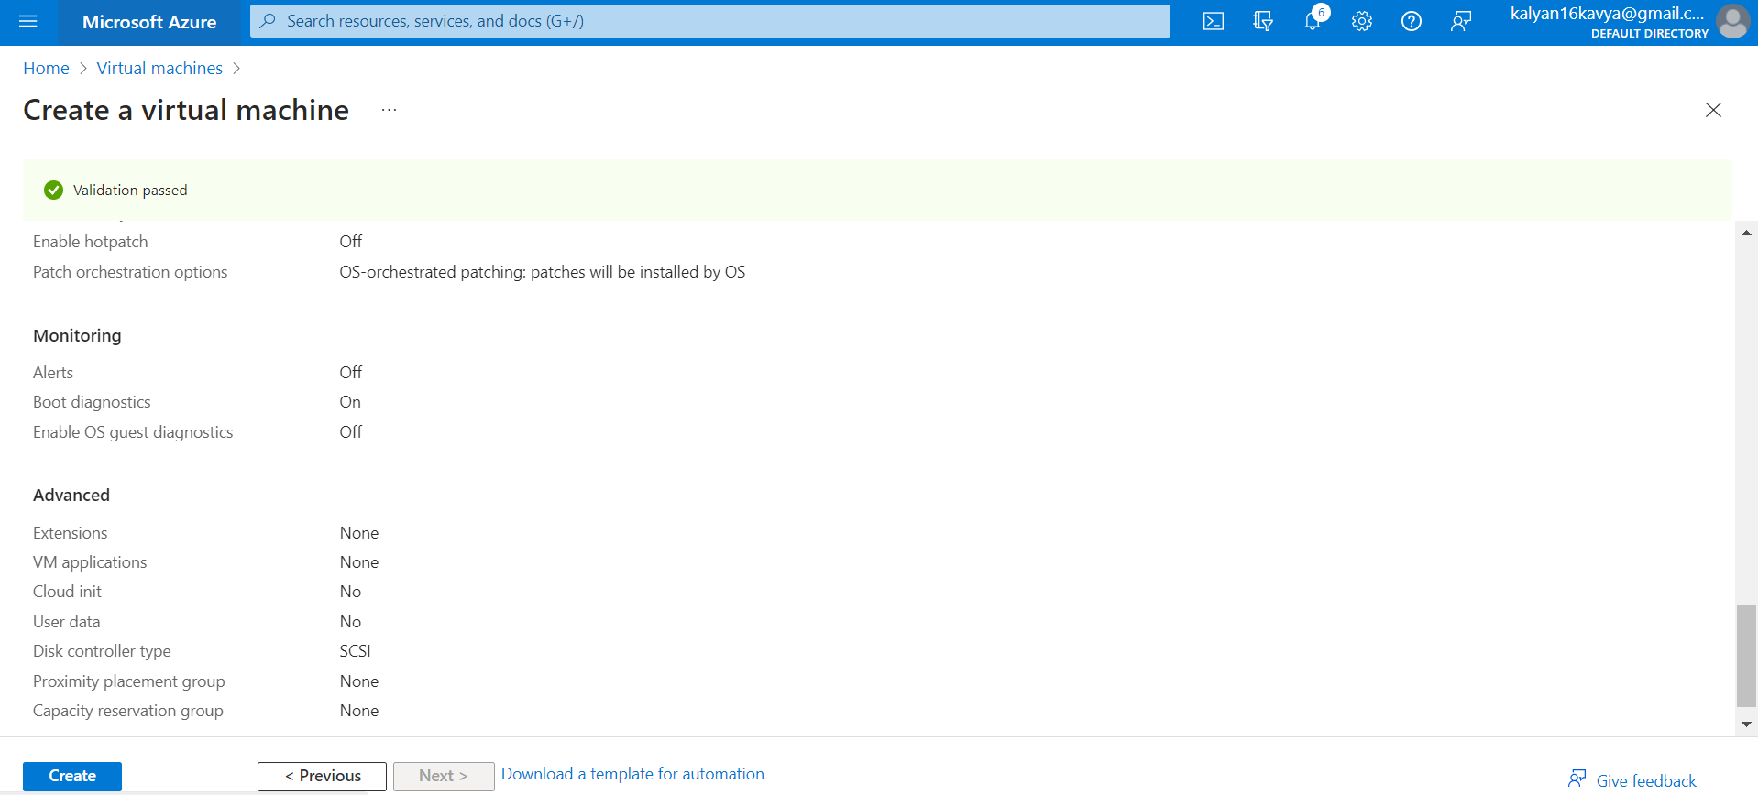

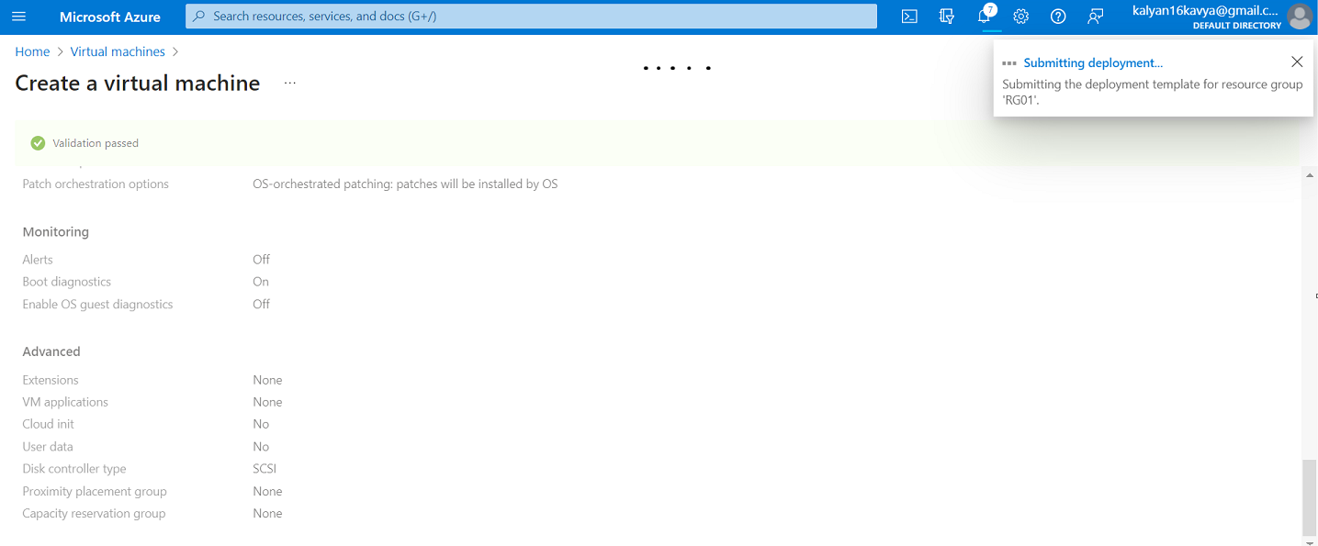

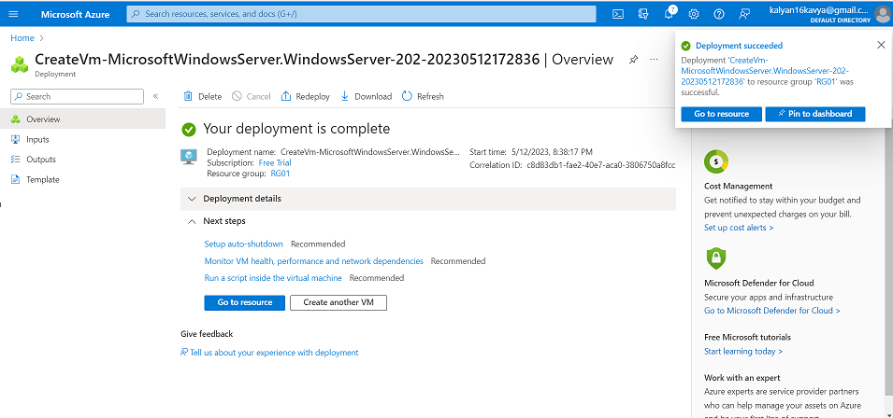

Click on Go to resource and view the details of the virtual machine.

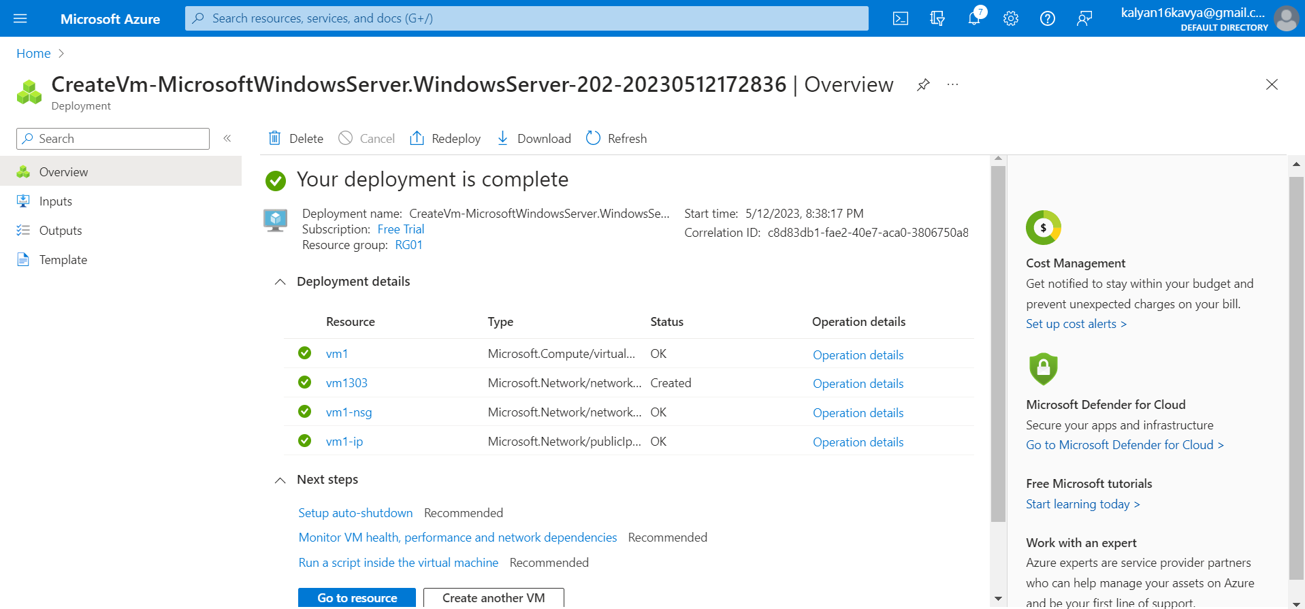

For running the virtual machine on the local computer click on the connect button and then click on Download the RDP file.

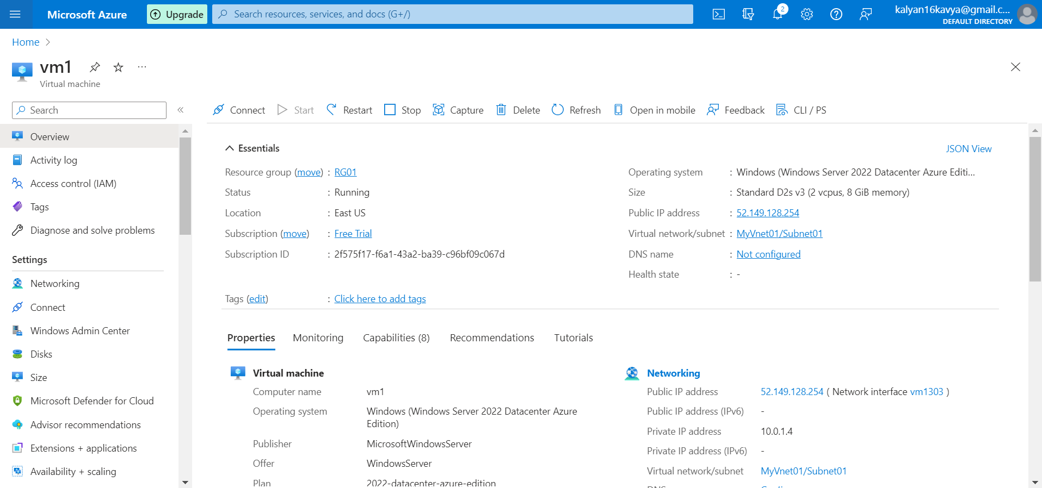

Download the RDP File.

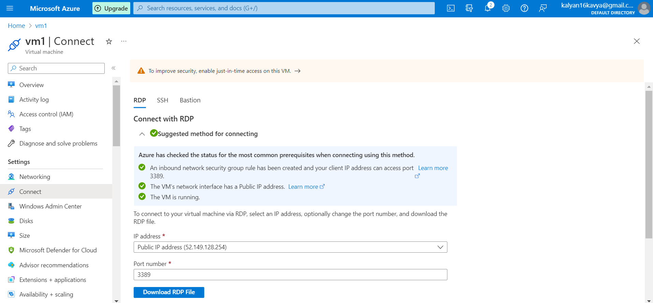

After Downloading the RDP file, double click on the downloaded file, the below pop-up will appear. Click on connect.

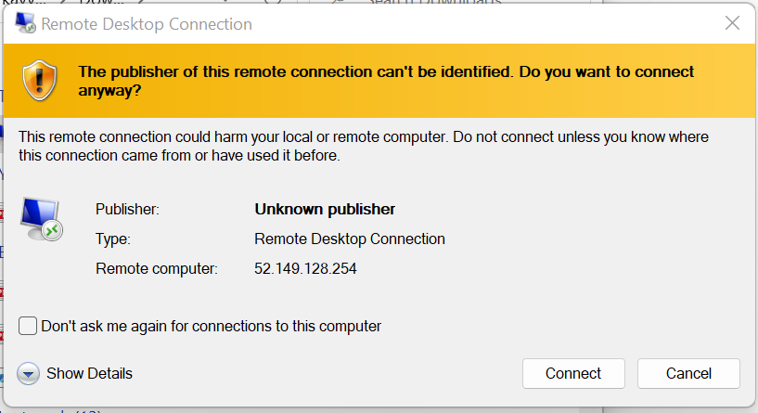

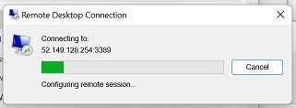

After downloading it run the RDP file and then enter the credentials to run the virtual machine. Enter your credentials.

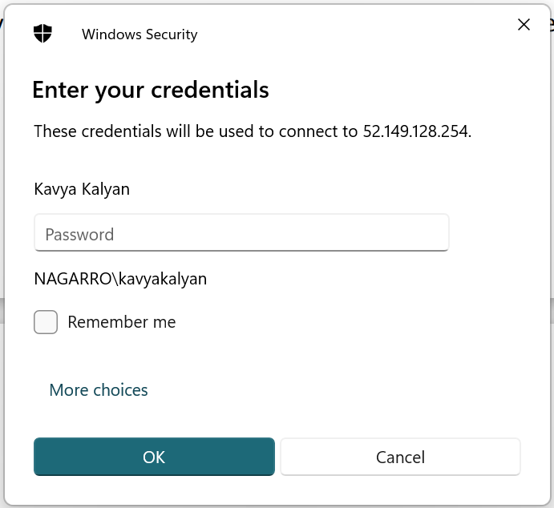

Virtual Machine is now running on your local.

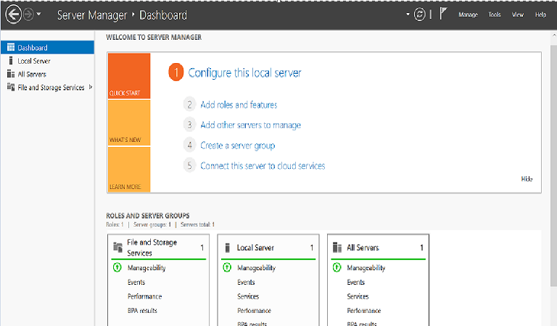

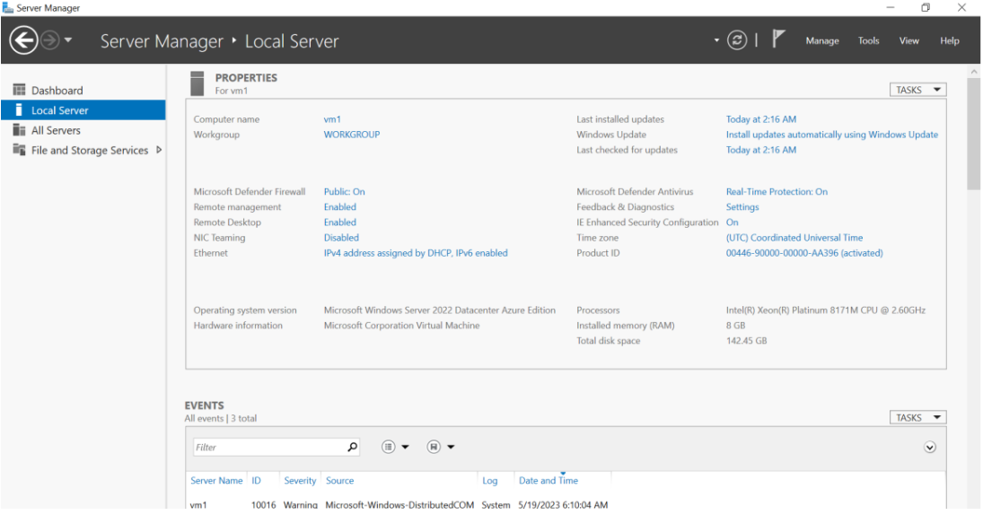



For publishing the database on Azure first create the webserver on the Azure portal.

Search for SQL server and click on Create.

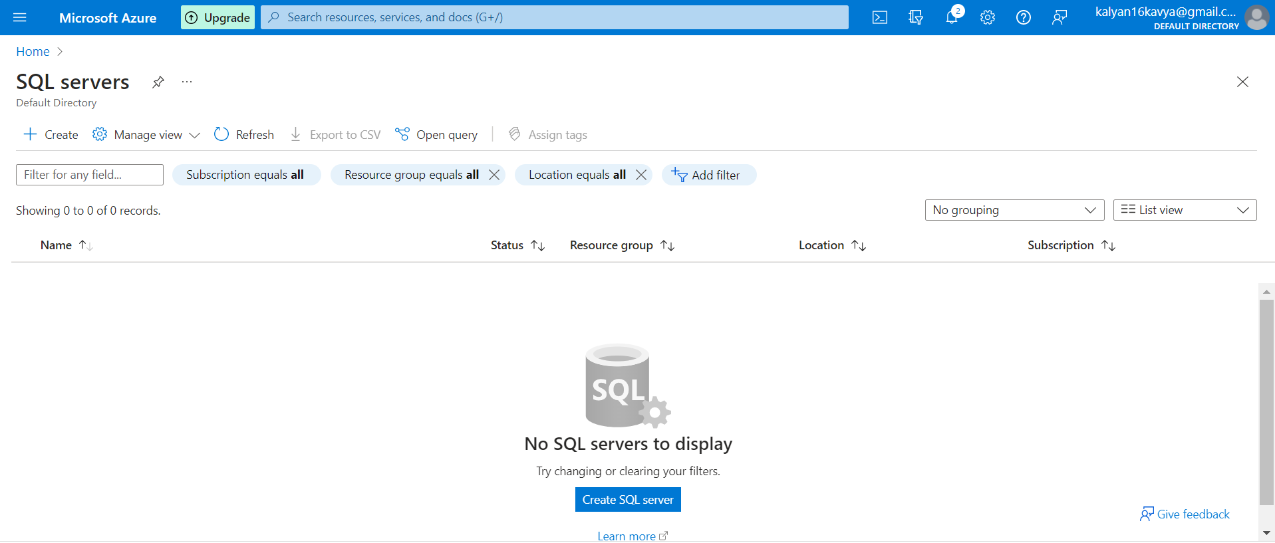

Add the Resource group and a unique server name.

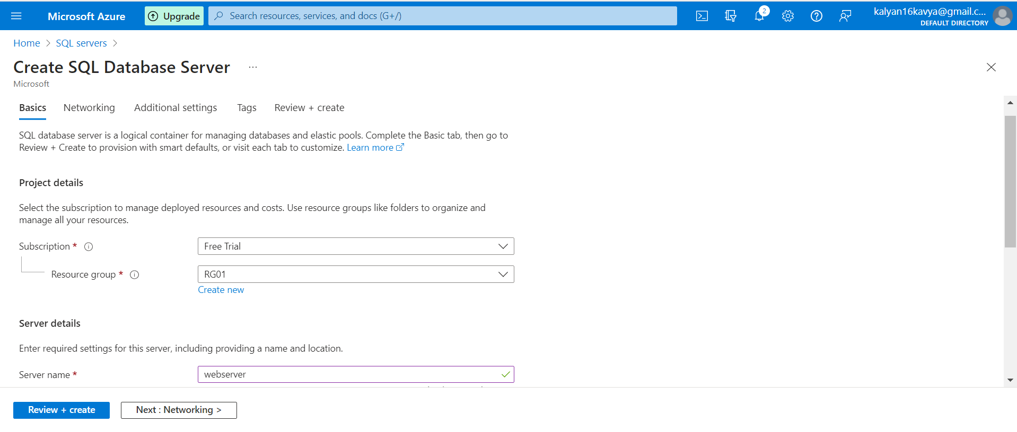

Select Authentication method as Use SQL authentication.

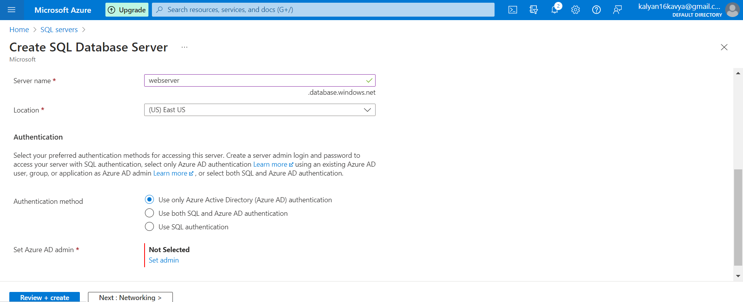

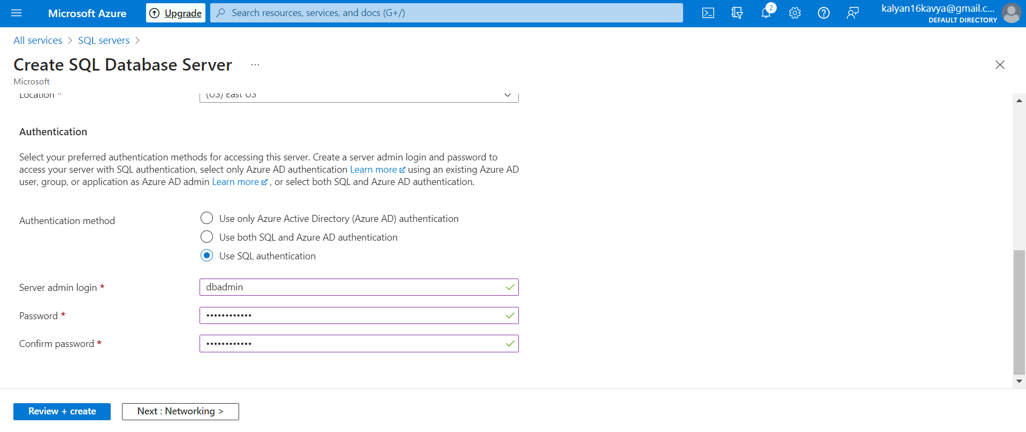

Select “Yes” for Firewall Rules.

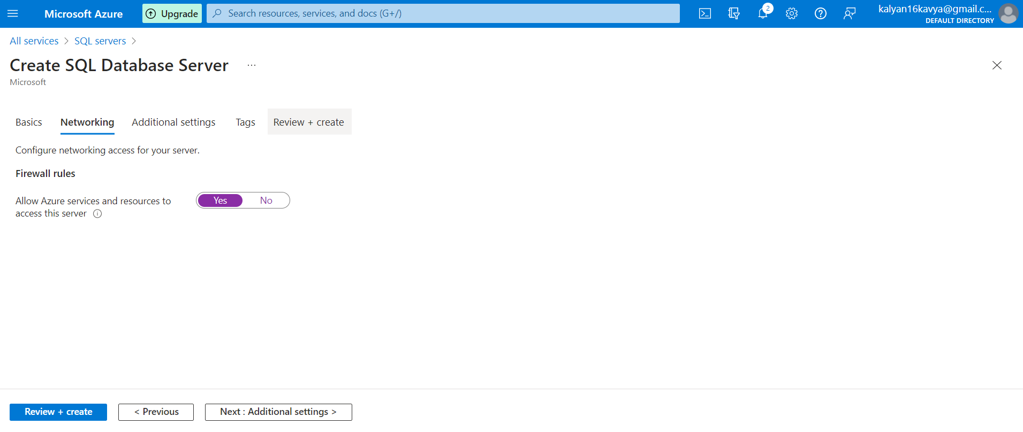

Let the other tabs have default values. Click on Review + Create and review the SQL Server details. And Click on Create.

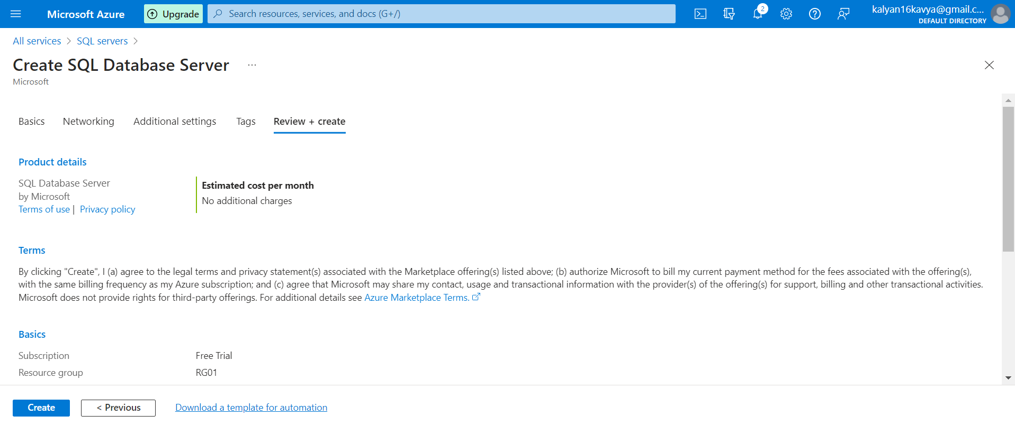

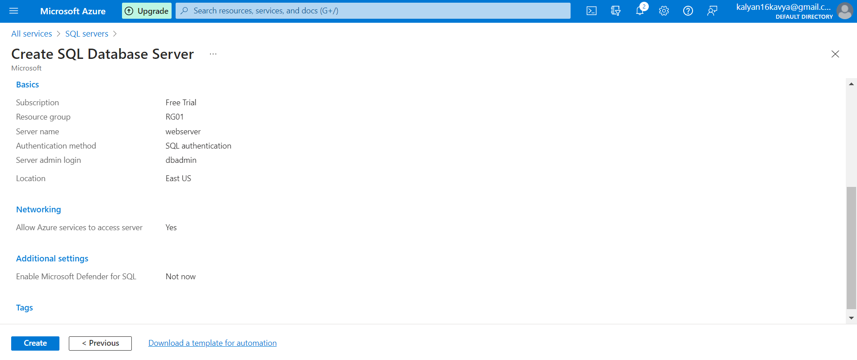

Click on Create.

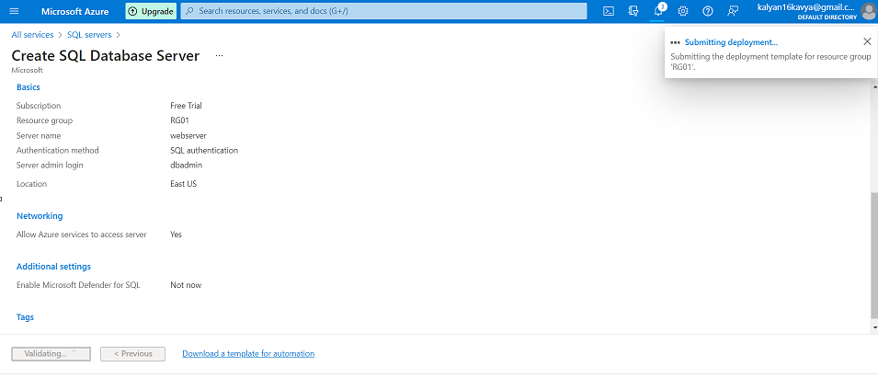

After the deployment is completed click on Go to Resource to view the SQL server details.

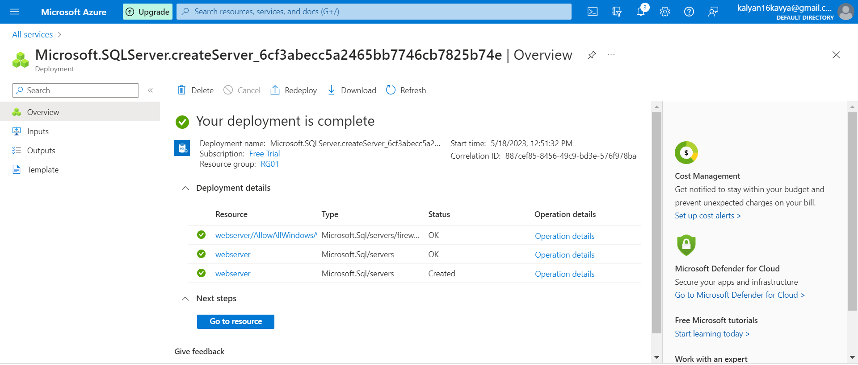

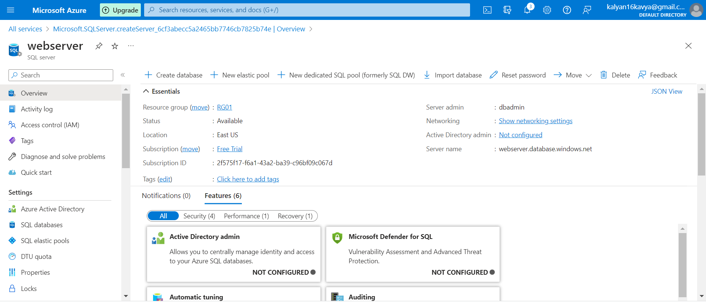

Next, we need to create SQL Database. Search for SQL Database in the search bar and click on create.

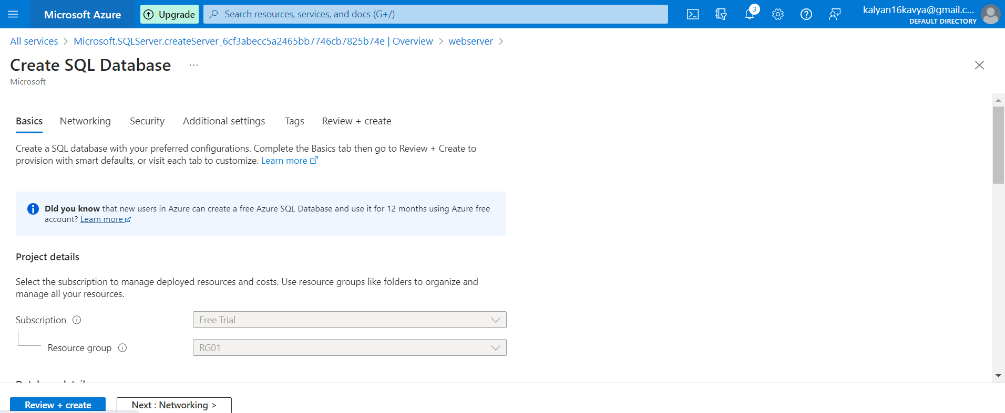

Add the Resource group and a unique Database name and click on Configure database.

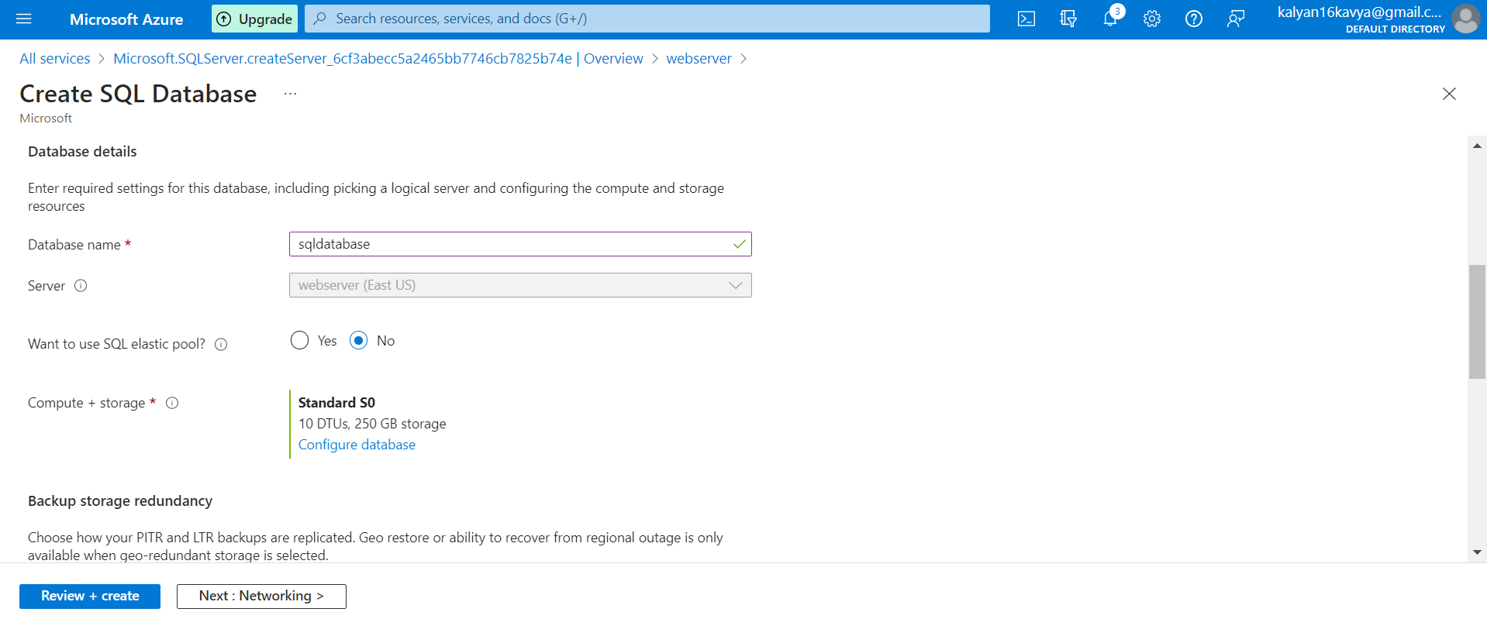

To configure the database, select the Provisioned Compute tier.

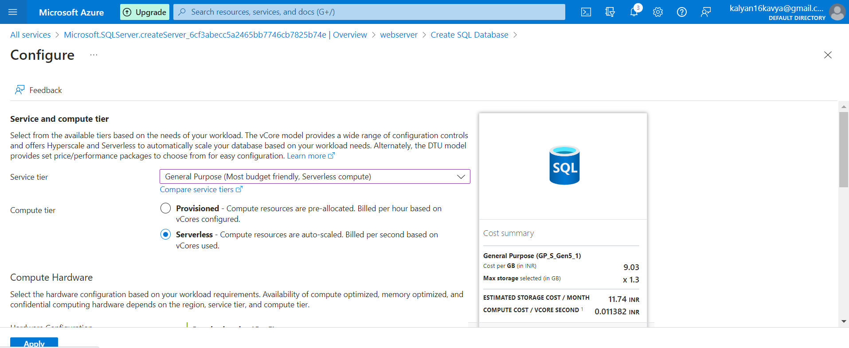

Max vCores should be 1 and Min vCores should be 0.5vCores.

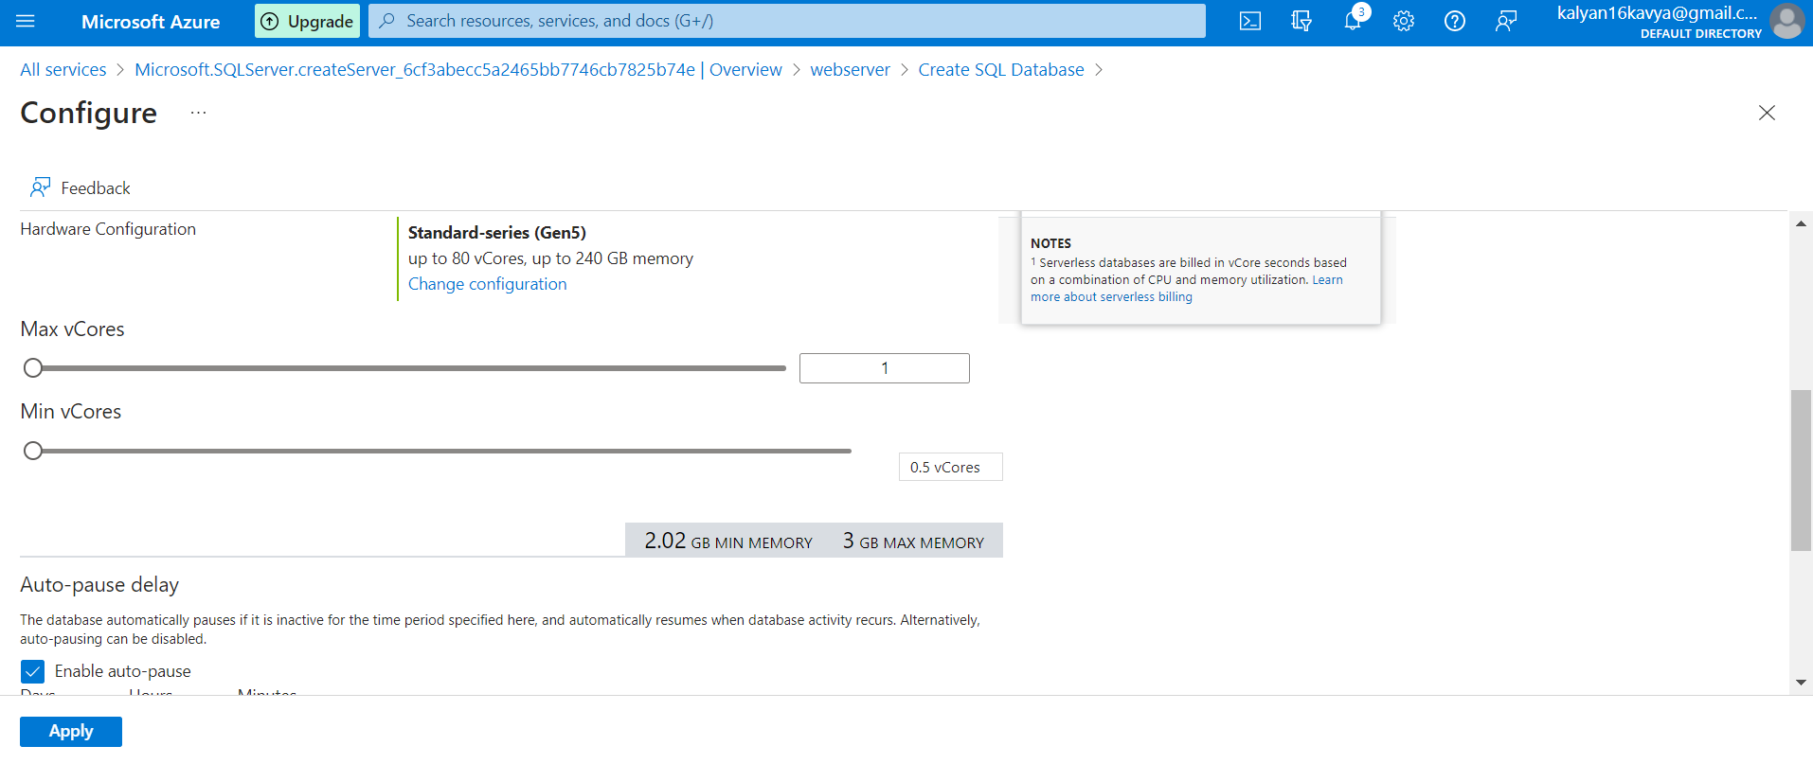

Data max size (GB) should be 1GB. And click on Apply.

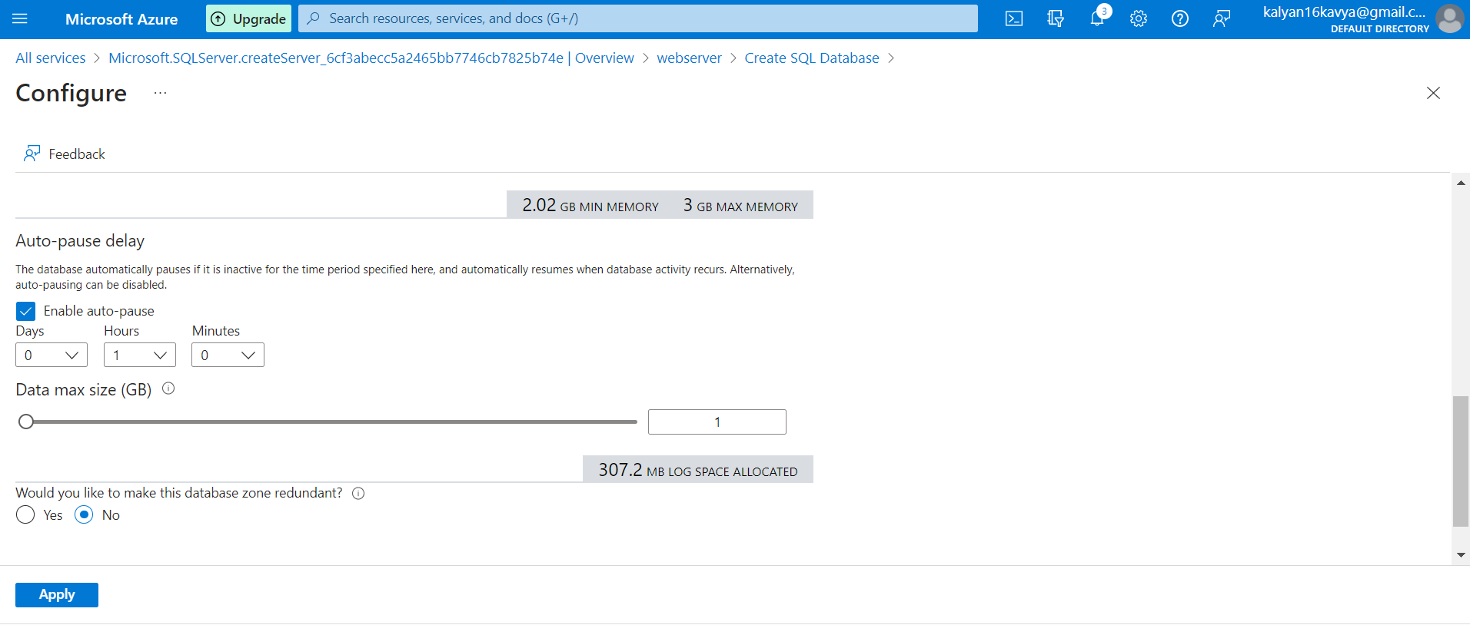

Let the remaining tabs have default values. Click on Review + Create.

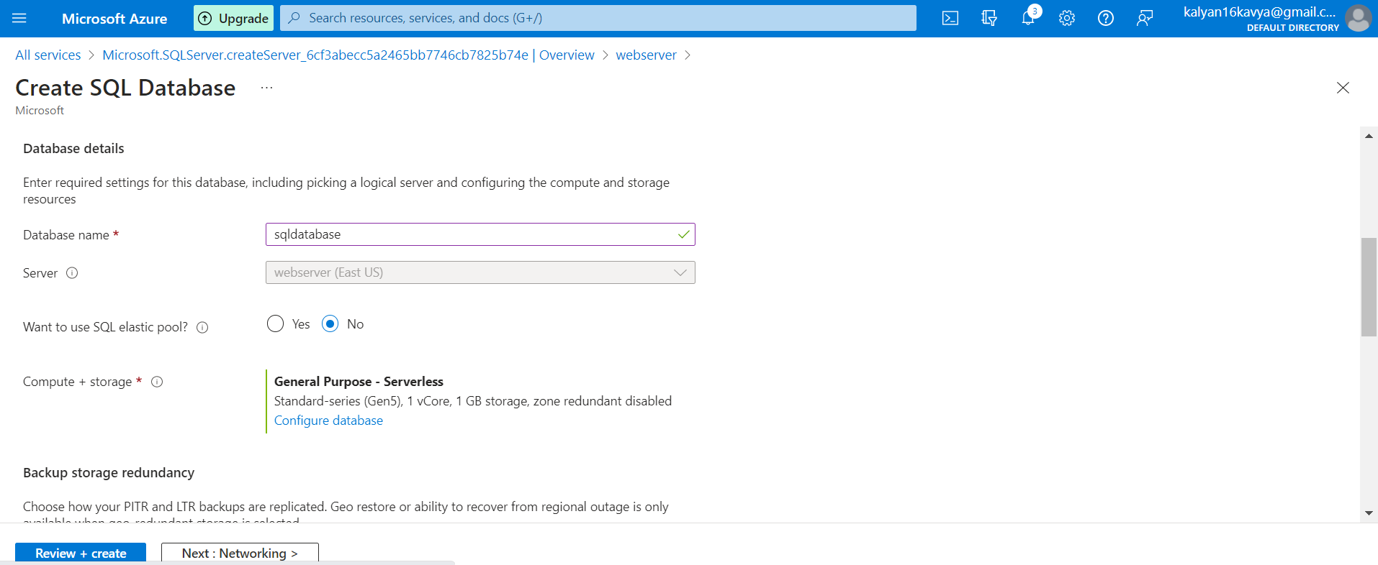

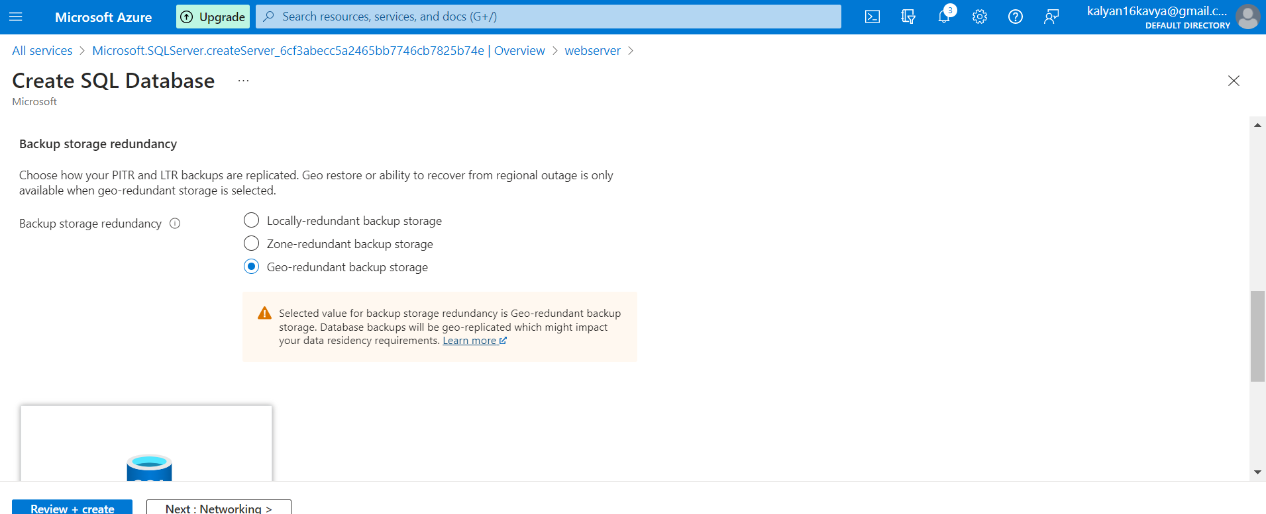

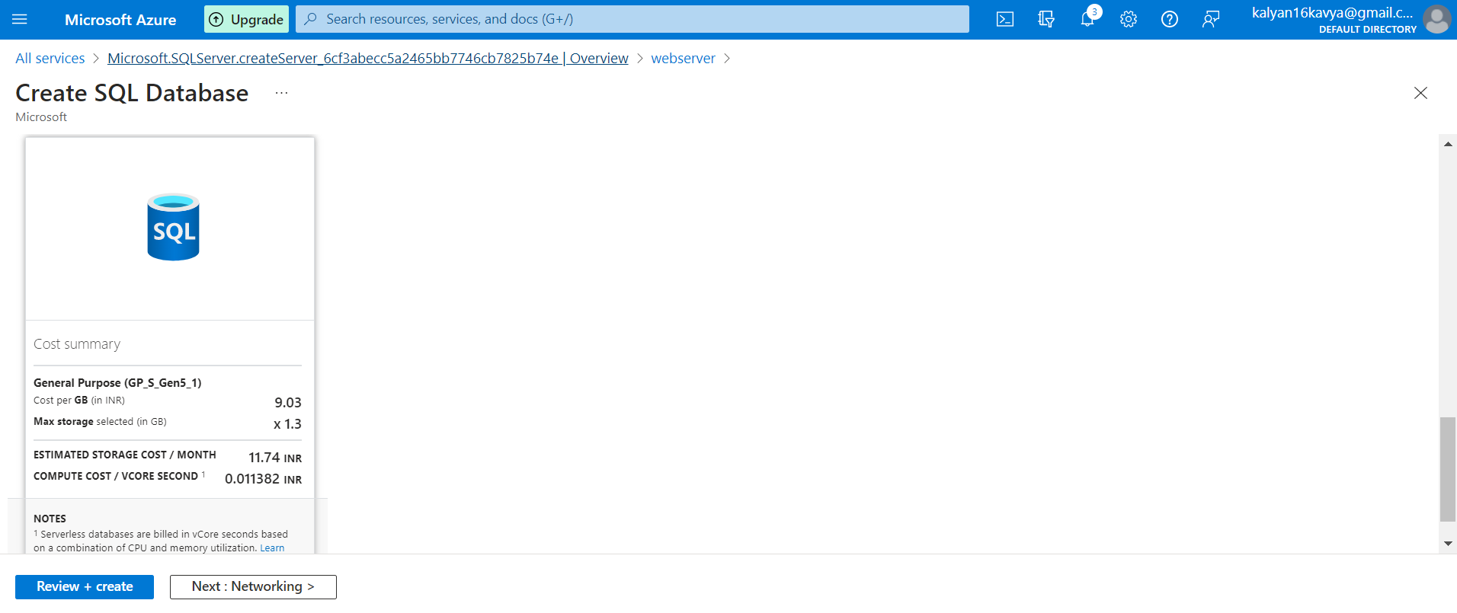

After reviewing the details click on Create.

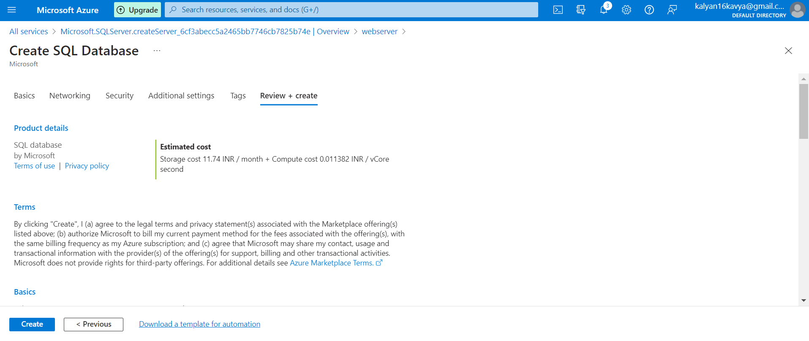

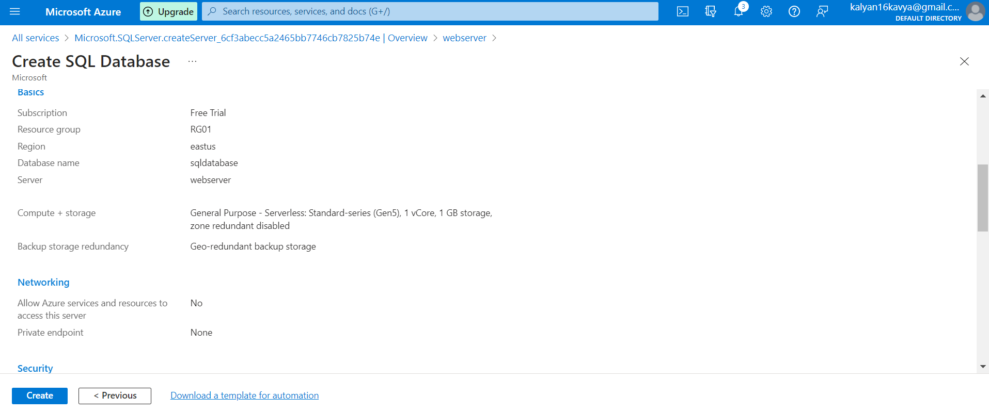

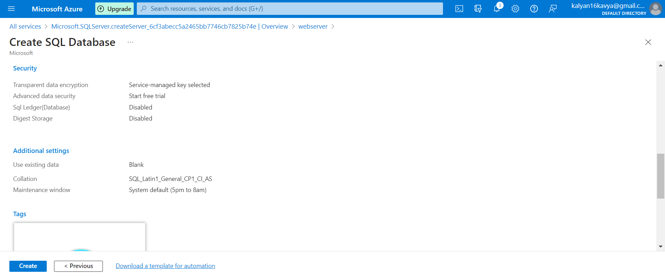

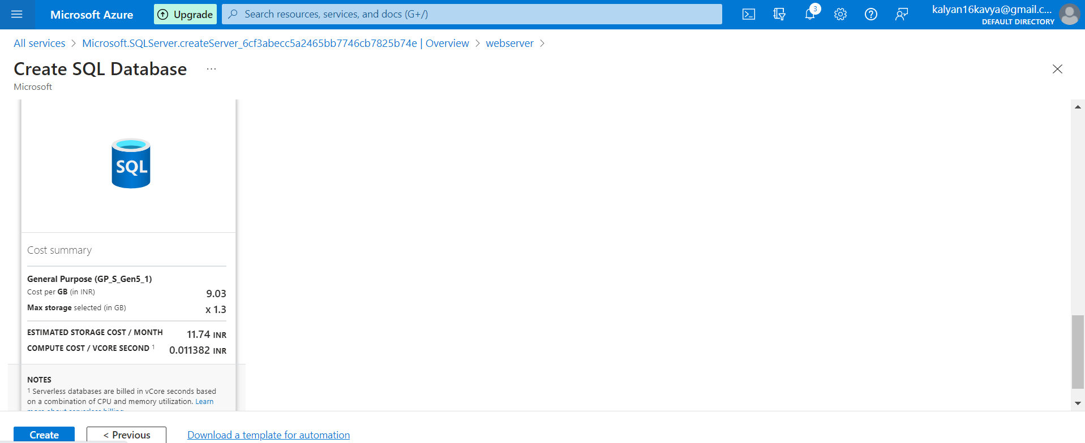

Once the Deployment is completed click on Go to Resource.

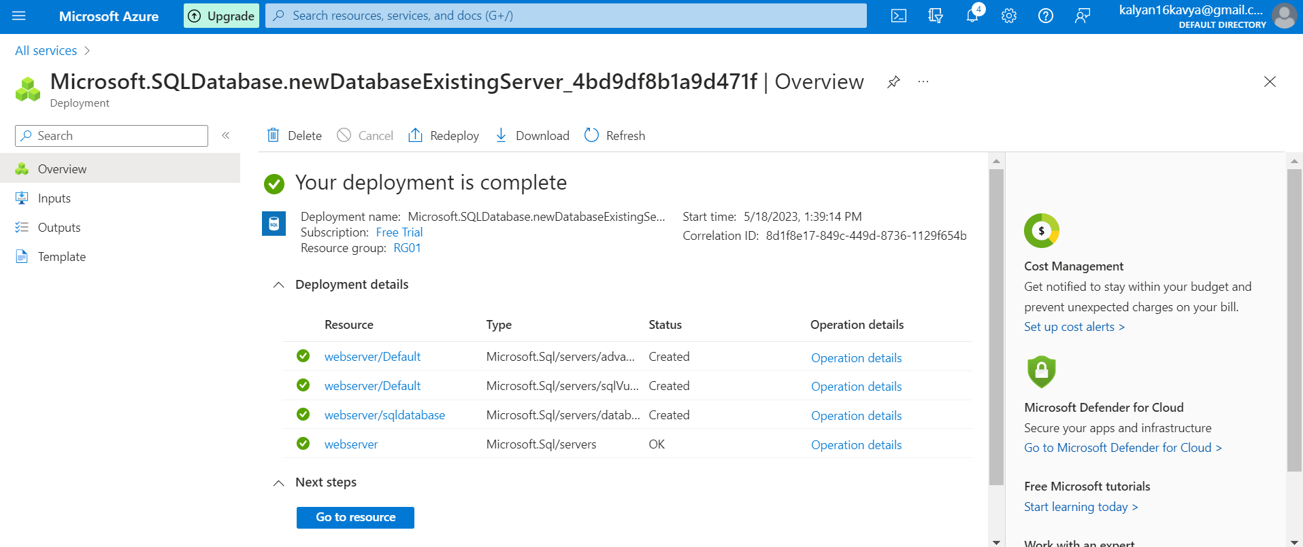

Below are the details of the SQL Database. Note down the Server name “webserver.database.windows.net”

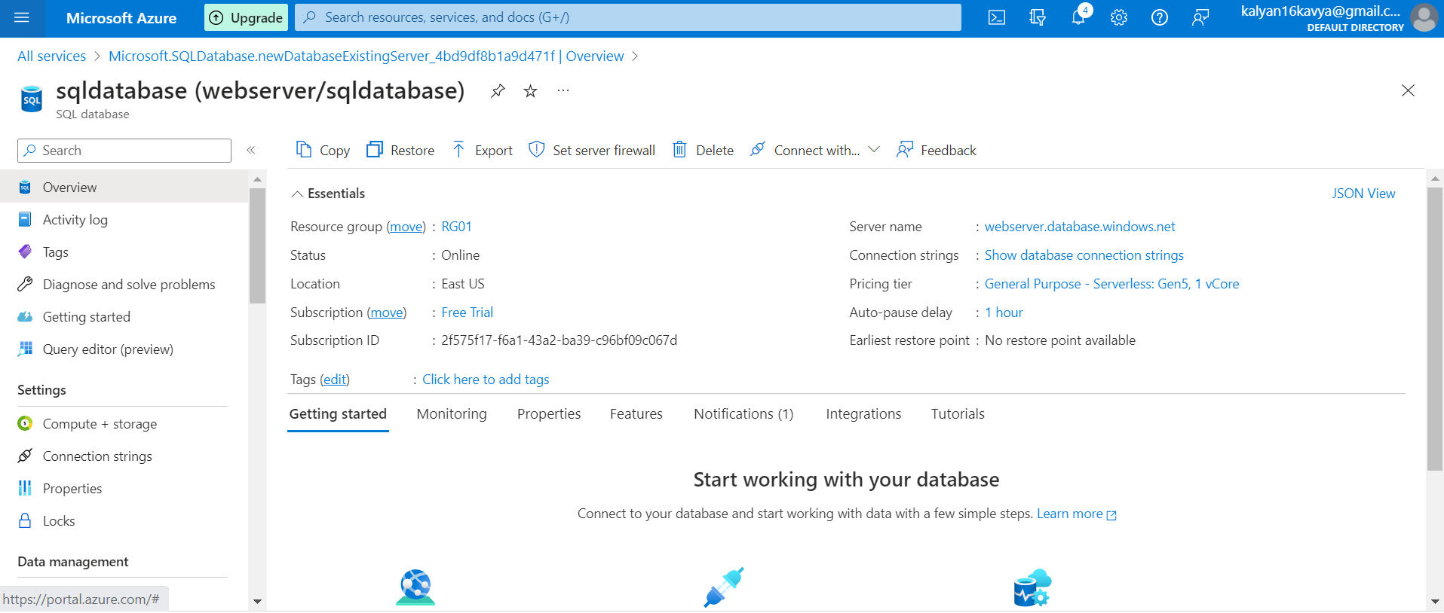

Then open the Microsoft SQL Server Management Studio for publishing the database.

Enter the Server Name. And choose the Authentication as SQL Server Authentication.

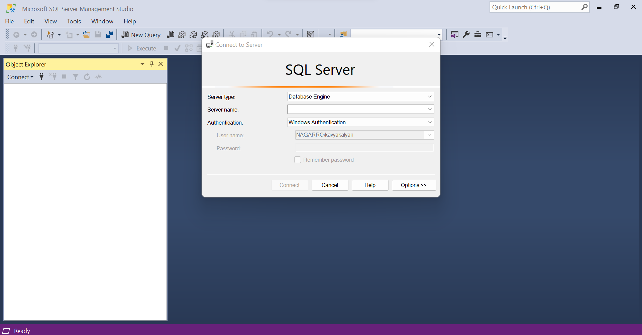

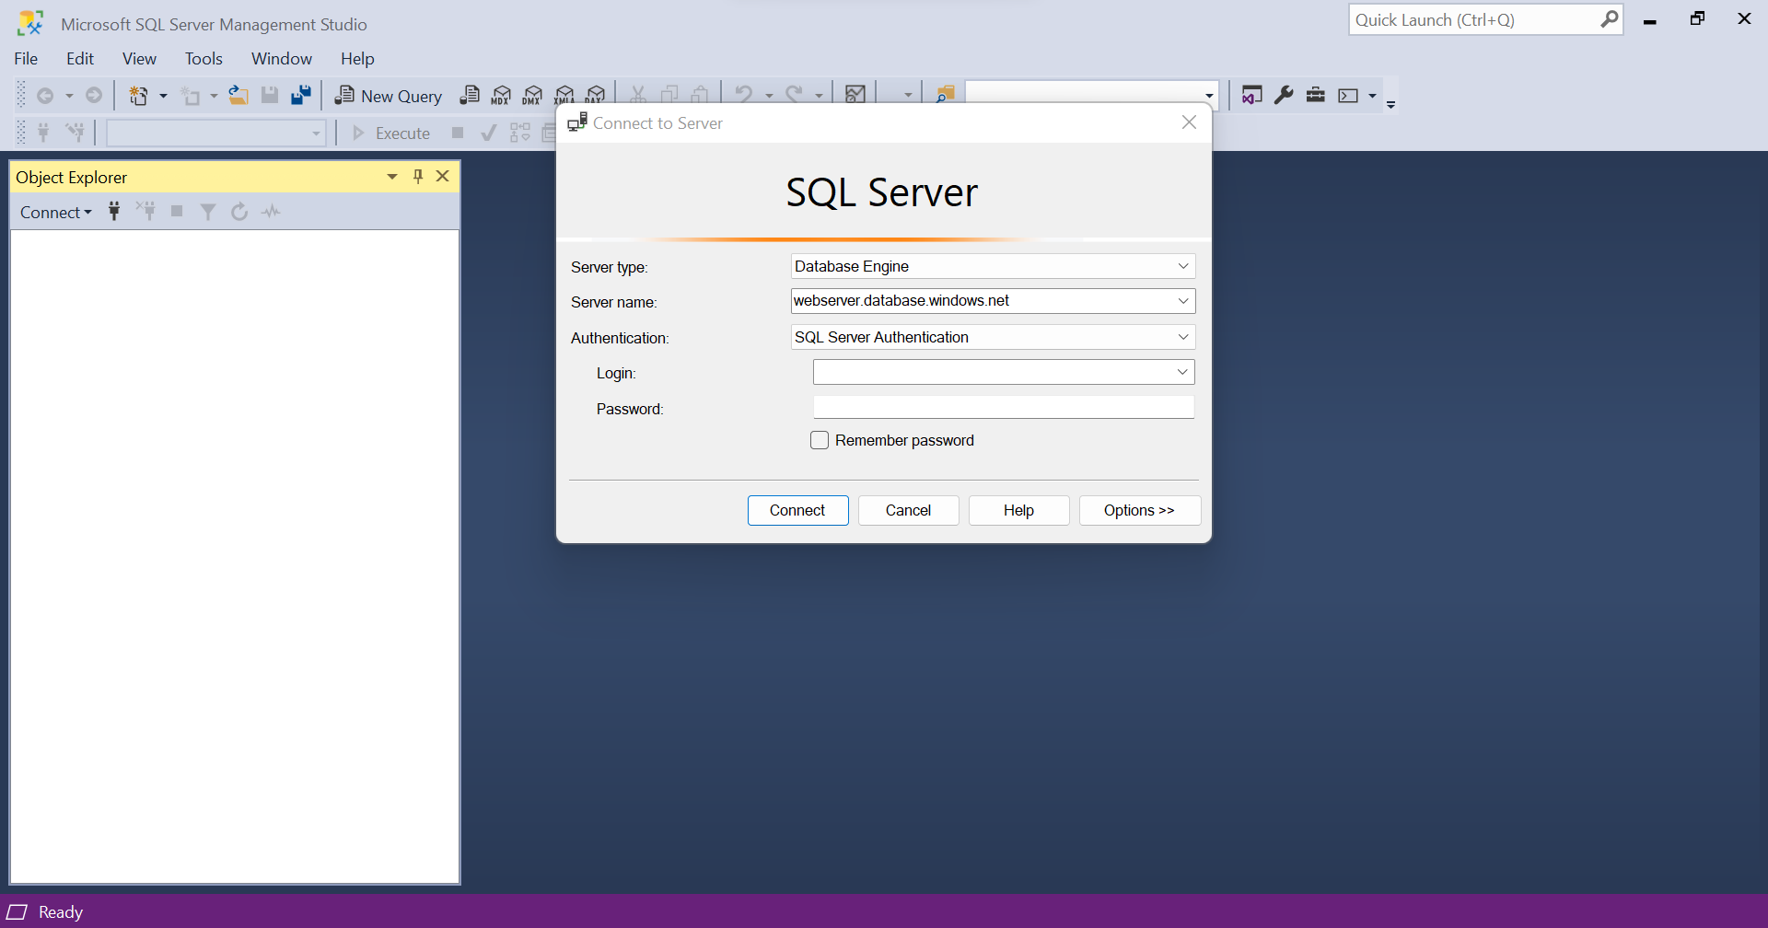

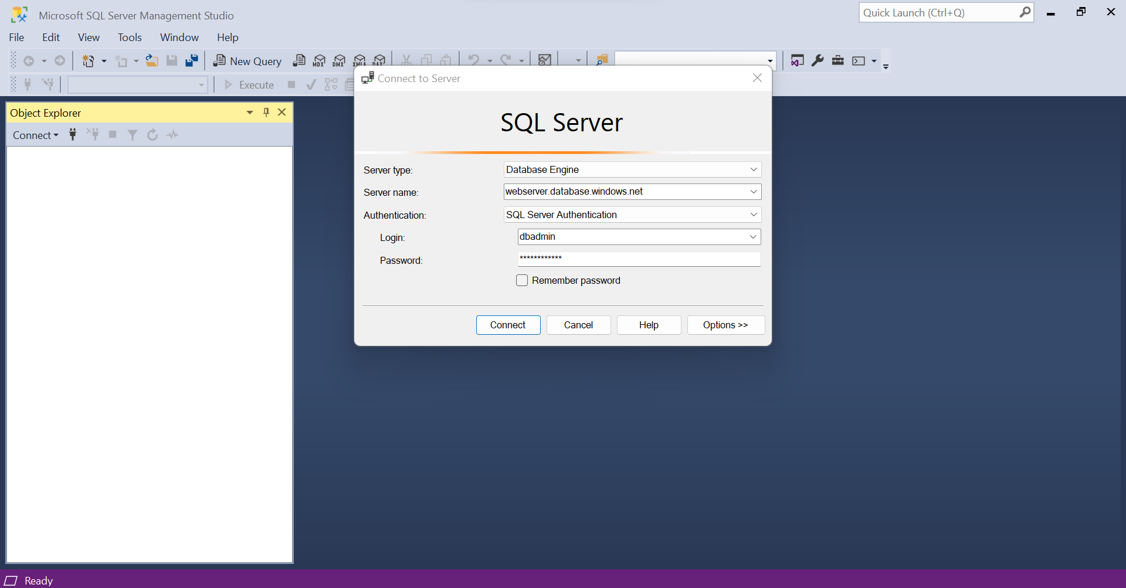

Click on Sign In. You will be redirected to the Azure Portal.

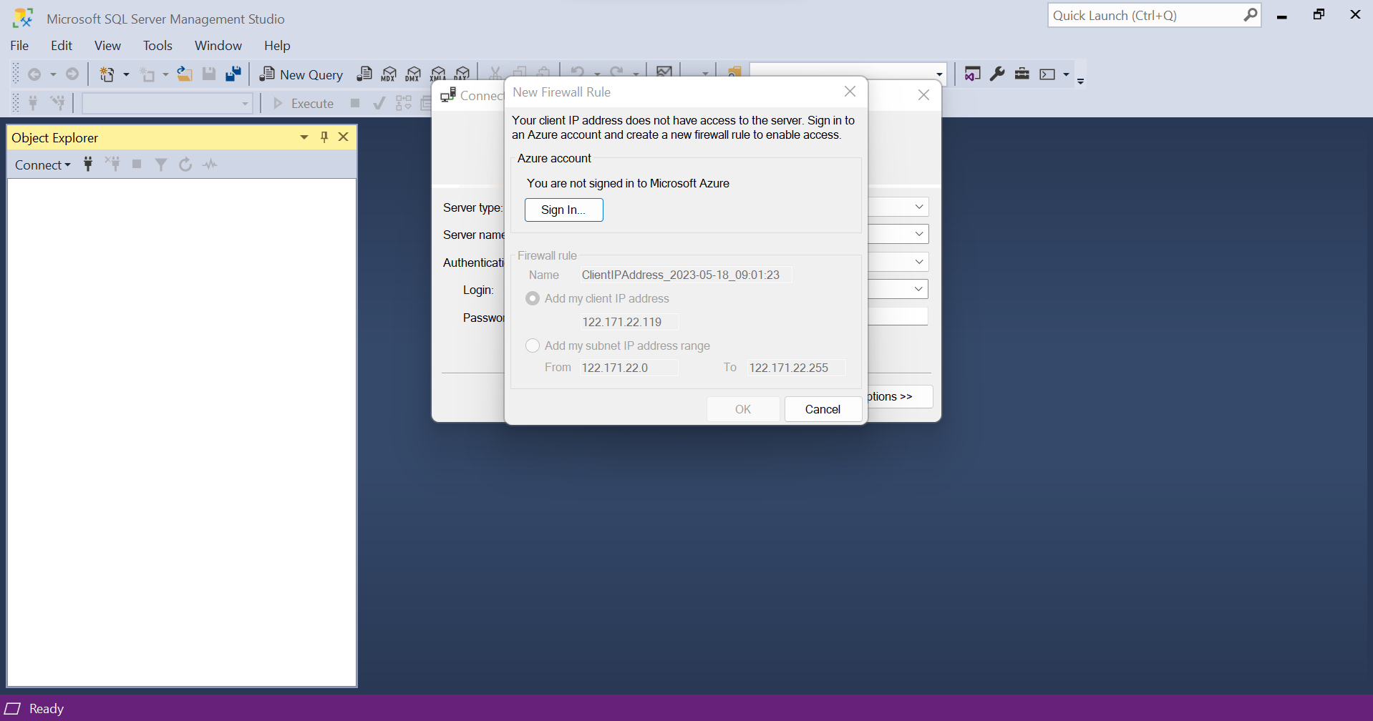

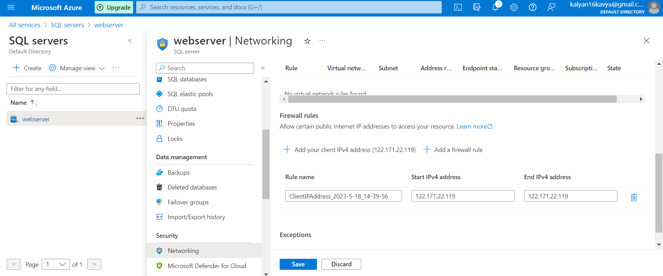\ 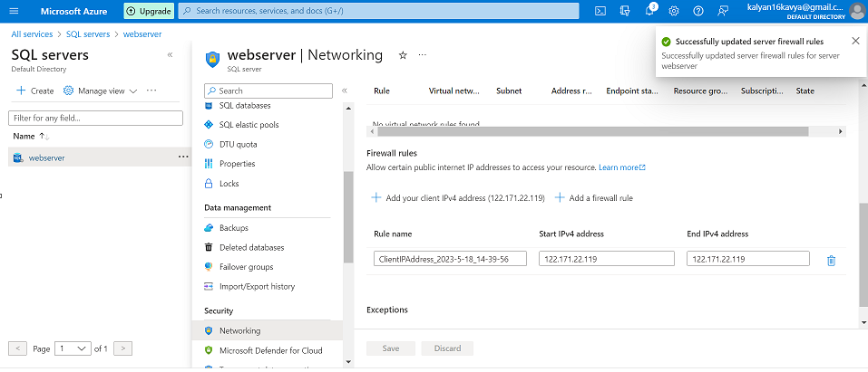

Then right click on the database name and then click on deploy database to azure.

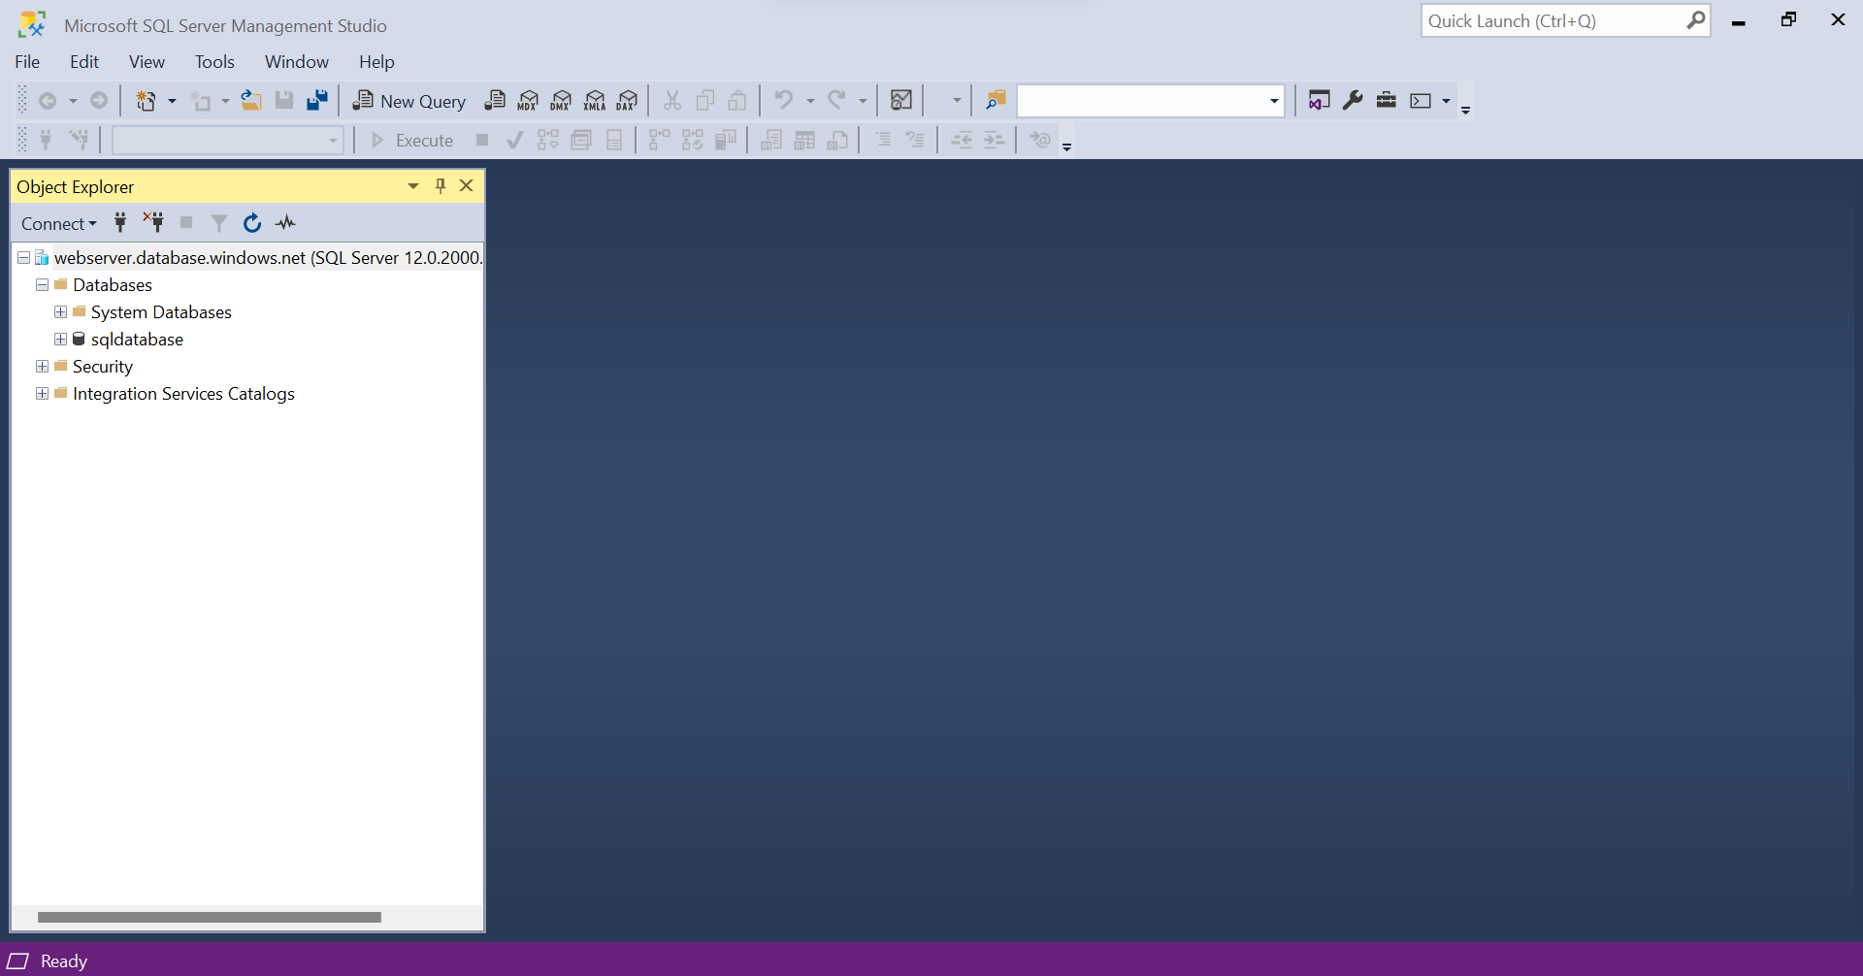

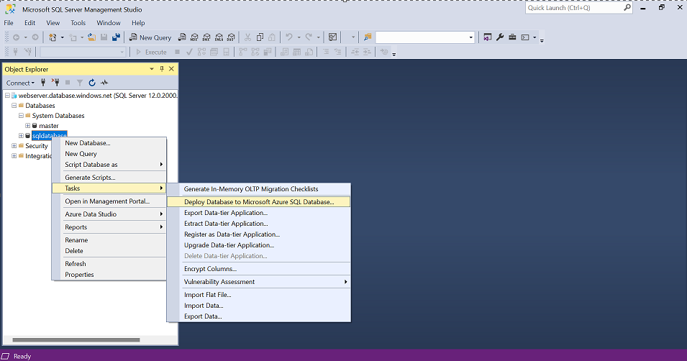

Click on Next.

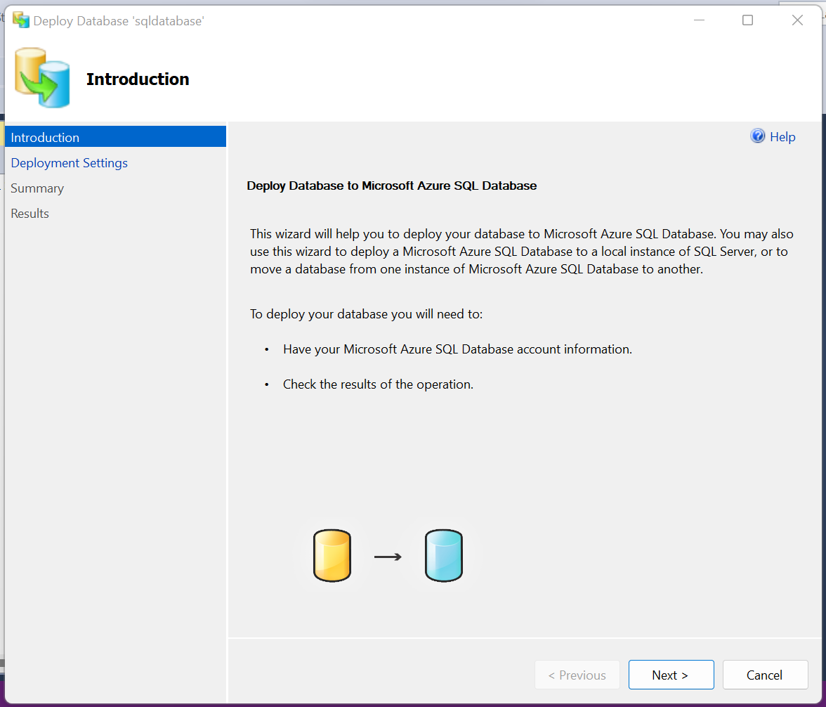

Connect to azure web server by providing the credentials.

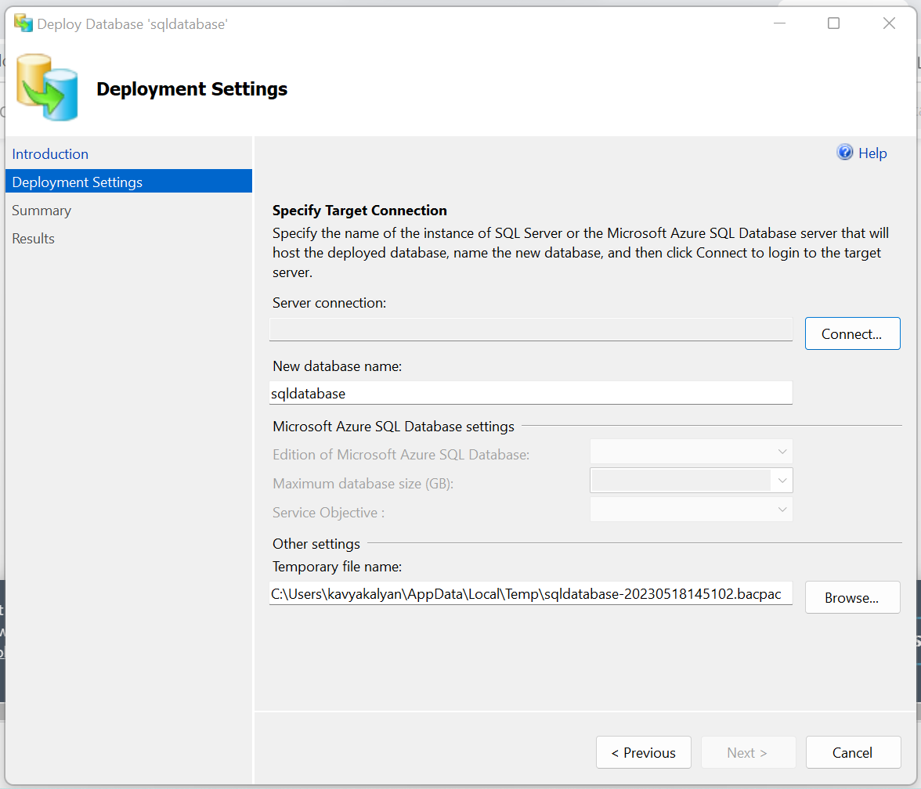

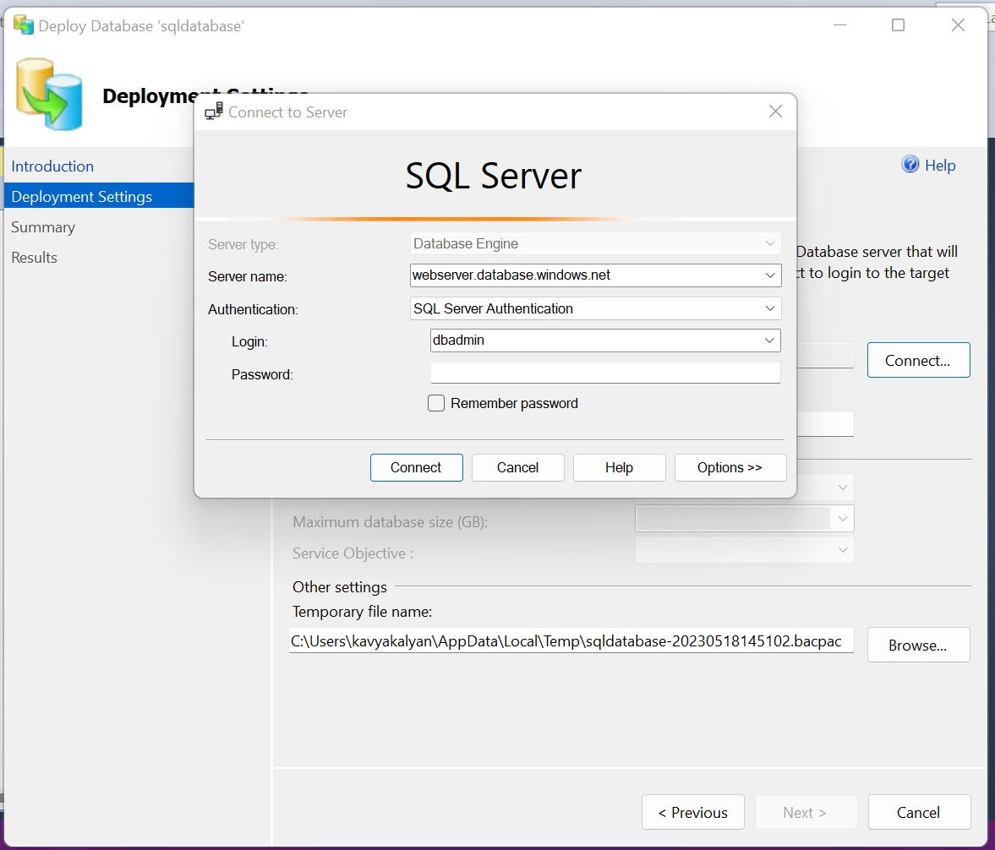

Add a name to the New database name field. “Events”. Click on next.

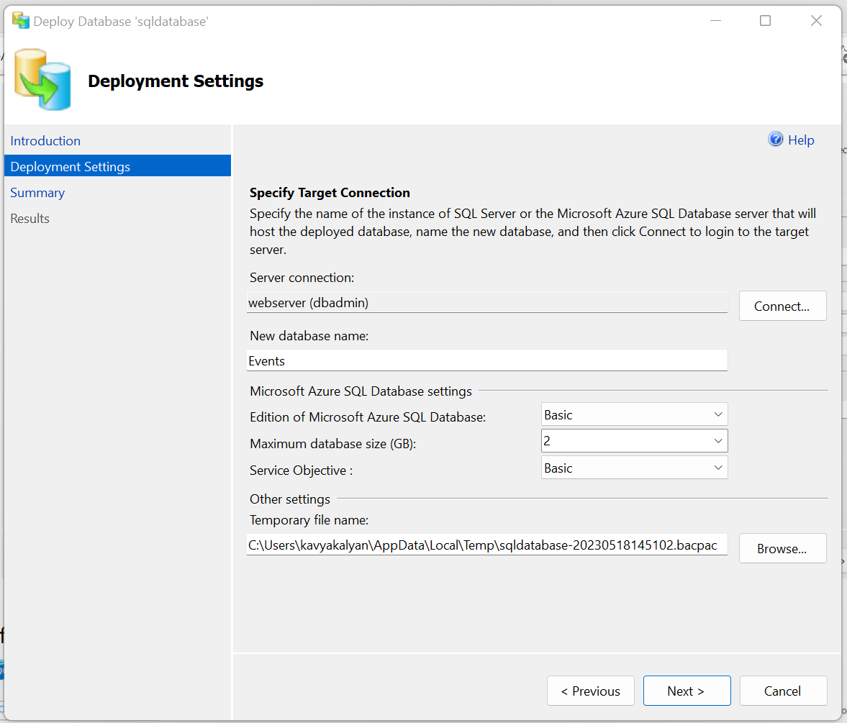

Click on finish.

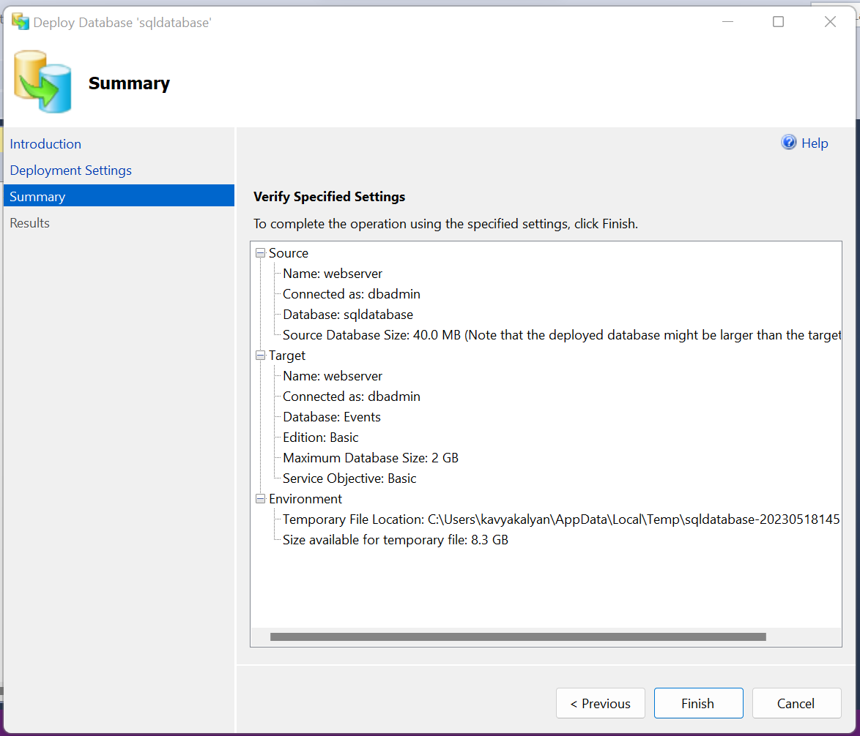

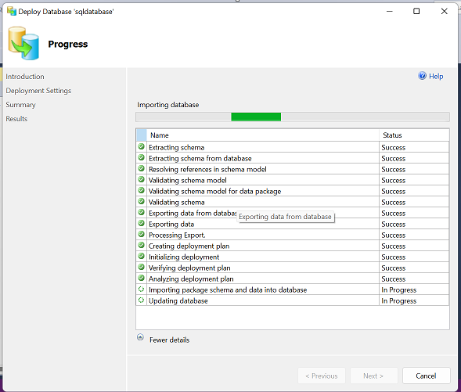

Click on Close.

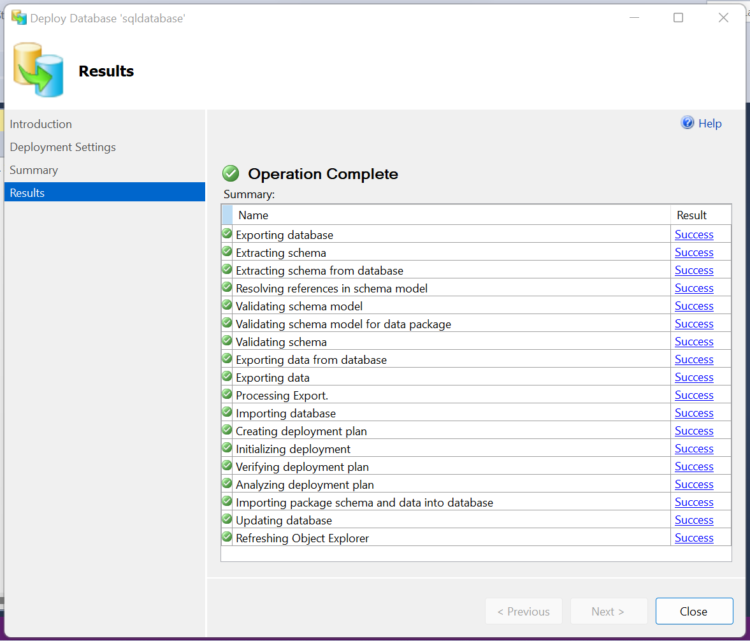

After closing, open the azure SQL database you’ll able to see the “Events” database created.

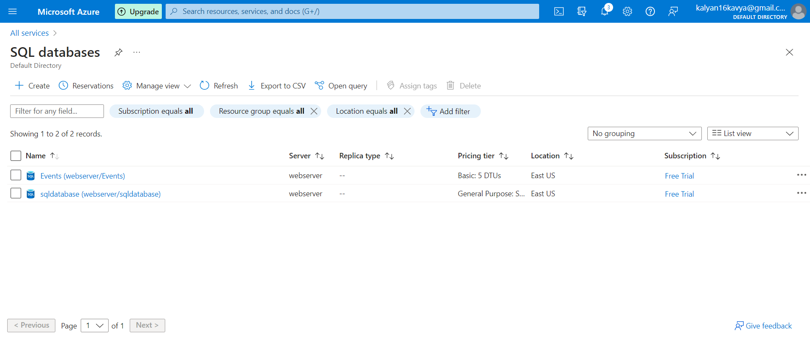

Check the details of the Events database.

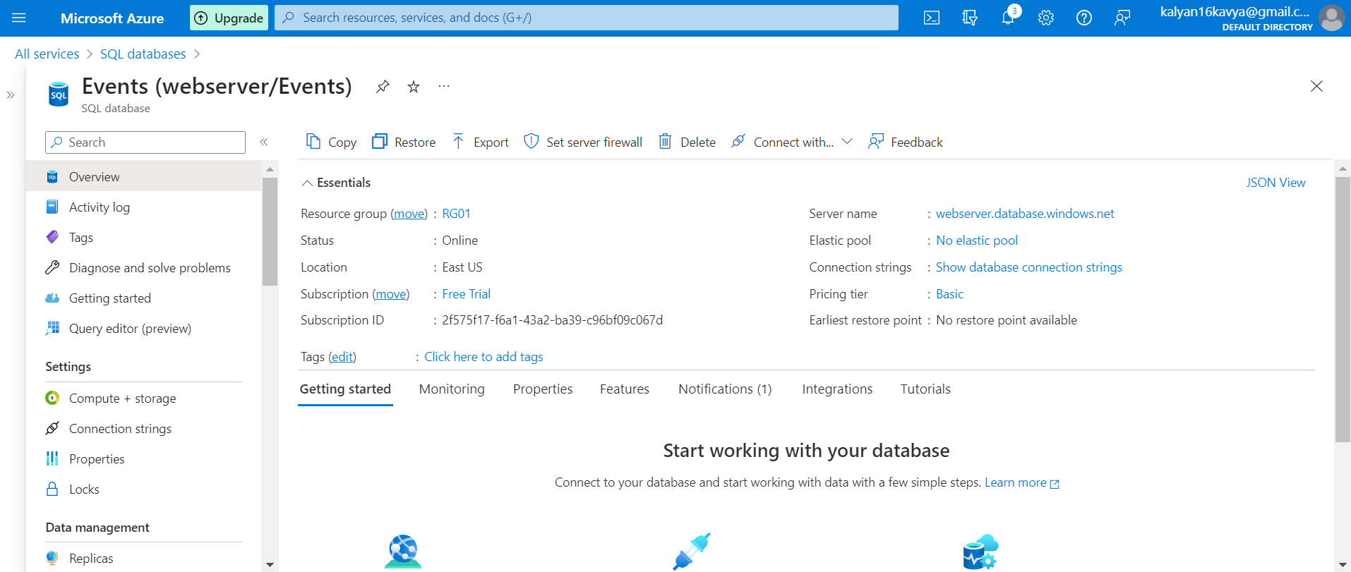

For connecting the application with azure database copy the connection string and then paste it in web.config file of application.

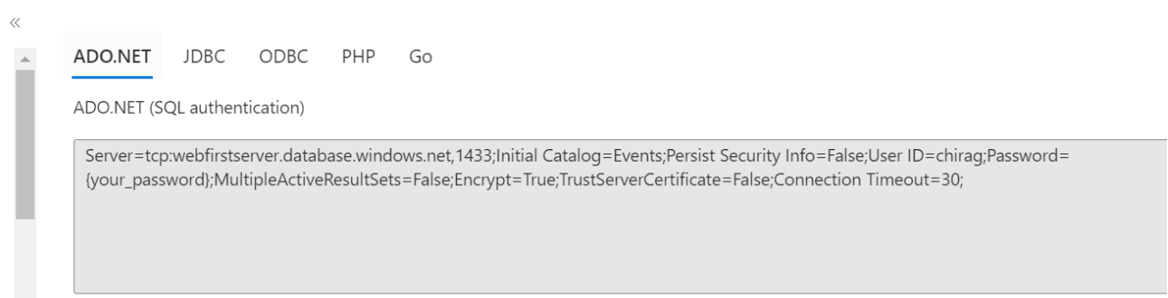

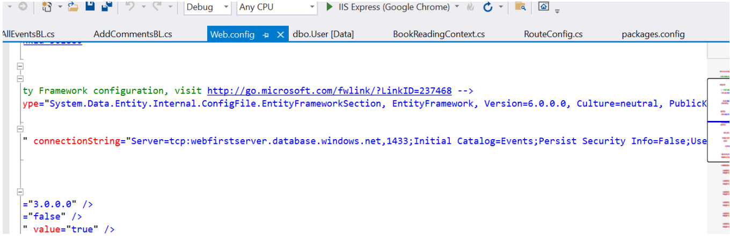MVC Application

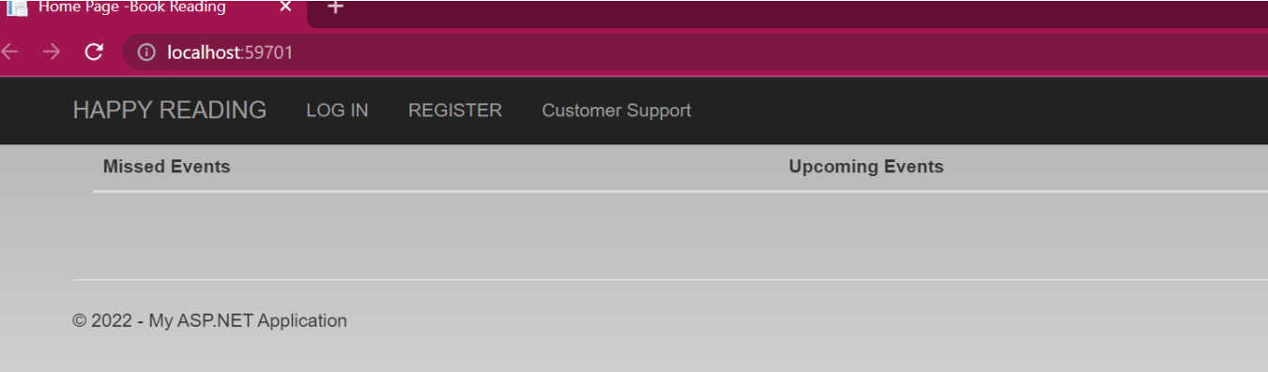

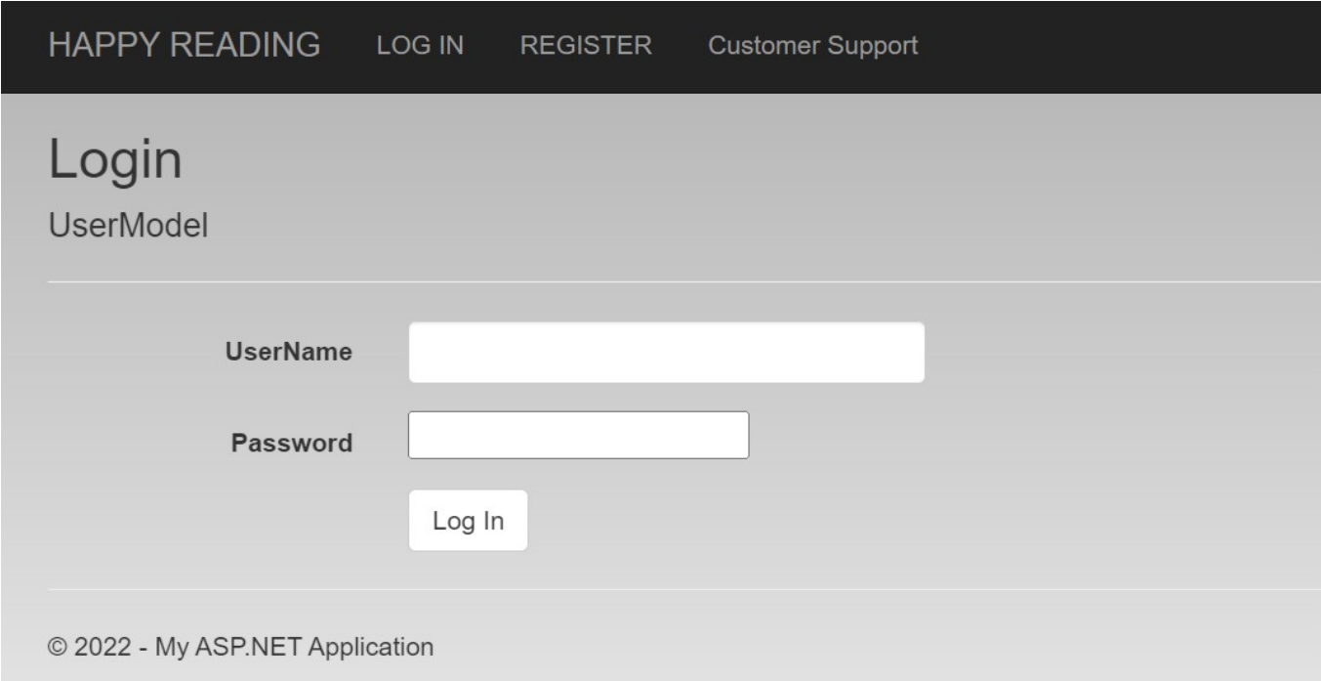

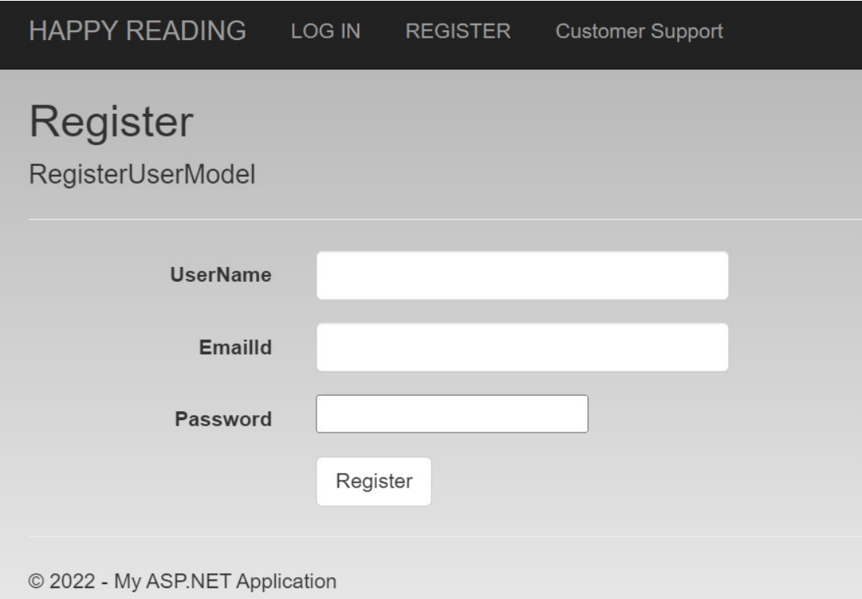

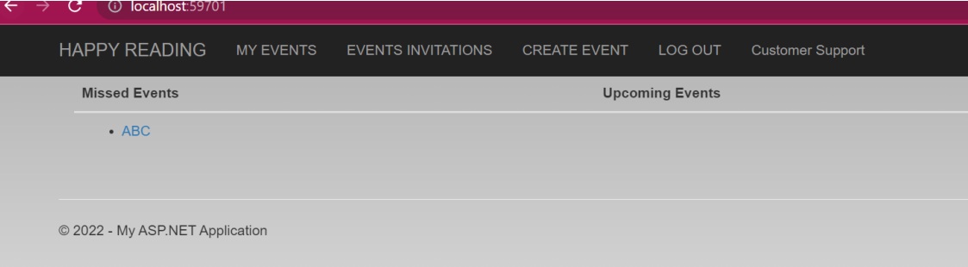

Q3. Deploy an application to Azure App Service. It should also leverage the database on the cloud.

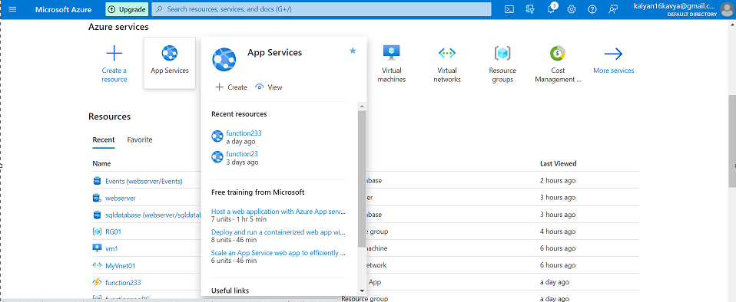

Create an App Service

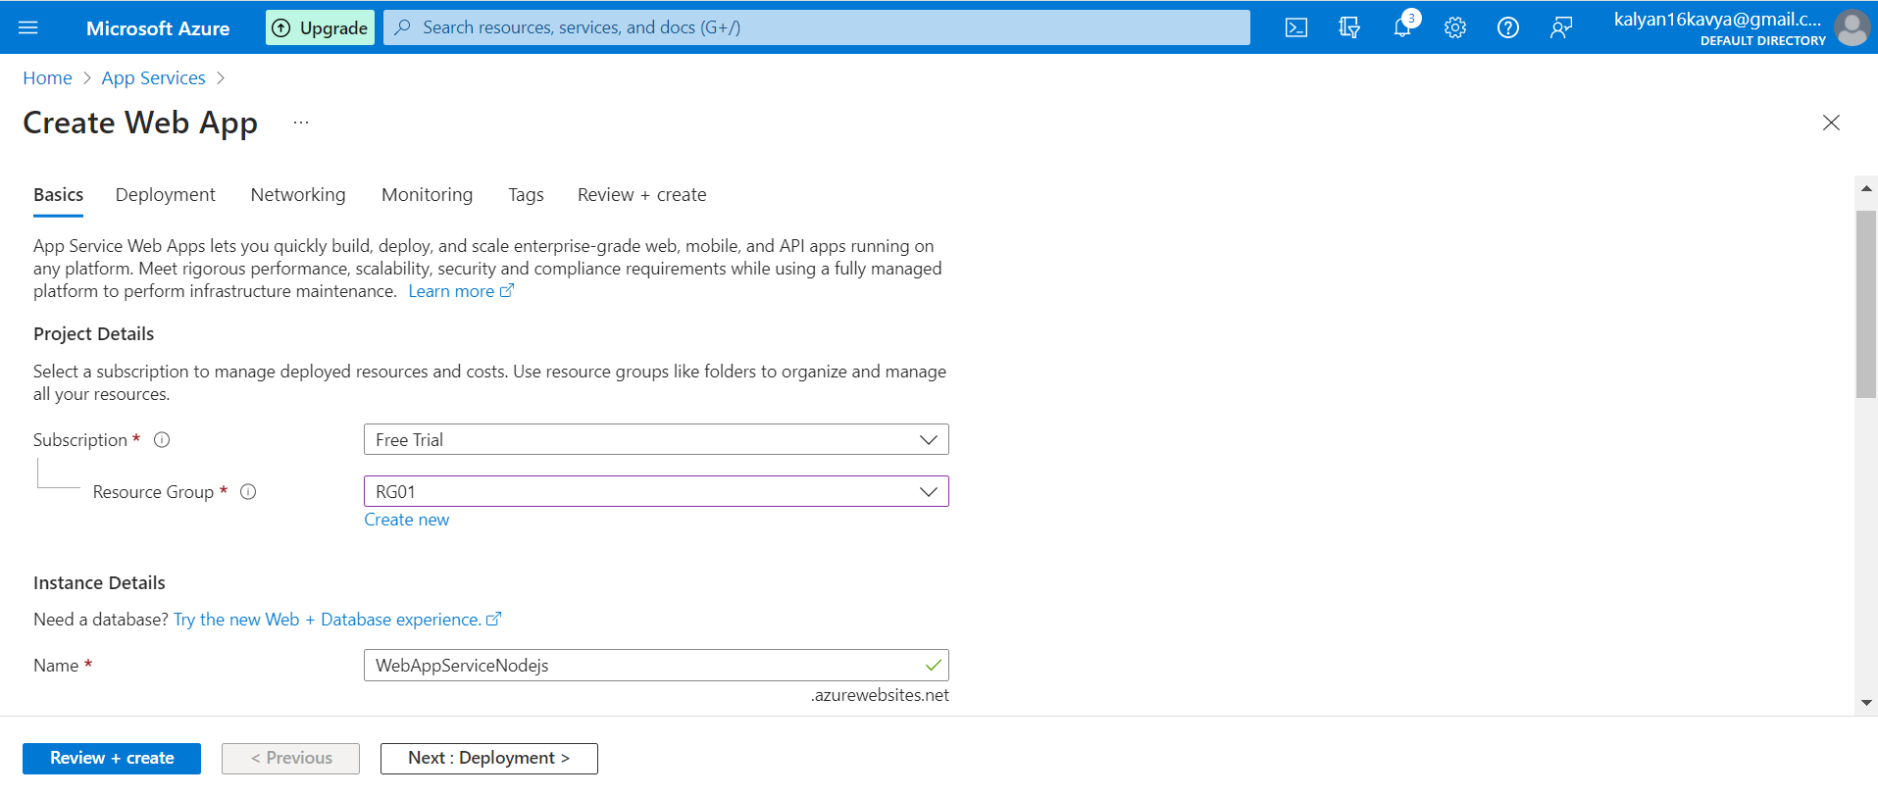

Give a unique name to the App Service and select the NodeJS version.

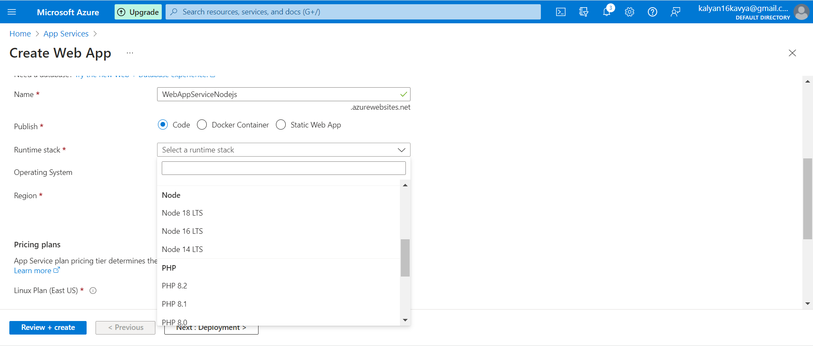

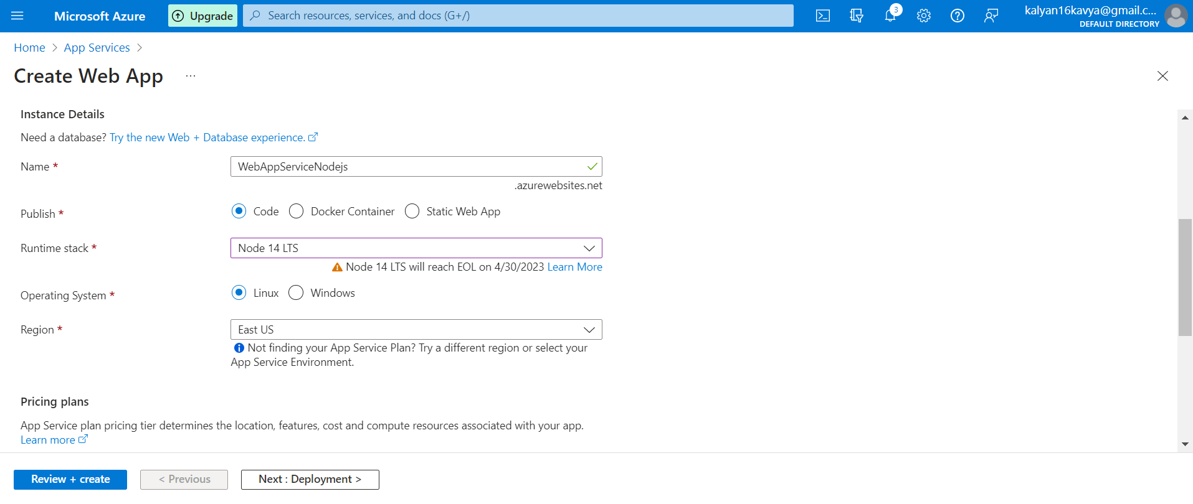

Select the Free Pricing Plan as Free or any plan which you have subscribed to.

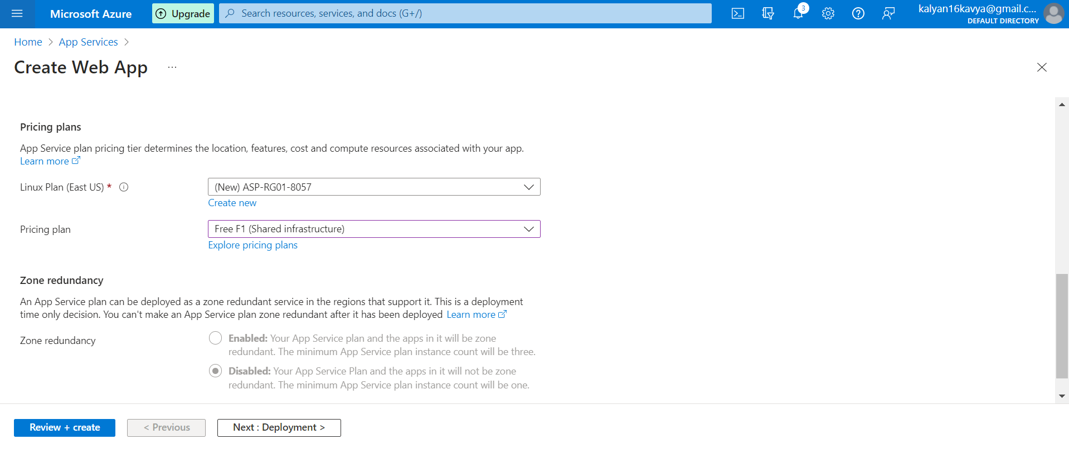

Let the other tabs have the default values. Review the details and click on create.

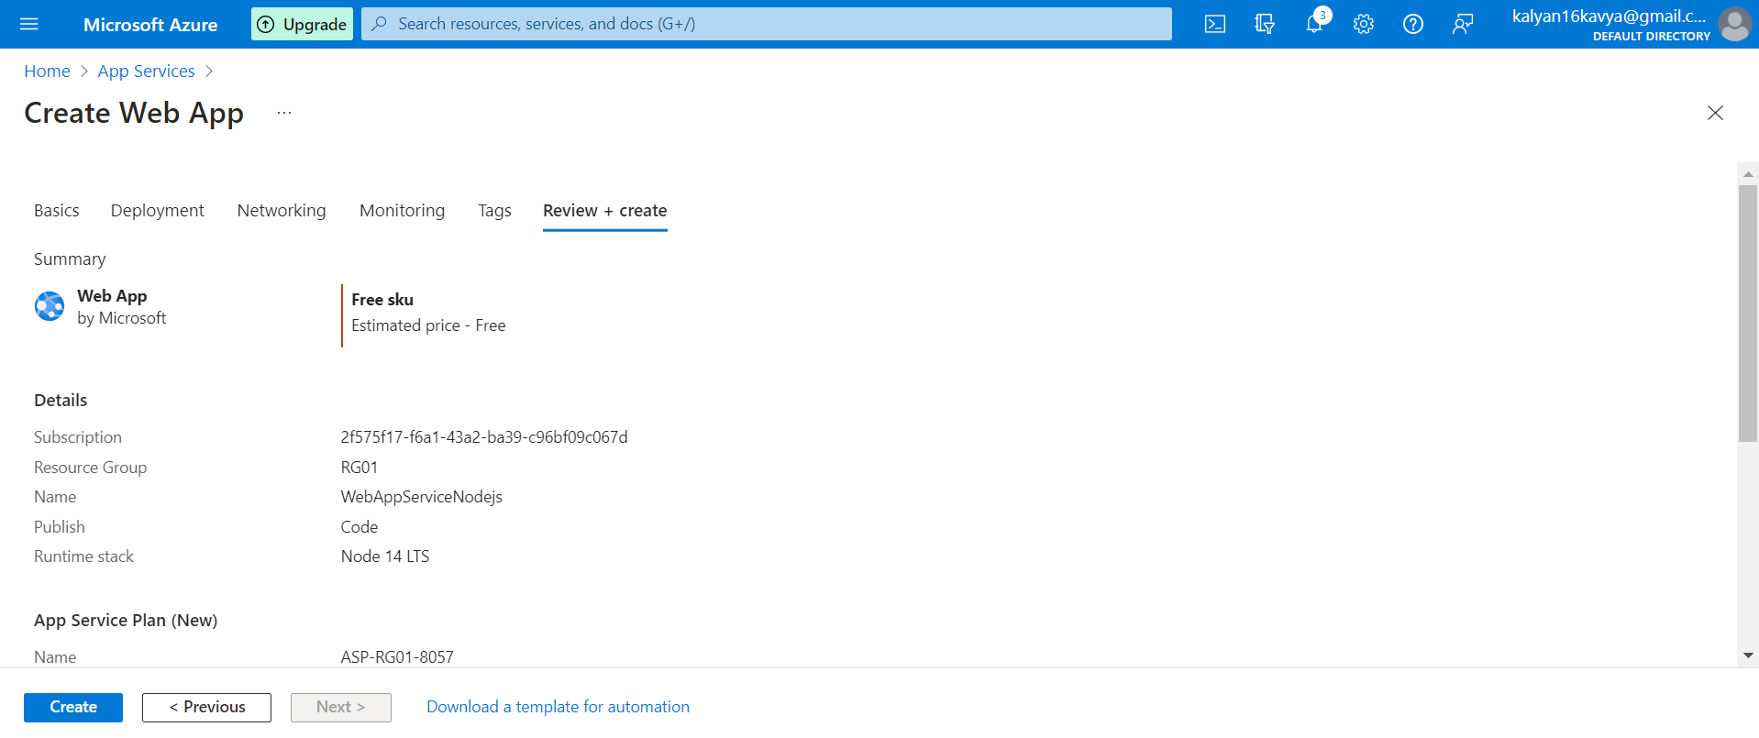

Click on Create.

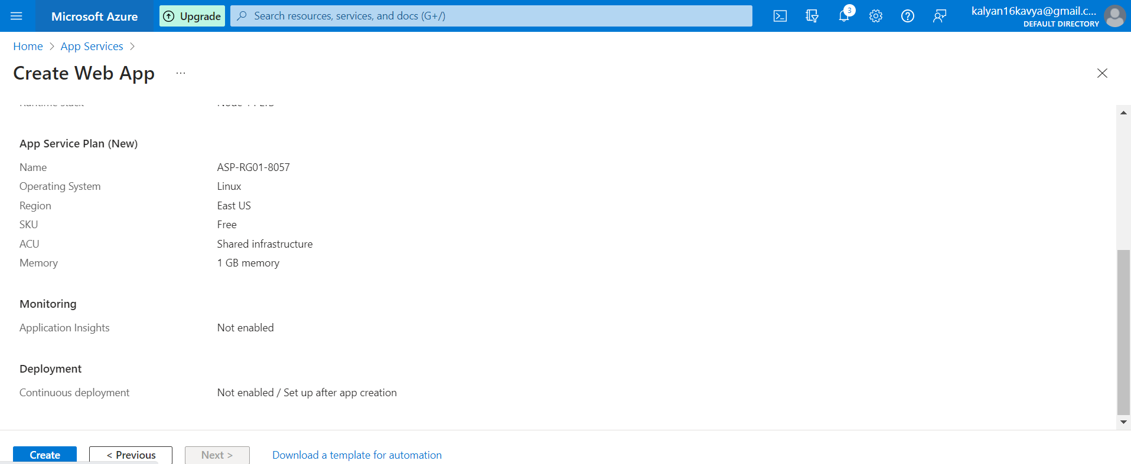

This screen will be visible once the deployment is completed.

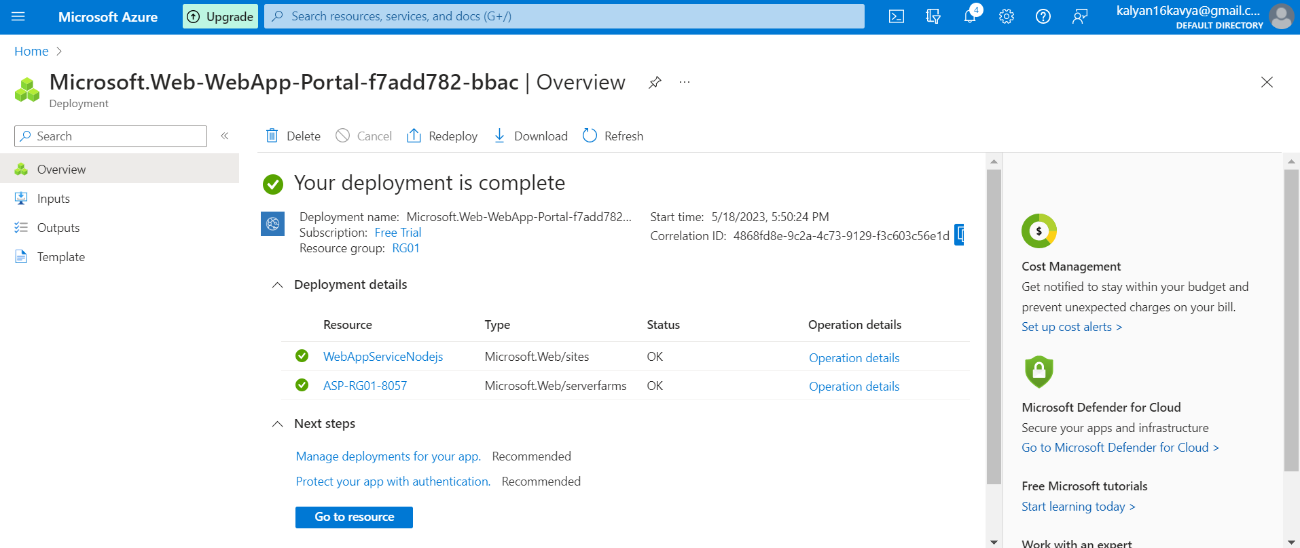

To deploy NodeJS application from the Visual Studio code, we need to install the Azure tools Extensions from Extensions.

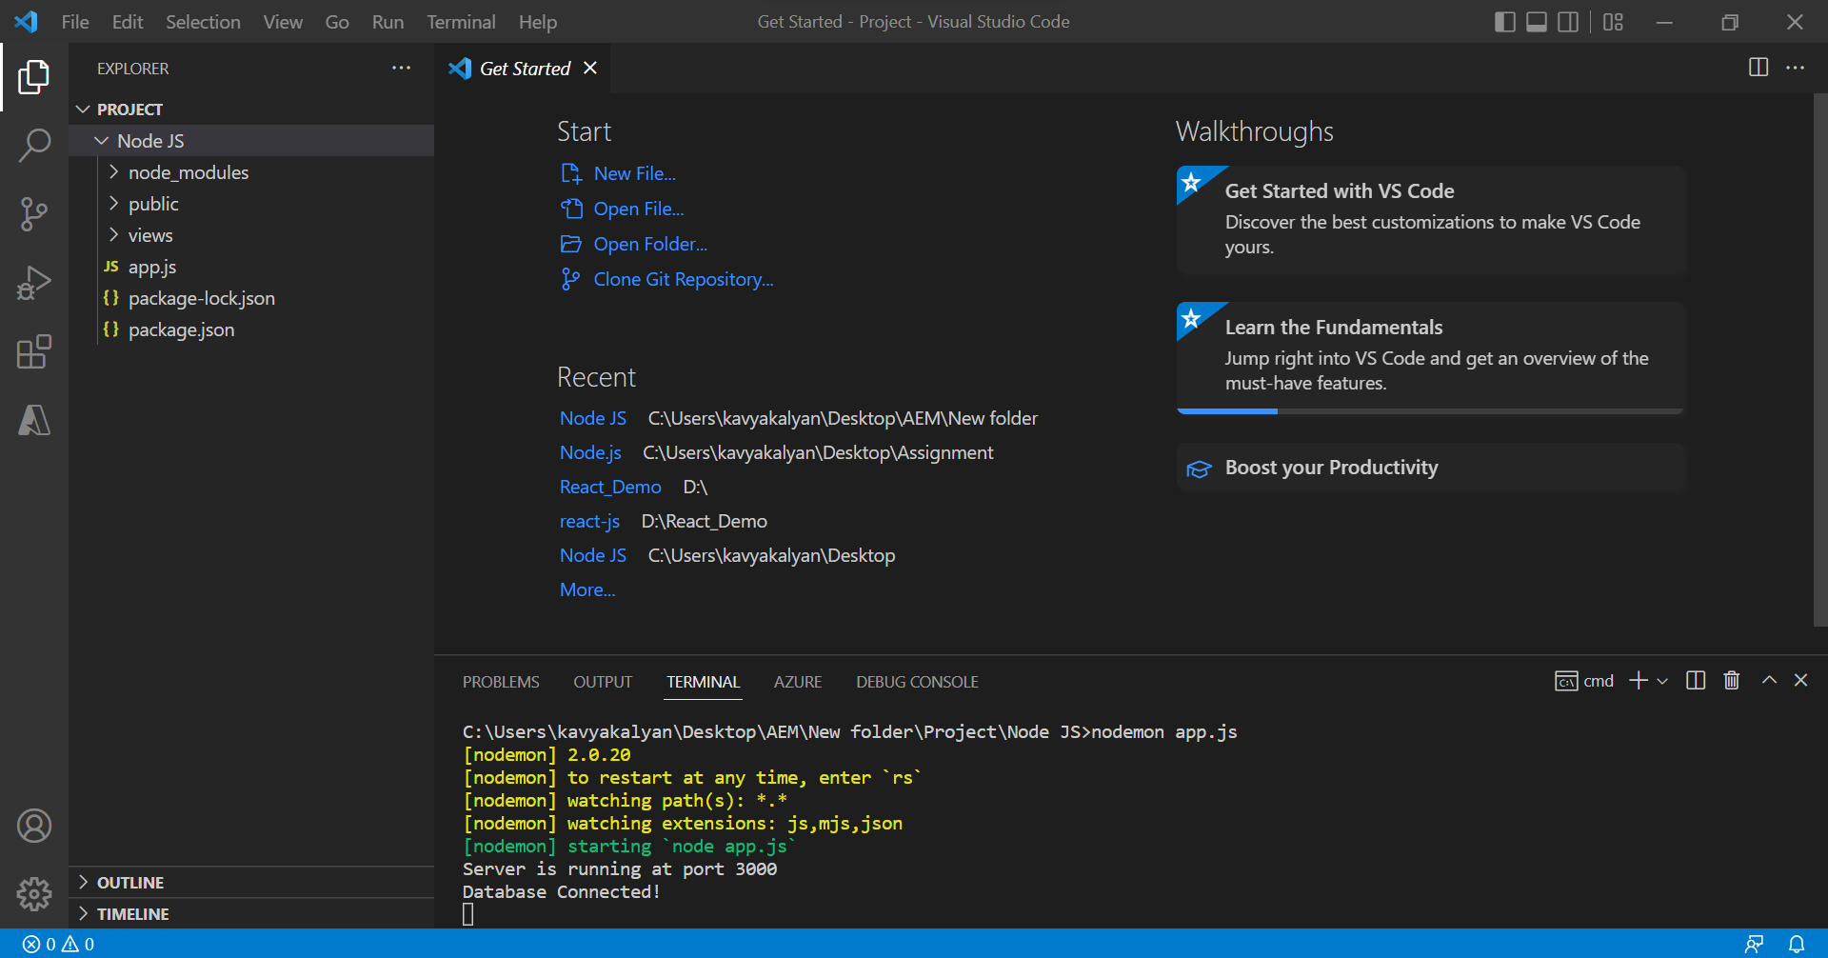

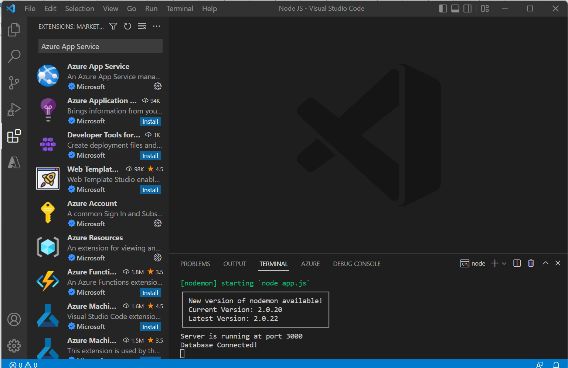

In the Azure tab, go to App Services and right click on the App Service we created, in my case it is “WebAppServiceNodejs”. Then click on Deploy to Web App…

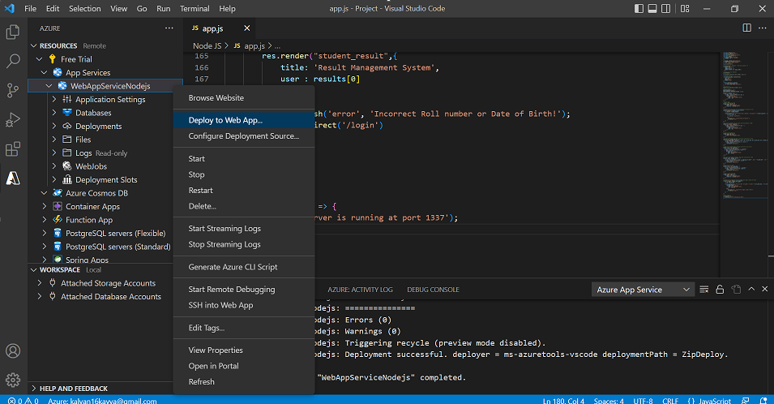

Browse your project folder.

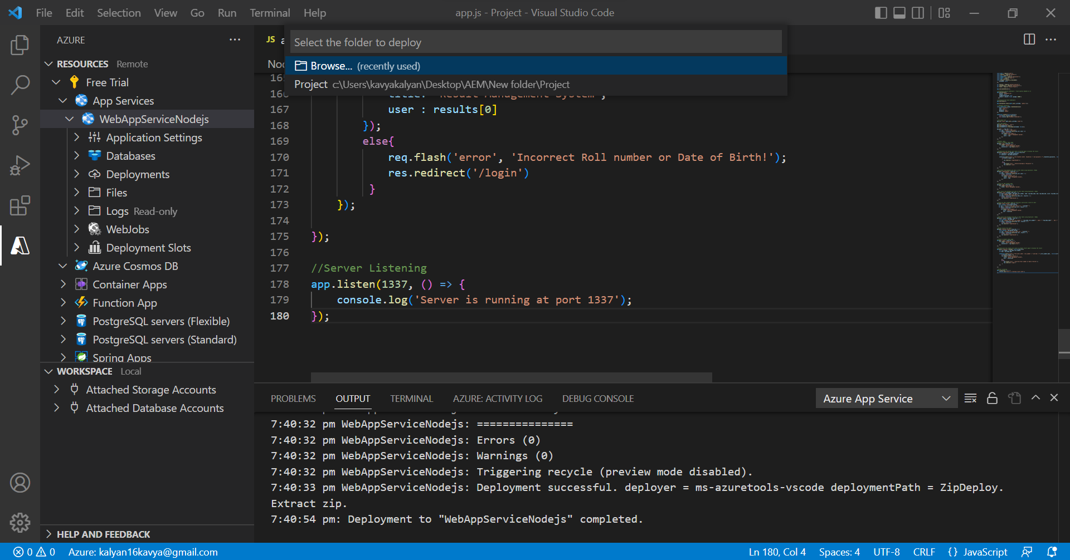

Click on Select

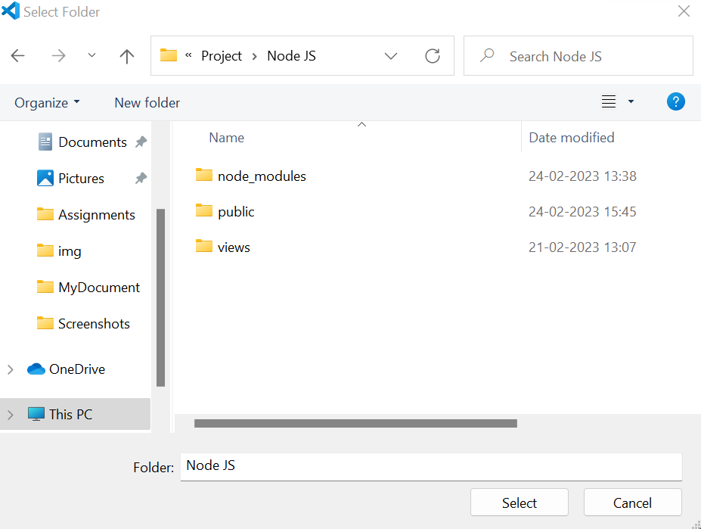

Deployment has started, it will take some while to get deployed. Click on Skip for Now

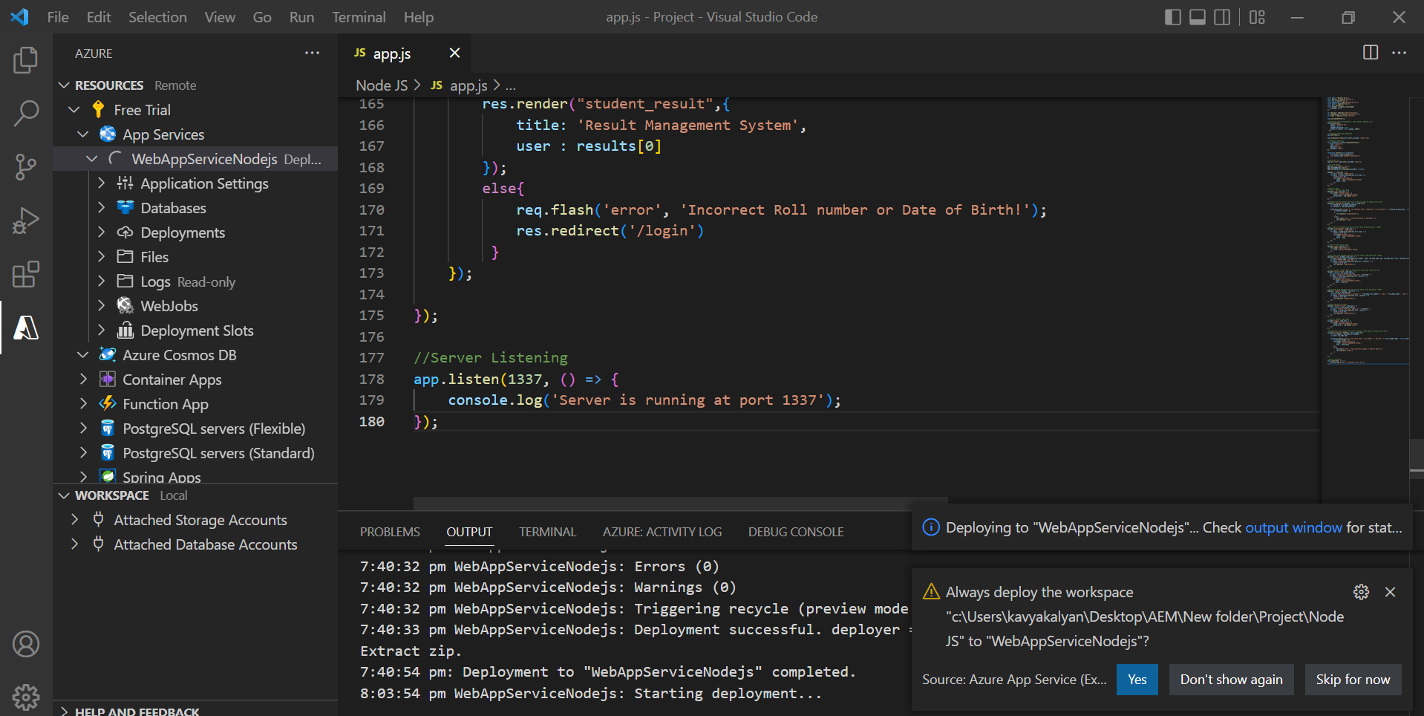

Click on Browse Website, and the page will open in the cloud.

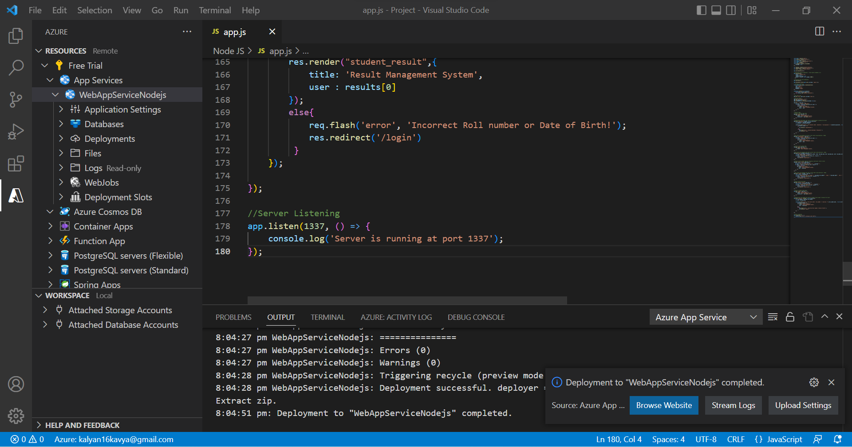

I’m getting this error, even after the deployment is completed.

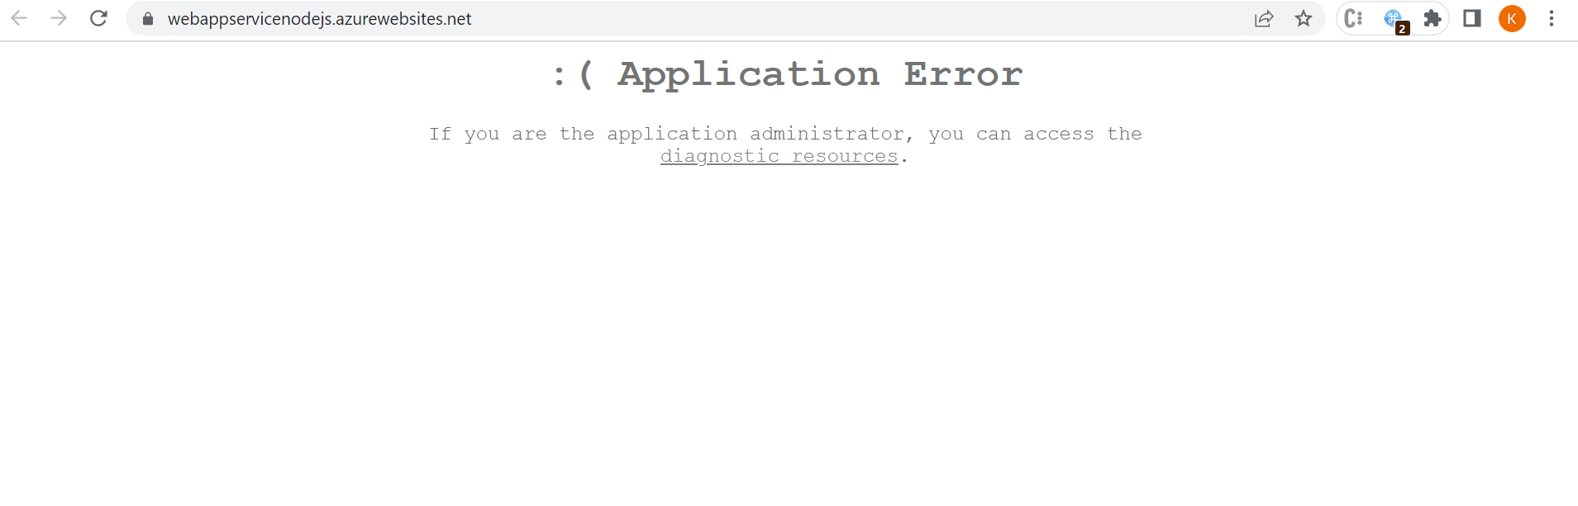

Q4. Create the AKS cluster (2 nodes, smallest size VM) and deploy any two services on it. Services should be accessible from the internet.

To create Kubernetes service, click on the Kubernetes services icon or search for Kubernetes services in the search bar.

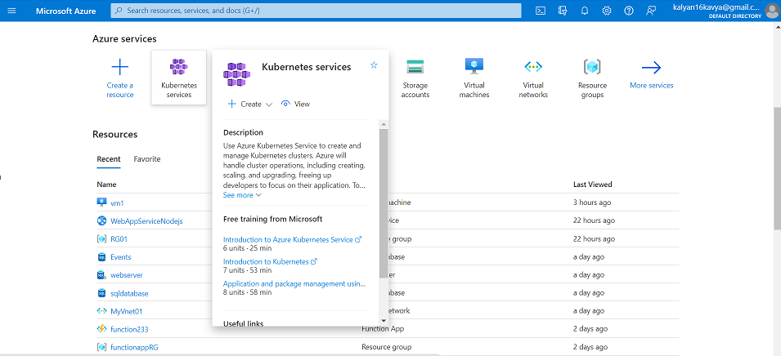

Click on + Create, then click on Create a Kubernetes Cluster.

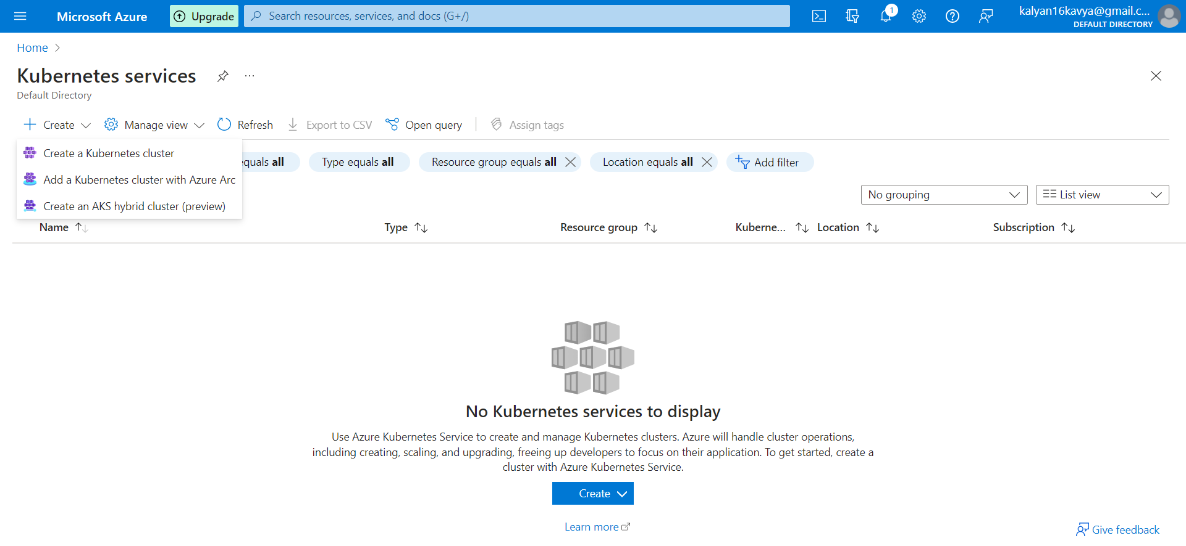

Add the Resource group or create a new Resource group and give a unique Kubernetes cluster name “myaks”.

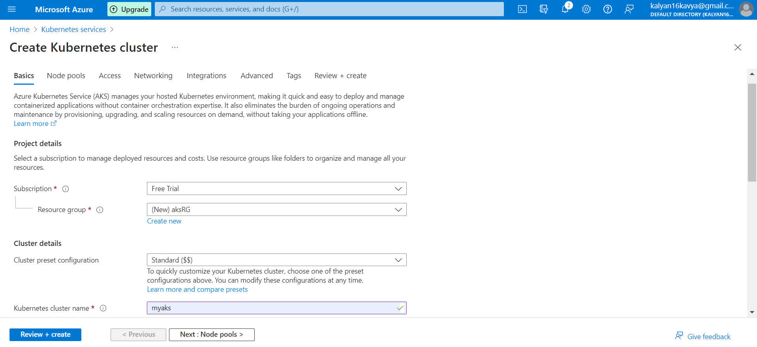

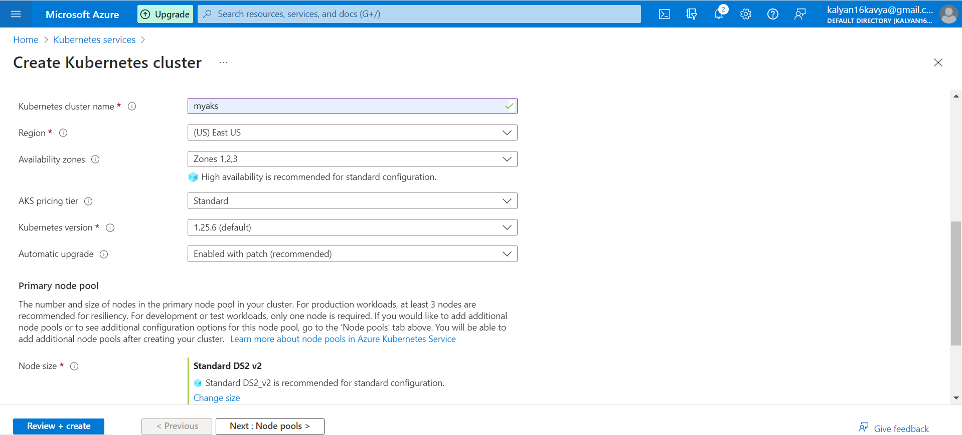

Node count range should be 2, since I was getting an error due to some quota restrictions, I had to keep the count as 1.

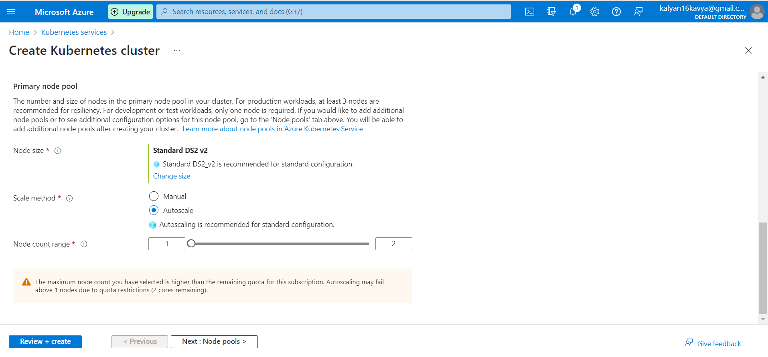

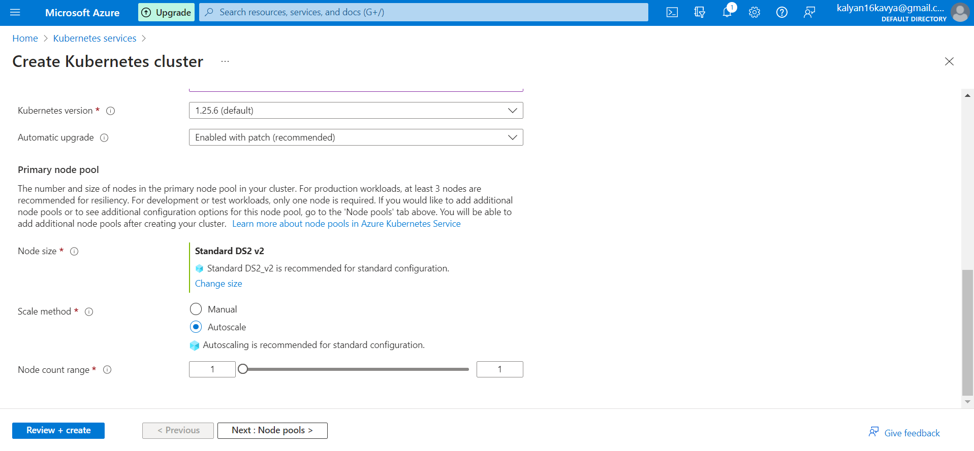

Click on Review + create and view the details.

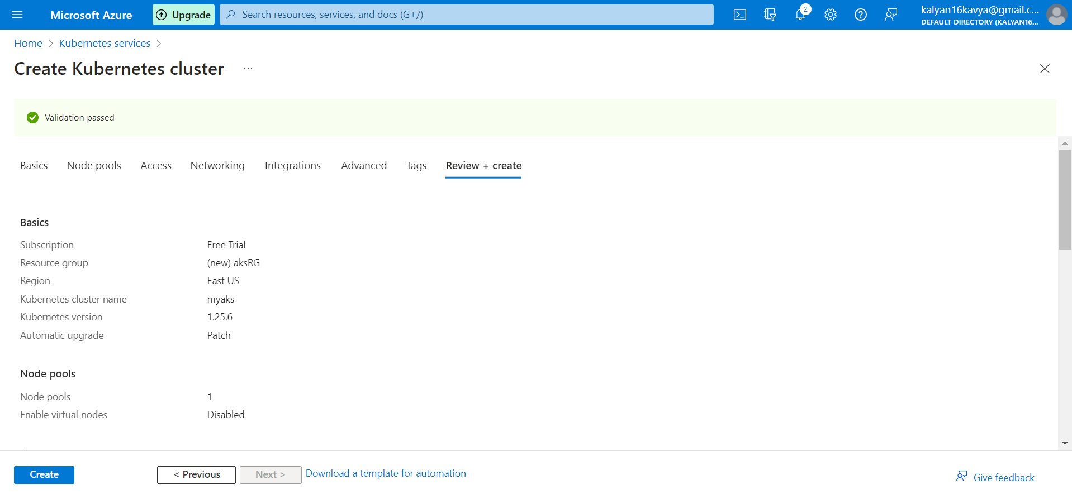

After deployment click on Go To Resources, and view the details of the Kubernetes cluster.

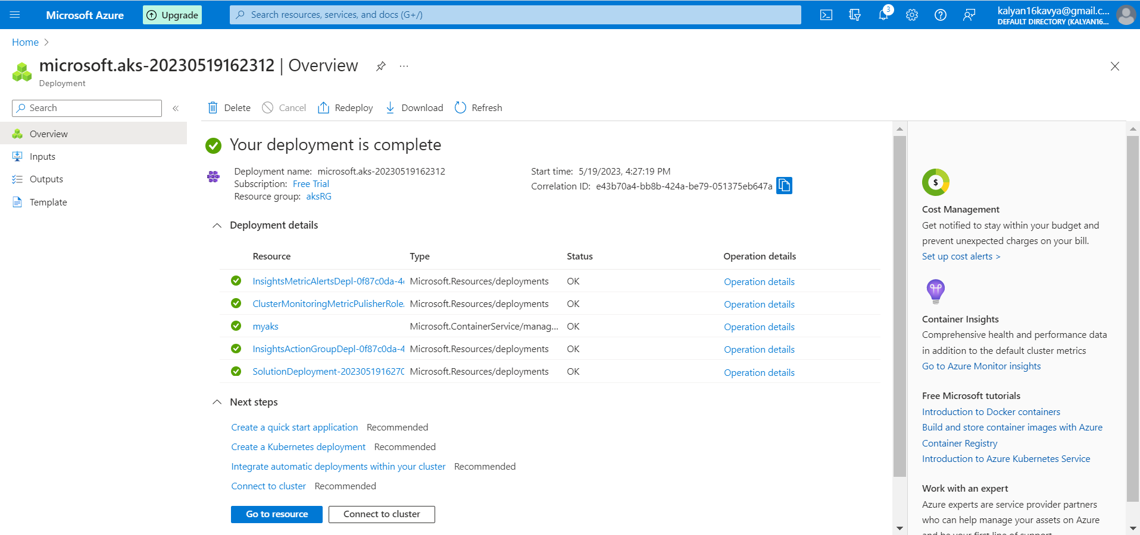

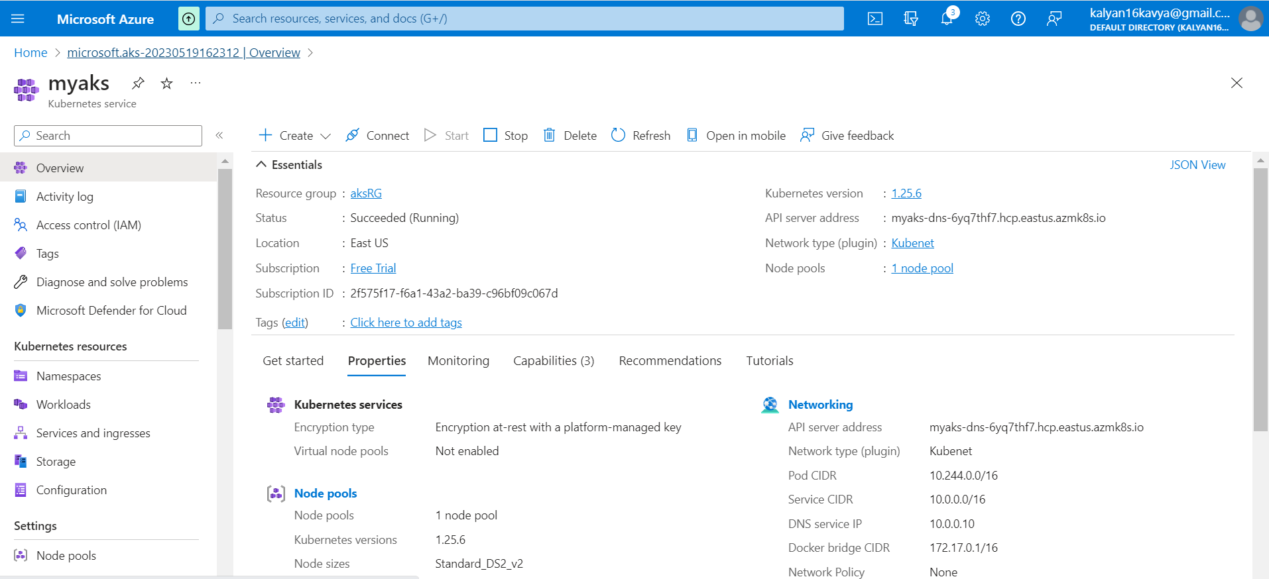

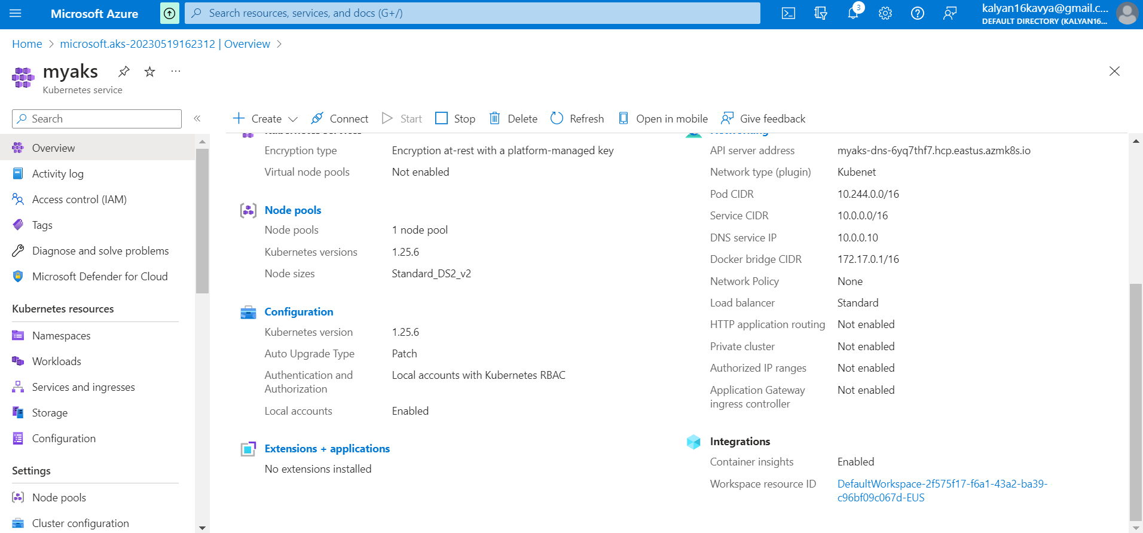

5. Create an Azure function that should trigger as soon as you upload a file in the blob storage. Function should be able to print the name of the file uploaded in the function.

To create a Storage account, search for Storage accounts in the search bar.

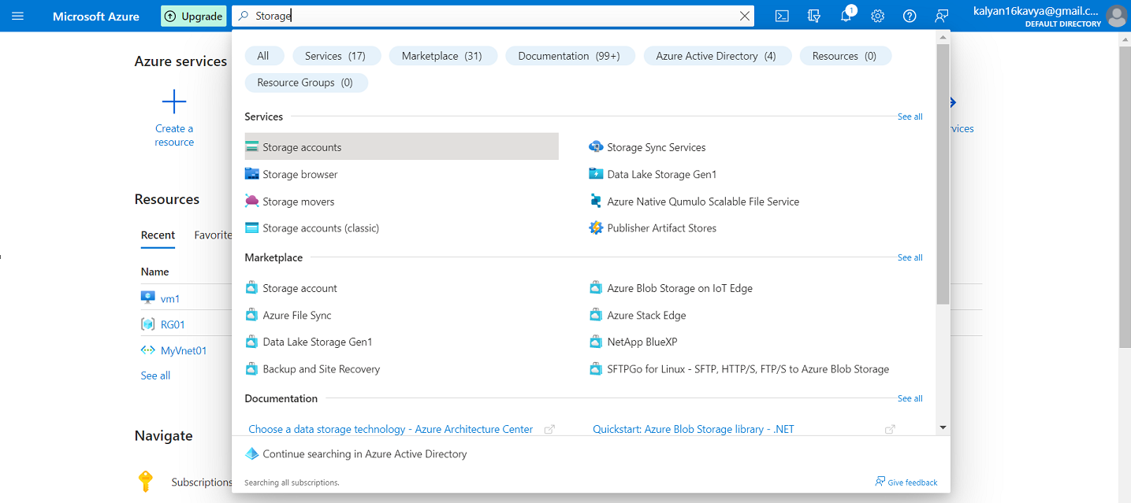

Click on + Create

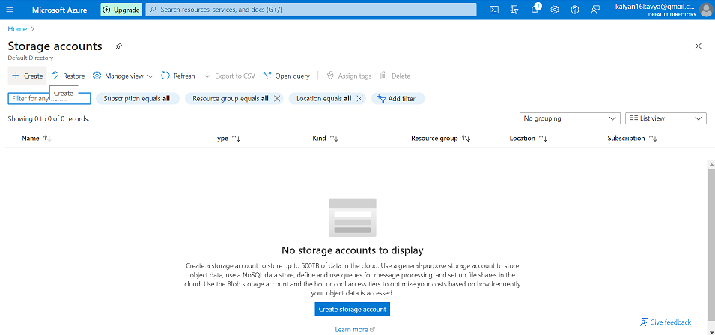

Select the Resource Group from the existing or create a new Resource Group.

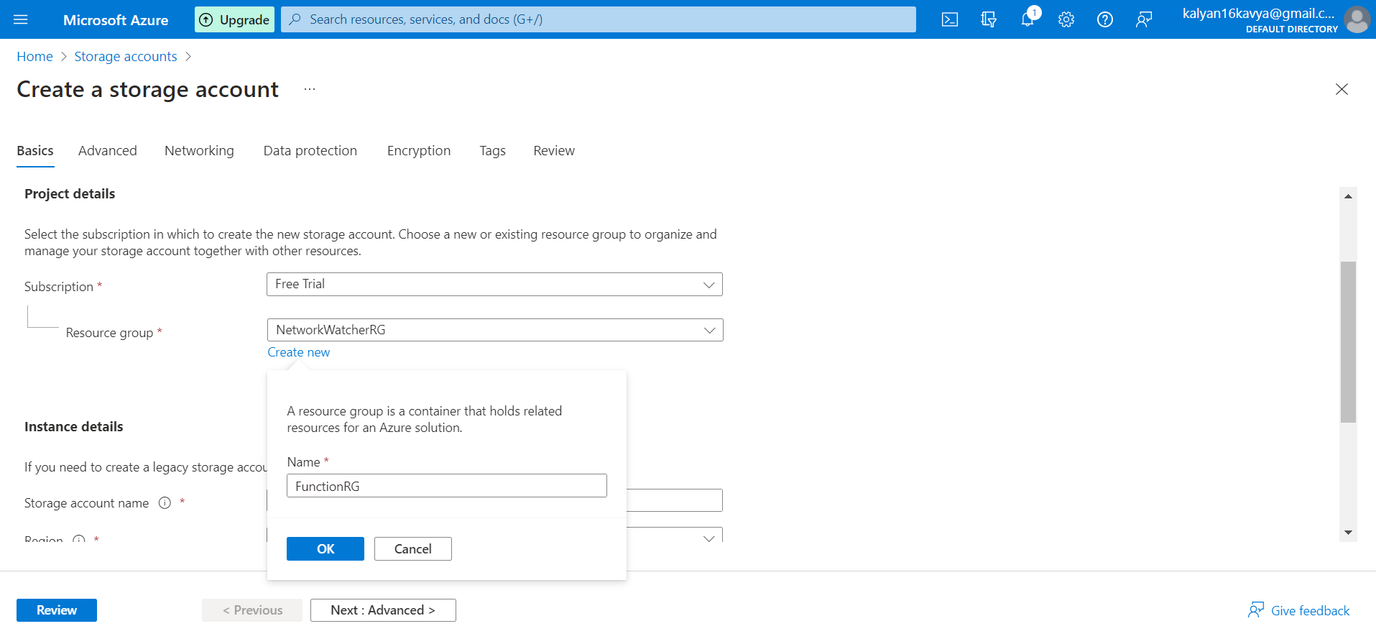

Give a unique Storage Account name. “functiontestblobstorage”

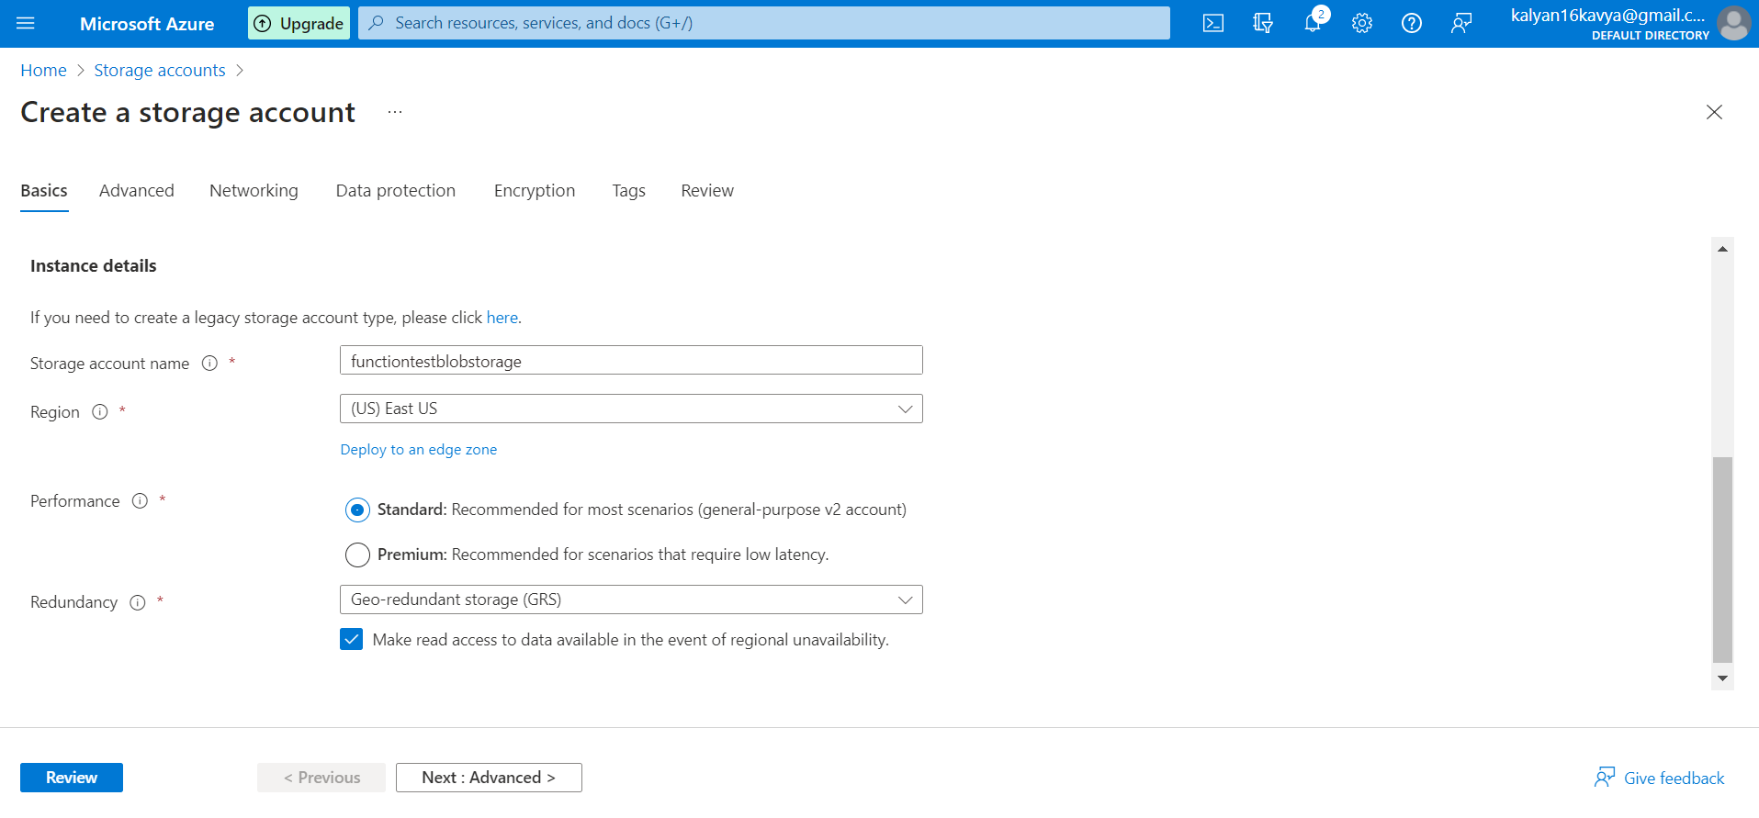

Let the other tabs have the default value. Click on Review + Create.

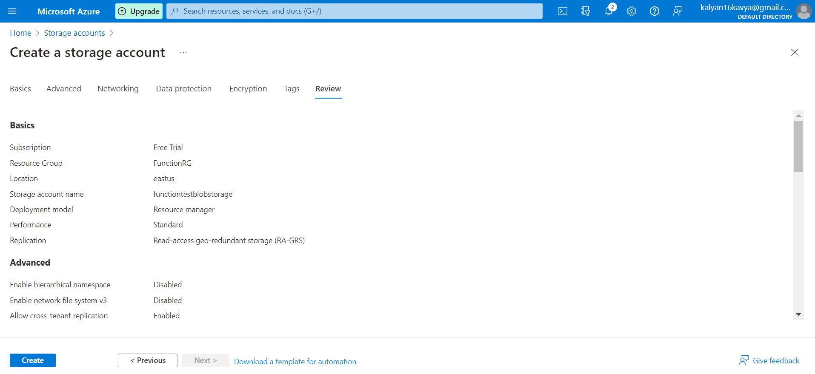

After completion of the deployment, Click on Go to Resources to view the details of the Storage accoount.

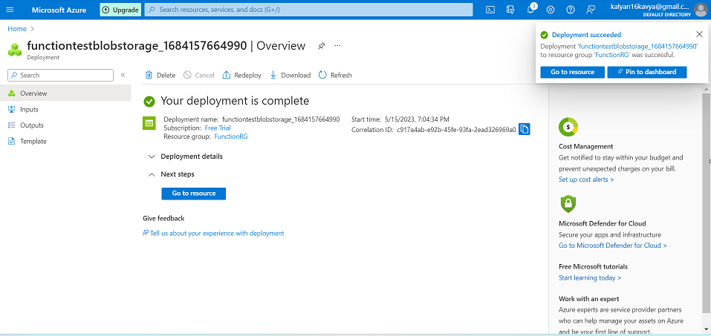

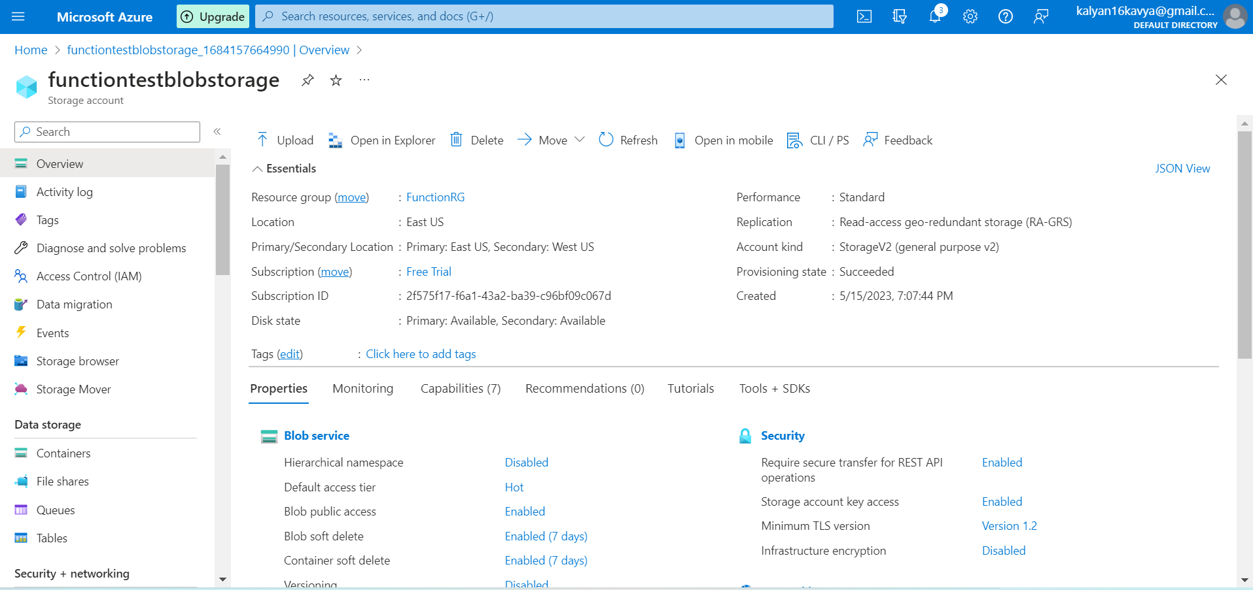

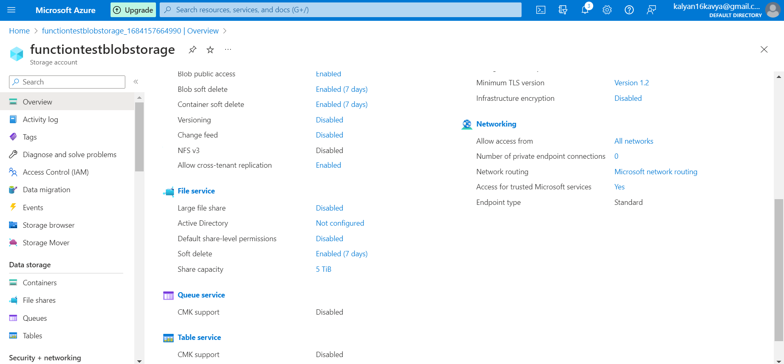

Search for Function App.

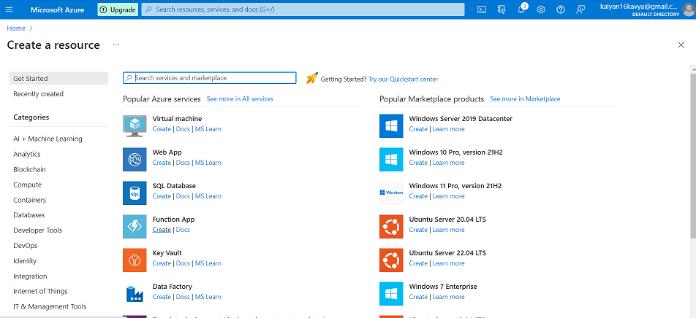

Add the Resource Group and a unique Function App name. “function233”.

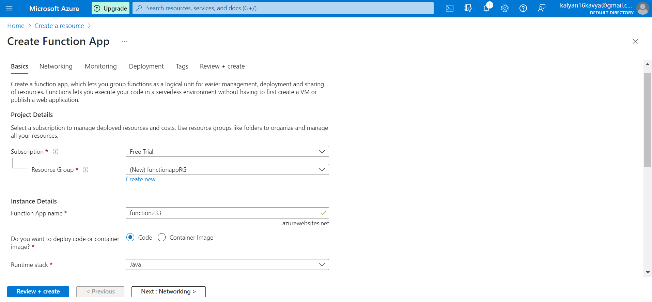

Click on Review + Create and view the details. And click on Create.

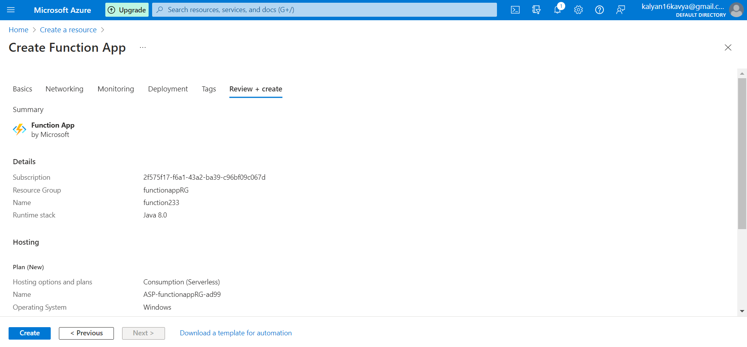

After the deployment click on Go to Resources

